Literacy  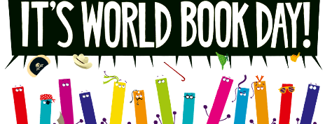 | Numeracy  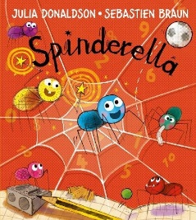 | Health and wellbeing  Gruffalo cake  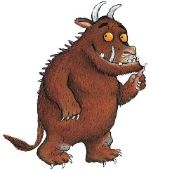 | World book day challenges
This Thursday it is World Book day. The tasks for this week are all based around different books. At home, you could celebrate by dressing up as one of your favourite characters from a book.  I would love to see some pictures if you do decide to dress up!  I book I have assigned in your Giglets account is called, ‘’Ali Baba and the forty Thieves.’’ You can also find a fun art activity that goes alongside the story.  Extra challenge  Can you Create a new front cover for this story? | If you have this book at home, I would like you to read this with an adult.  You can also click on this link and it will let you listen to the book.  https://youtu.be/9639_WmGRLk  Before Christmas, we were working hard on our number bonds and adding up to 10 and 20. Can you think of all the ways we can do this?  0+10=10  1+9=10  Can you keep going? | At home, follow this recipe to make some delicious Gruffalo cake! Yum!  Click this link to find the recipe https://www.gruffalo.com/activities/activities/gruffalo-cake-recipe  Alternatively, you could try and make some of Monster Max’s spider sandwiches or bug burgers!!  https://www.worldbookday.com/resource/monster-max-scary-recipes/ | Can you act out the story of Goldilocks and the Three Bears?  Can you think of a different ending for the story of The Gingerbread Man?  What would you like to find at the top of a magic beanstalk?  What is your favourite story?  Can you describe the big, bad wolf without saying his name?  What would you use a magic lamp to wish for?

