Literacy  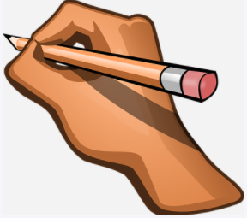 | Numeracy  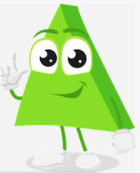 | Health and wellbeing  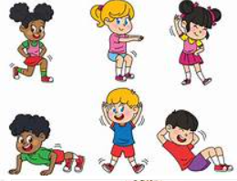 | Expressive Arts  Purple Friday  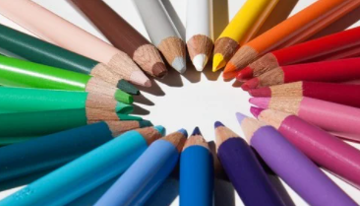
This week we are going to look at poetry. A ‘diamante’ poem is a special kind of poem that has 7 lines written in the shape of a diamond (rhombus). Here is one about a lion. Maybe an adult could read it aloud for you.  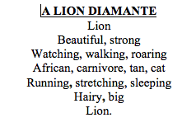  Could you create a diamante poem?  Choose an animal.  Spend some time looking at pictures and finding out some facts about your chosen animal.  Make a list of words about your animal. These could be words to describe how the animal looks, say how it moves, tell what it does.  Arrange the words into a ‘diamante’ following these steps.  Line 1: Name of animal  Line 2: 2 words describing the animal  Line 3: 3 words saying what the animal is doing  Line 4: any 4 words about the animal  Line 5: 3 words saying what the animal is doing  Line 6: words describing the animal  Line 7: Name of animal  Can you learn or practise the sign for your animal? Can you draw a picture of your animal to go with your poem? | Let’s recap some of our 2d shapes. You could:  Watch the video and do the activities at the following site:  https://www.bbc.co.uk/bitesize/topics/zjv39j6/articles/ztpwdmn  Make 2d shapes using buttons, coins, or sticks.  Choose a room at home and create a tally chart of the different 2d shapes you can see. Which shape did you see most of?  Draw these shapes on a piece of paper and continue the pattern.  1)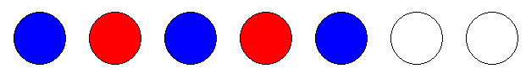  2)  3) | Stay in shape by trying out some of these activities this week.  Follow the moves in this video and call out the name of the shapes you see as you go:  https://youtu.be/WClLu2RcT1g  Draw some shapes on large pieces of paper and space these out on the floor in a room at home or in the garden if you have one. Have an adult call out a shape name and jog, hop or jump to the correct shape.  Practise remembering the number of sides for each 2d shape. Have an adult call out a shape name and perform your favourite move (e.g. star jump, burpee, jumping jack, squat) the same number of times as the number of sides the shape has e.g. triangle = 3 star jumps, square = 4 squats. | This week we are going to watch a short extract from a book written by Dr Seuss and it is called, ‘’One fish, two fish.’’  https://youtu.be/1s7Vwis4Rrk  In the story one fish is red and the other is blue. When you mix these colours together, we create a new colour. Can you think of what that new colour might be?  Can you create some fish using your handprints? Afterwards, create smaller fish using both colours and look and see what new colour you have.  