Literacy  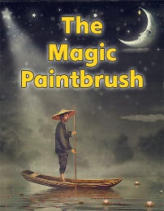 | Numeracy  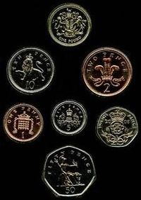 | Health and wellbeing | Chinese New Year  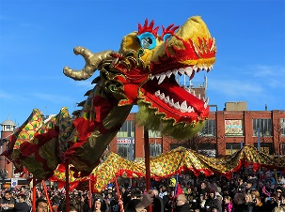
This week we are going to the read the story of, ‘‘The Magic Paintbrush.’’ This book can be found in your Giglets account.  Attached to this book are some questions relating to the story.  At home you can discuss the answers with an adult, or you can simply read the book and enjoy.  The book comes with an audio feature which can be found in the top right-hand corner. This appears when the book has been opened. | In our story, the author talks about people being rich and poor. Can you find out what these words mean?  We are going to focus on money for our numeracy task this week.  First, I would like you to watch this video  https://youtu.be/wnrHLsHOVgM  Next you can play this game and try to spot all the different coins  https://natwest.mymoneysense.com/students/students-5-8/spot-the-coins/ | The rich man from our story was not very kind when he stole the paintbrush from Ma Liang.  Here is a song I would like you to listen to-  https://youtu.be/KBEiKn8VgTg  Kindness brings huge benefits to everyone! You make someone feel good, you feel good because of your actions and those who see what you are doing are inspired to act kindly themselves!  How many of these kindness challenges can you complete this week?  1.Offer to help tidy an area of your house or garden if you have one.  2.Draw a rainbow to display in your window for people walking past to see.  3.Write or draw something for people in your household. | This Friday it will be Chinese New Year.  It is the year of the OX. If you would like to find out more on the Legend of the OX click this link-  https://youtu.be/QJm0pky7sjo  Why not celebrate with some of these fun art activities-  You could try and create an OX lantern like the one below-  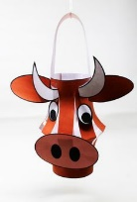  OR  Create some firecrackers from toilet paper tubes-  