Literacy  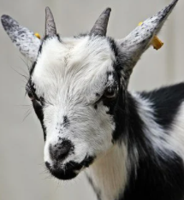 | Numeracy | Health and wellbeing  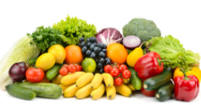 | STEM
This week in Giglets we are going to read ‘’The Three Billy Goats Gruff’’.  You will find some questions to aid discussion and comprehension by clicking on the highlighted words or sections.  I have assigned a ‘Sink or Float’ task to accompany the book. You can follow the steps described in the task. You will need a basin of water and a selection of items that you can test whether they sink or float.  Remember to make predictions on whether the items will float or sink and check whether you were correct after testing each item. | There are 3 billy goats in our story. Let’s think about the number 3.  1)Watch this song to see the different ways we can show the number 3  https://youtu.be/1DLqZOujkCM  2) Can you make a poster all about the number 3?  Here are some ideas to include on your poster:  How would you show the number 3?  Can you think of three facts about the number 3? Include fun facts if you like.  Can you draw a 2d shape with 3 sides?  Can you create a pattern on your poster using 3 different shapes?  Can you add some colour to your poster using the 3 primary colours red, blue and yellow?  3) The waltz has 3 beats to the bar. Have at go at dancing along to this waltz and see if you can hear, feel and count along with the 3-beat time.  https://youtu.be/5b7WCxf0Cdc | The billy goats are hungry and want to eat the sweet grass on the other side of the bridge.  Can you describe how you feel when you are hungry?  Fruit and vegetables are important foods for keeping our bodies healthy.  Can you and your family think of a fruit or vegetable for every letter of the alphabet? You could name or draw them. ‘x’ is tricky!  Can you eat a rainbow this week by choosing lots of different coloured fruit and vegetables to eat?  Here is a recipe for a tasty snack using vitamin-packed spinach and cheese made from goat’s milk. Maybe you could give it a try?  Time: 5 minutes  Ingredients  - 110g soft goat’s cheese  - 1 tbsp milk  - 40 g fresh spinach, finely chopped  Directions  - Stir together goat’s cheese and milk until soft  - Add finely chopped spinach and stir until combined  - Serve on crackers for a tasty snack  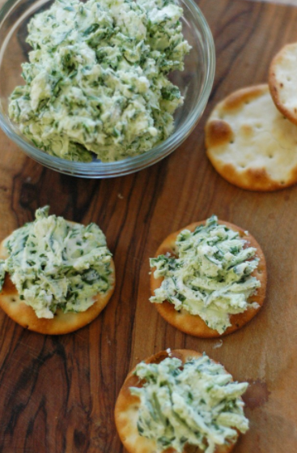 | The billy goats cross a bridge to get to the sweet grass.  Can you see any bridges when you are out walking near your home? What shapes can you see in their structure?  Can you build a bridge of your own using items you have at home? Maybe you can use some recycling items or experiment with different materials.  What is the longest bridge you can build?  Can you build a bridge that will support the weight of a small item? What changes could you make to your bridge so that it can hold a heavier weight?  If you need some inspiration here are some examples:  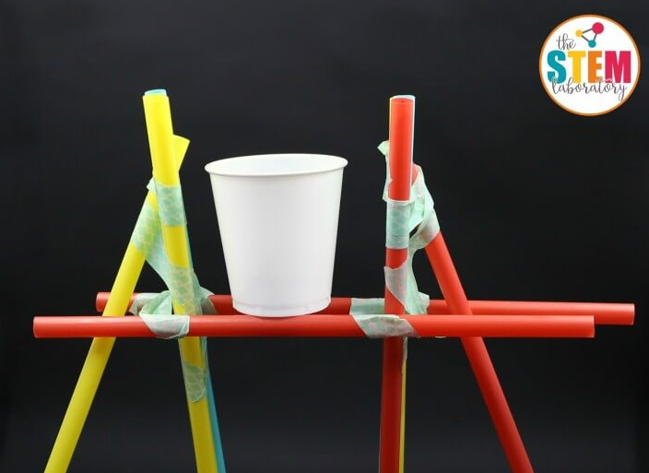  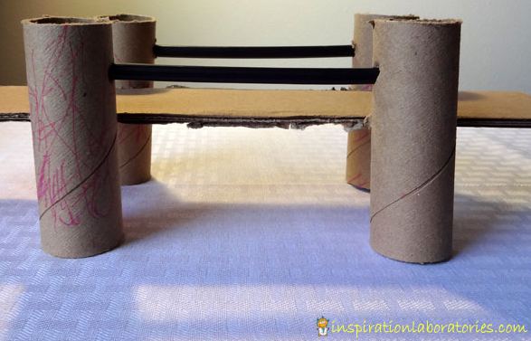  https://www.sciencebuddies.org/stem-activities/build-best-bridge  It would be great to see some pictures of your work!

