Literacy  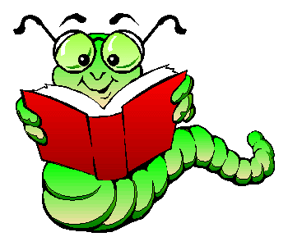 | Numeracy  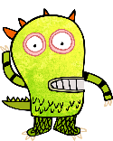 | Health and wellbeing  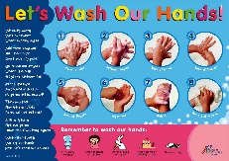 | Robert Burns  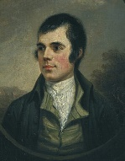
As directed on our calls this week we are going to start using Giglets for our reading tasks.  For children in school a letter has been sent home in their school bag.  You should have received log in details for your child, However, if you have not received these please get in touch.  This week we are going to be looking at a book called,’’ What the monsters munch.’’  Throughout the book I have highlighted sections and words. If you click on these questions will pop up. These questions are to encourage dialogue and comprehension around the story.  I have an art assigned activity that relates to the story. In addition to this, colouring pages from the book can also be found.  I would love to hear any feedback you have on this resource.  If your child is looking for some extra books to enjoy, please let me know and I can add it on to their account.  I hope you enjoy the book as much as I did! | For our numeracy this week we will continue with theme of monsters from our literacy task.  First,  I want you to listen to this song and try and count the monster’s hiccups  https://youtu.be/iJxwcu05AH0  You can do this as many times as you would like to get you warmed up for our monster matching game.  Next,  try the Monster Mansion matching game. Click on the windows of the Monster Mansion to reveal friendly monsters inside  https://www.abcya.com/games/number_match  For this activity you can select for the cards to be shown or if you want a little bit of a challenge try and do it from memory. | In the Comets class we are fantastic at washing our hands.  Each morning we remind ourselves of how to wash our hands properly. A video that we enjoy watching is-  https://youtu.be/S9VjeIWLnEg  At home you could-  Create instruction cards for how to wash your hands.  Stop the video after each stage to discuss or demonstrate with someone at home.  Challenge an adult or family member to follow the instruction cards.  Or  You could show someone at home how to do it. | To celebrate Burns night on the 25th January I have attached some activities that you can complete at home.  Watch the video in the link below to learn more about Robert Burns and why we celebrate this day-  https://www.bbc.co.uk/newsround/16722720  At home you could-  Draw pictures of food that comes from Scotland  Design a new tartan for Burns night.  Make a Scottish flag  If you would like to learn more about Robert Burns, click on the link below and find some fun activities, arts and crafts and some of his poems!  https://docs.google.com/presentation/d/1sphOOwFIXzvZZk6NoGfzKSZtvIdbebToKb1J62CB61g/edit?usp=sharing

