Literacy | Numeracy | Health and wellbeing | Art
This week’s story is ‘’The Snail and the Whale’’ by Julia Donaldson.  - Read along with the story here  - See attached some of the symbols and signs for the story.  - Listen along to the story and practise the signs Makaton Snail and the Whale  Extra challenge- Literacy  Can you tell the main parts of the story to someone at home?  Can you draw your own picture of your favourite part of the story?  Snail and whale are rhyming words as they have the same sound at the end. Can you hear any other pairs of rhyming words in the story?  Which animal would you like to travel around the world on? Why? Where would you like to go first? | The snail in our story this week is very small, and the whale is very big so try these activities which focus on estimating, comparing and measuring.  -Can you find 5 things in your house that are as small as the snail?  -The blue whale is the largest animal in the world! Choose the largest room in your house. Estimate how many small steps it will take you to walk the length of the room. Now check your estimate by counting your steps as you walk. How close did you get? If you like, you could try this with each room in your house. How many more steps did you take in the largest room compared with the smallest room?  - Choose 8 objects from around your home and sit them in order from smallest to tallest. Can you measure the tallest using a unit of your choice e.g. how many lego bricks tall is it? Or paper cups? Or tin cans?  Let’s recap our numbers to 20 with the following song:  https://www.youtube.com/watch?v=w6q4vhU3JSI  Now have a go at this game where you can practise number bonds to 10 and save the whale: http://www.ictgames.com/saveTheWhale/  or try this comparison game:  https://www.topmarks.co.uk/early-years/lets-compare | Wake yourself up by dancing along to this:  u can’t touch this  Take a brain break during the day and follow along to this:  banana-banana-meatball  When you are ready to relax, practise some yoga:  Yoga - Squish the Fish  or, lie down, close your eyes and listen to the relaxing sounds of whales:  Whale soundscape  You could also try some whale breathing to help stay calm and relaxed.  Whale breathing | Here are two art activities that link to our story.  1.Make a snail and decorate the shell.  Cut a snail body from some card/paper. Add antenna and a face. For the shell cut a large circle from card/paper. Decorate the shell using coloured pens, pencils, paints or scraps of coloured tissue paper, wallpaper, wrapping paper or newspaper. Attach the shell to the body of the snail.  Here are a few examples:  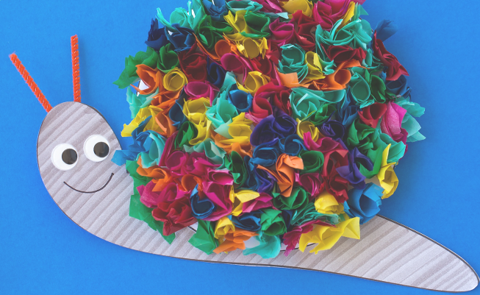  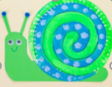  2.Have a go at making an origami whale by following along with this video:  https://youtu.be/kOm47eh2AYk?list=PL2vt_TPKQbZob-85AoY8Cxtj8LjigvTNk

