**s**

**Home Learning Challenges**

**POLO**

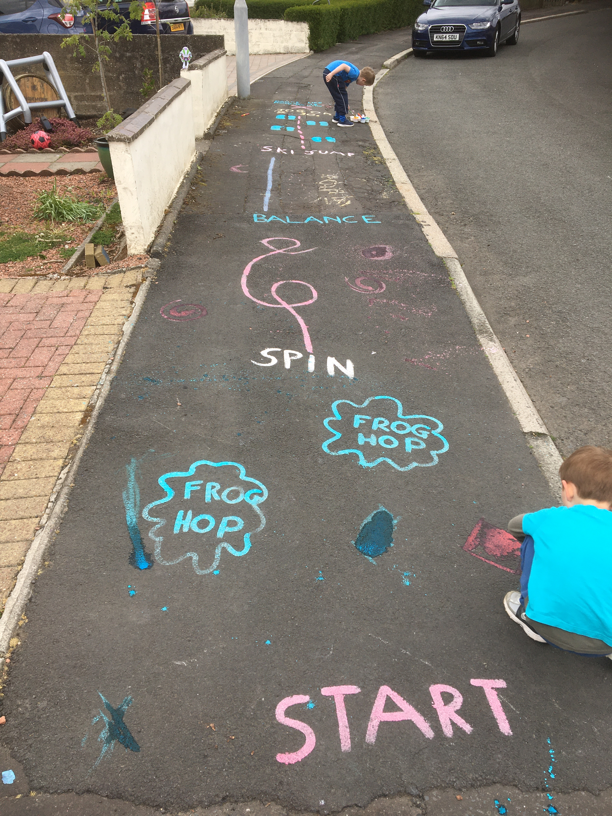

Use Here is a link to the instructions to make chalk paint. <https://www.happinessishomemade.net/sidewalk-chalk-paint/> What can you paint on the ground outside? Can you write your name? Can you make sums for your family to complete? Can you think of different actions to make an activity trail like the one in the photo?

**Art**

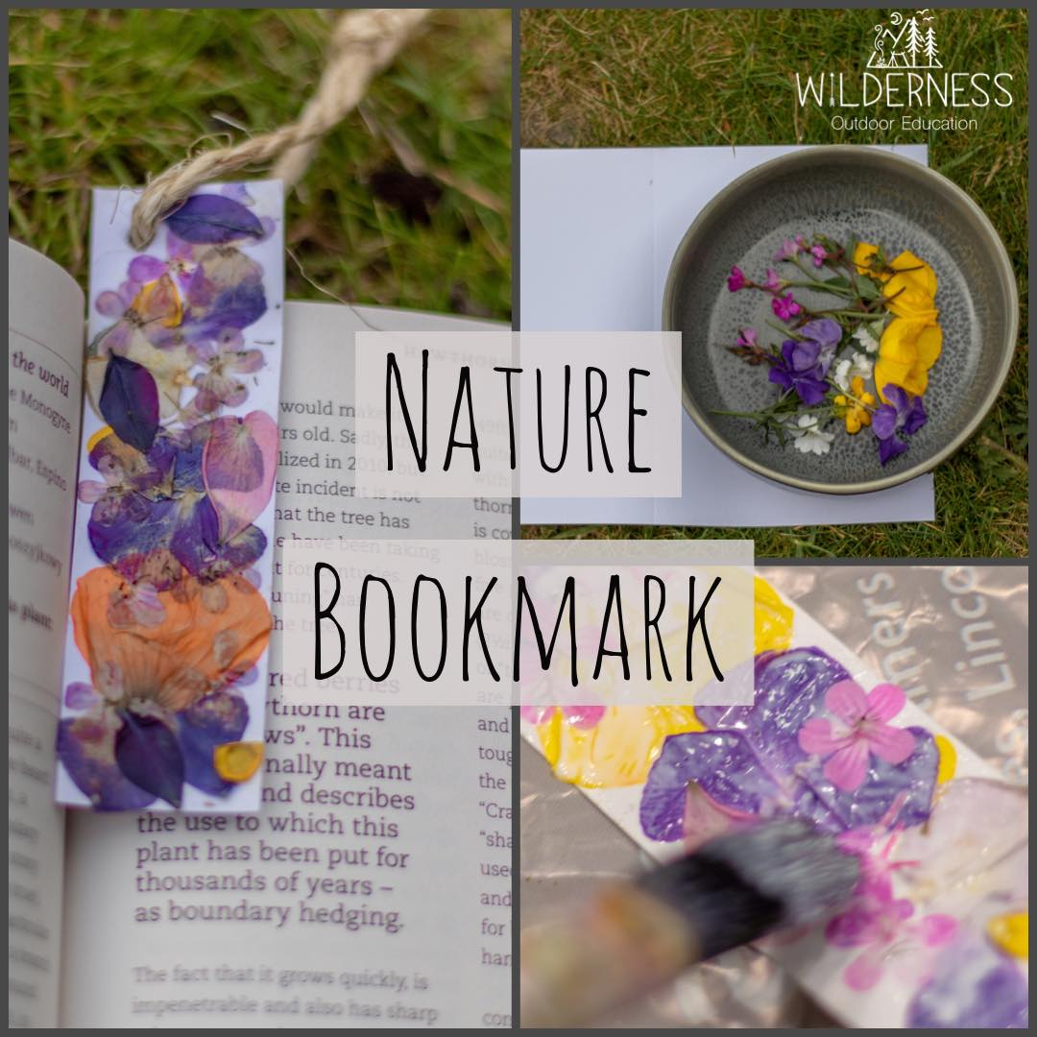

Use your flower pressing skills from pervious home learning to make a nature bookmark. Use PVA glue to slick pressed petals onto a strip of card. You could make them for gifts to post to someone you are missing during lockdown.

**P.E.**

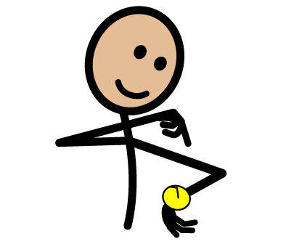

There will be a virtual prom on Friday. Why not practice your dancing for then? You could practice; The Slosh -(*Mr N's favourite!)* The cha cha slide, the conga and the hokey cokey

**Literacy**

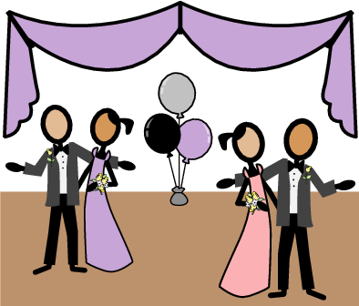

Write an invitation to prom for someone in your house. A template is below this page. Remember our theme was to be Vegas so don't forget to decorate your invitation in this style!

