**s**

**Home Learning Challenges**

**HWB**

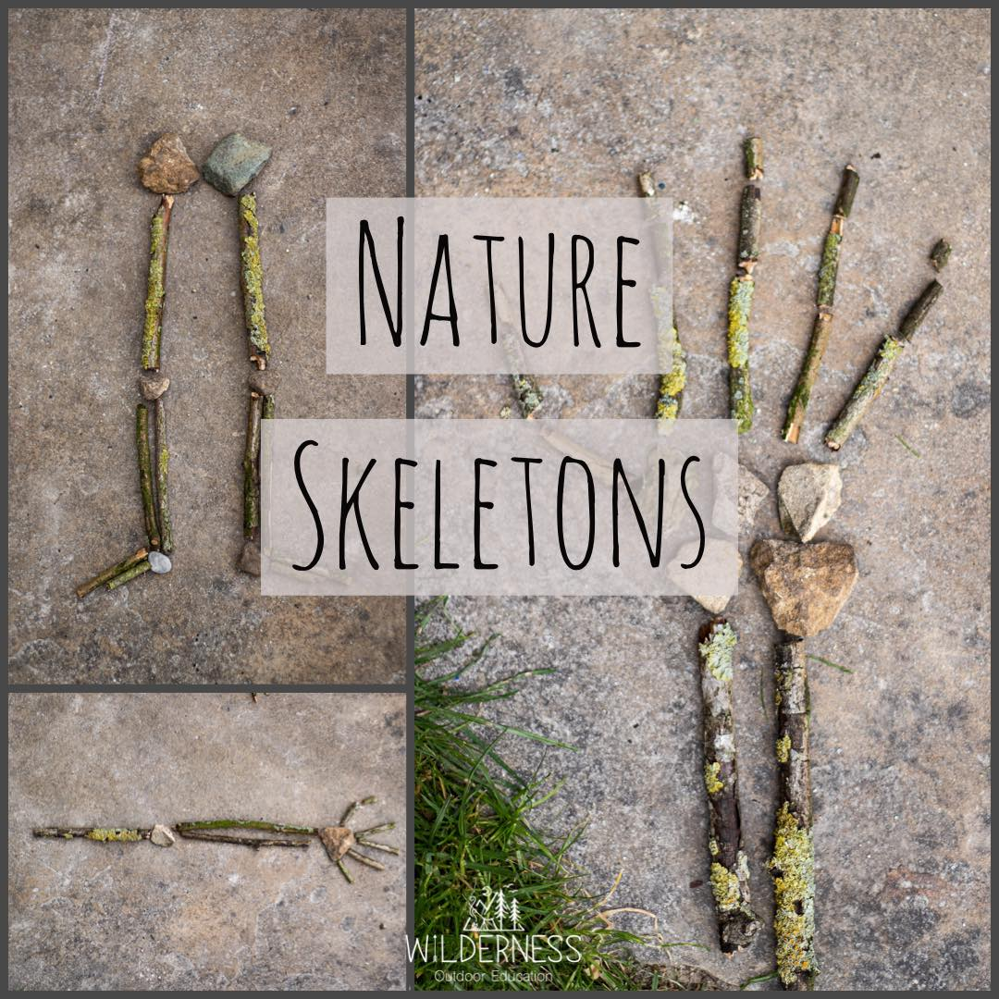

Use sticks and other outdoor objects to make a skeleton or just your body outline. See if you can make it the same size as you!

**Outdoor Cooking**

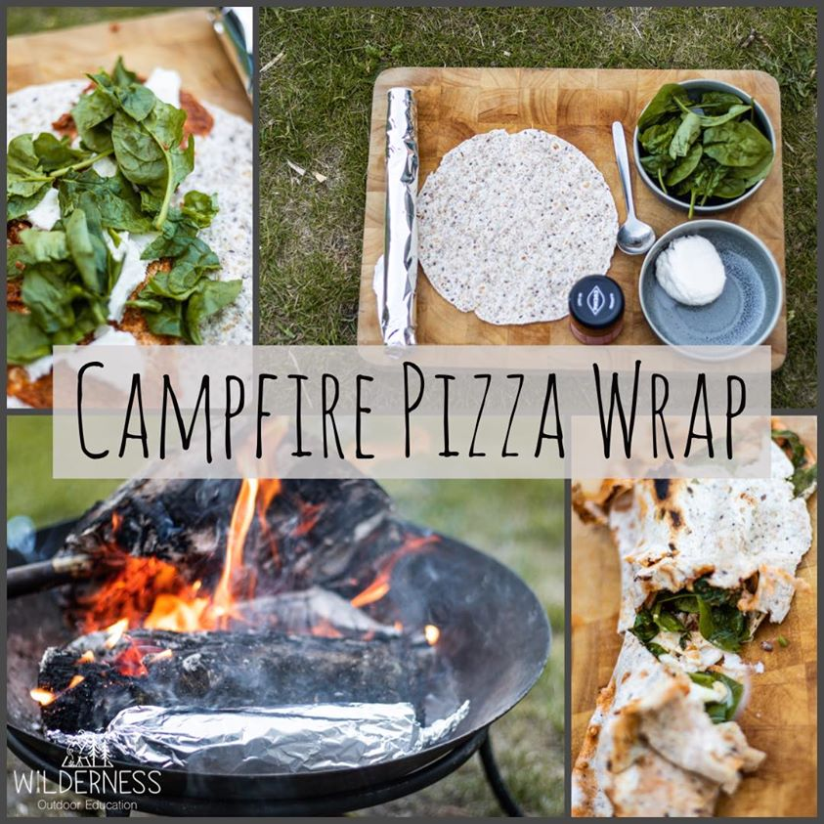

Fill a wrap with tasty ingredients. Wrap in foil and place at the edge of a fire or BBQ until toasty and done. Be careful around the fire!

**Active Numeracy**

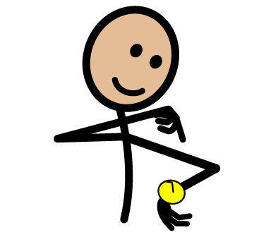

Talk about the time.

What time do you wake up?

What time do you eat lunch?

What time do you go to bed?

**Literacy**

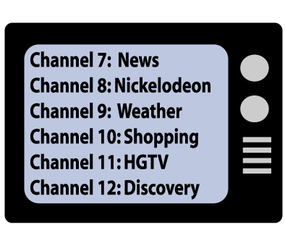

Look through the electronic episode guide on your television. Is there a programme you would like to watch?