**s**

**Home Learning Challenges**

**Hospitality**



Use the internet or a recipe book to find a recipe that you haven't tried before. Follow the instructions carefully. Did you like what you made?

**Active Numeracy**



Play eye spy for colours. You could play indoors or outdoors. What was your favourite colour? What was your favourite object?

**Chore time**

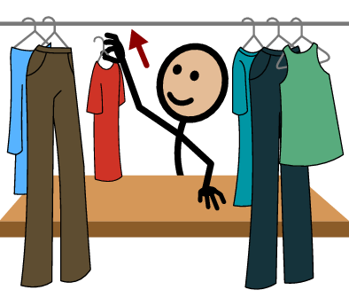

Help out around the house by cleaning out your wardrobe. Did you enjoy doing this activity?

**Literacy**



Build a den in the garden and choose a book to read in it. What did you choose?