**s**

**Home Learning Challenges**

**Hospitality**

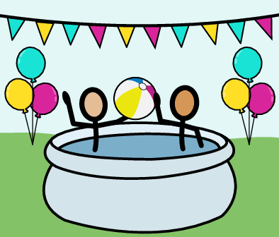

If you have a paddling pool, host a pool party. You will need to have some snacks, games and a good playlist of songs. Make sure and invite everyone in your house.

**Numeracy**

Birds are busy building nests and getting ready to lay eggs. From your window or during your daily exercise count how many birds you can see. See if you can spot the bird carrying the biggest load. Keep a look out for rooks, they can carry very big sticks!

**Work Experience**

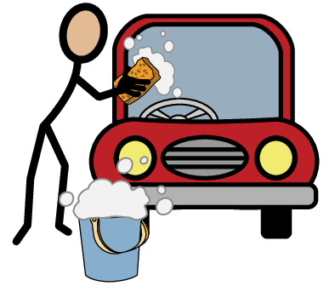

Help out around the house by washing the car. Make sure to take your time and don’t miss any areas!

**Literacy**

Make a quick sketch of your clothes cupboard or drawers. Label your sketch to show what clothes go in each compartment.