**s**

**Home Learning Challenges**

**Hospitality**

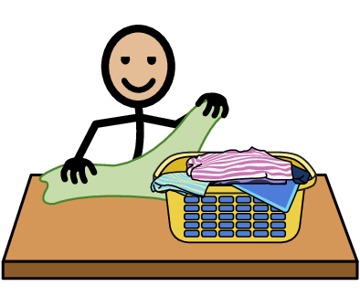

Help out at home by folding your clothes and putting them away in the correct place.

**Hospitality**



Take advantage of this lovely weather and make a picnic for everyone at home. Use your literacy skills to create a simple menu. Some recipe ideas are here.

<https://www.thespruceeats.com/tea-sandwiches-for-kids-parties-2104447>

<https://www.bbcgoodfood.com/recipes/iced-fairy-cakes>

<https://www.bbcgoodfood.com/recipes/really-easy-lemonade>

**Work Experience**



It is spring and the plants are beginning to grow. Help our around the garden by helping to pull some weeds. Turn them into compost or put them in the correct bin.

**Numeracy**

Watch the weather forecast or look it up online. Record the highest temperature expected this week. If you have a thermometer, leave it in a shady place and check the temperature to see if the forecast is correct.