Regrow Your Own Vegetables!
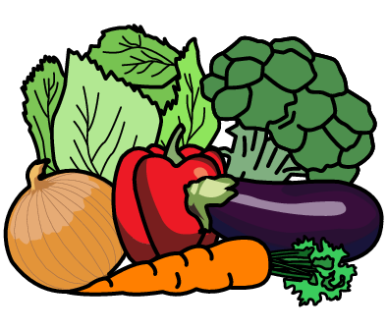
Methods:
1. Carrot - Place the top cut-off end of a carrot in a shallow bowl of water. The green leaves will shoot from the top. Keep inside and place in a sunny spot.
2. Celery - Cut off the bottom 8cm of the stalk and place in a small bowl of water. After 3 or 4 days it will start to grow from the centre of the celery. Keep inside and place in a sunny spot.
3. Lettuce - Cut off the bottom of the head of lettuce and place it in a small bowl of water. It will start to regrow in around 3 days. Keep inside and place in a sunny spot.
4. Spring Onion - Use the white part of the onion, with any roots still intact. Place in a glass with water and it will start to grow. Keep inside and place in a sunny spot.

Skills to be developed:
Your young people can practise cutting (with your help!), pouring, peeling, listening to instructions, measuring, colour identification, observation, size/size order and positional language (“small”, “shallow”, “bottom”, “top”)

Here is a link to a video showing how other people may regrow their vegetables:
https://www.youtube.com/watch?v=YtucOcLDxW0

