Bubble Snake STEM Activity!
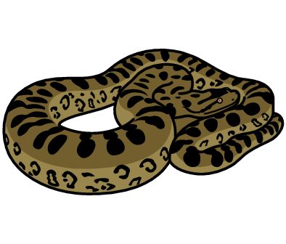
Soapy Serpent Lots of bubbles sticking together is called foam. With every puff in this activity you will create hundreds of bubbles to make a long, foamy snake.

- Ask an adult to cut off the base of the empty plastic water bottle (it’s a bit easier if you keep the lid on for this bit).
- Place a sock over the open bottom end but be careful as the cut edges of the bottle may be sharp!
- Remove the lid of the bottle if it’s still on.
- Squeeze some washing-up liquid into a bowl. Add some water and mix them together.
- Dip the sock end of the bottle into the soapy water.
- Pick it up, take a deep breath and blow into the top end of the plastic bottle.
- Watch your snake bubble grow with every puff!
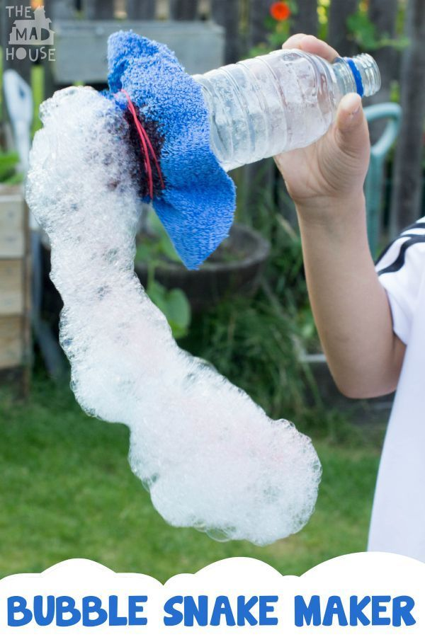

Does using different sized bottles make bigger or smaller snakes?
What’s the longest bubble snake you can make?
Can you use foot steps or cubes to measure your snake?

