**s**

**Fairtrade Home Learning**

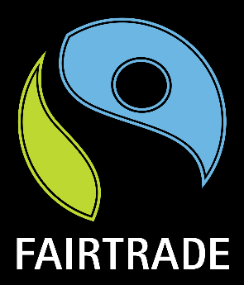

**Health and Wellbeing**

Find a Fairtrade smoothie recipe to follow!

How many different fruits did you use?

__________________________

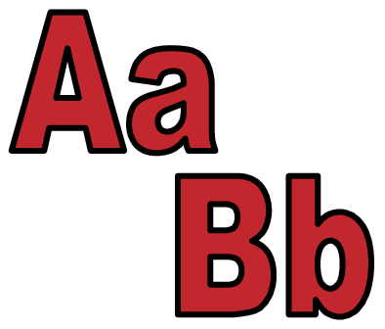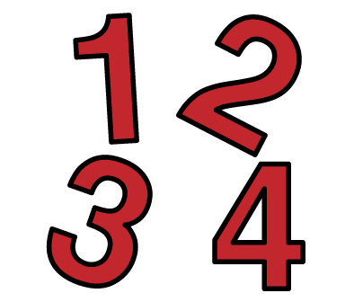

**Active Maths**

Go on to Sainsbury’s website and search for some products like; chocolate, bananas, coffee, nuts, tea, sugar and wine. How many Fairtrade symbols can you find?

**Active Literacy**

Listen to the story ‘ Beautiful Bananas’ by Elizabeth Laird on Youtube.

Did you enjoy the story?

Yes

Email your photos to [willowbank.schoo@eastayrshire.org.uk](mailto:willowbank.schoo@eastayrshire.org.uk) to be featured on our blog!