**s**

**Home Learning Challenges**

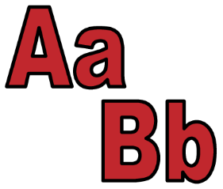

**Literacy**

Use natural materials like sticks and leaves to create the letters in your first name. Can you find items around your house that start with the same sound as your name?

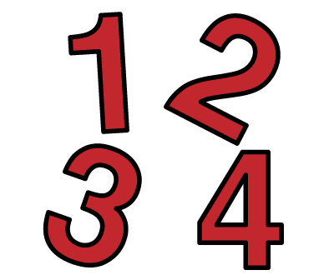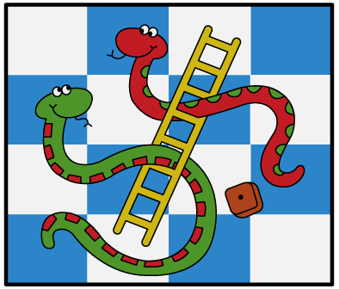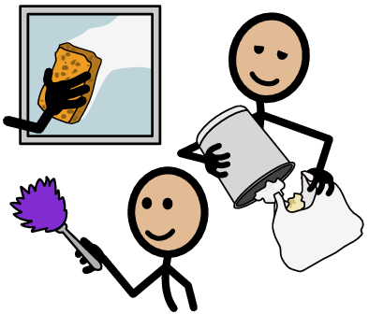

Email your photos to [willowbank.school@eastayrshire.org.uk](mailto:willowbank.school@eastayrshire.org.uk&subject=Photos).to be featured on our blog!

**Numeracy**

When tidying your room, organise and sort some toys into groups according to size or colour. How many red toys do you have?

**Life Skills**

Practise your knife skills like cutting and spreading by helping to make a sandwich at lunch time!

**Board game**

Play a board or card game with a family member. Keep a score board – who won the most games?