The Robert Burns Academy – Curriculum Update Proposals November 2023

Curriculum Rationale and Design

Our Vision
The Barony Campus: Where we belong; where we reach our potential.

Our Values
- Achievement
- Respect
- Equity

Curriculum Drivers
Destinations
- 32% of pupils move on to Higher Education
- 68% do not:
- 27% - Employment
- 32% - Further Education
- 9% - other

Labour Market Information - Ayrshire
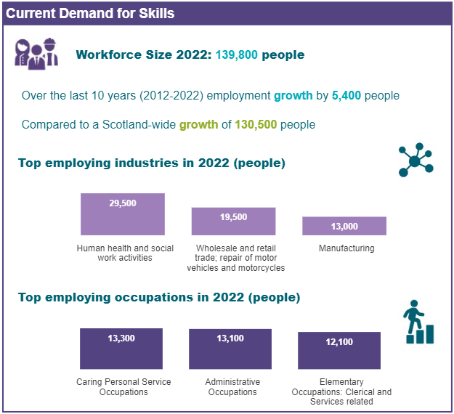
Key Drivers for Change
- Pupil attendance and truancy is a concern
- Pupil breadth and depth after S4 and S5 are below both our Virtual Comparator and other EAC schools
- No personalisation and choice in S2 BGE
- Progression can be inconsistent when pupils move to new courses after S3
- Pathways are not clear to staff, pupils, parents and partners

Curriculum Update Proposals November 2023

- New S3 Model including Skills for Life, Learning and Work courses

- S3 pupils will only be able to choose a new subject in S4 from the Skills for Life, Learning and Work courses.

S3 – S4 Proposed Model – Progression, Personalisation and Choice - 2 year Pathway – Level3/4 – Level 4/5
 | Level | 1 | 2 | 3 | 4 |  | 5 | 6 | 7 | 8 | 9 | 10 | 11 | 12 | 13 | 14 | 15 | 16 | 17 | 18 | 19 | 20 | 21 | 22 | 23 | 24 | 25 |  | 26 | 27 | 28 | 29 |  | 30 | 31 | 32
S3 | Many young people will progress on to working at level 4 in discrete subjects within curricular areas.  Some young people will continue to work at level 3. | English and Literacy  Pupils will follow pathways at different levels to suit their abilities |  |  |  |  |  | Maths and  Numeracy  Pupils will follow pathways at different levels to suit their abilities |  |  |  |  | Subject Choice – S3-S4  Pupils choose 5 subjects which they study for 3 periods in S3 and 4 periods in S4.  Subjects will be offered in all Curricular areas and studied up to Level 4 or in some cases to level 5.  A full range of subjects that can be studied up to Level 5 and in some cases Level 6 will be offered to support post school pathways into Higher Education. |  |  |  |  |  |  |  |  |  |  |  |  |  |  | Vocational Courses  DYW  Cybersecurity  Travel and Tourism  Creative Industries  Health Sector/Care  Sports Leader  Lab Skills  Languages for Life  Customer Service  Musical Theatre  Digital Media |  |  |  |  | Health, Wellbeing and RME  PSE, RME, PE |  |  |  | PLP Period – 10 minutes daily
 |  | Responsibilities of All - Literacy, Numeracy and Health and Wellbeing
 |  | Learning Across the Curriculum
 | Level | 1 | 2 | 3 | 4 |  | 5 | 6 | 7 | 8 | 9 | 10 | 11 | 12 | 13 | 14 | 15 | 16 | 17 | 18 | 19 | 20 | 21 | 22 | 23 | 24 | 25 |  | 26 | 27 | 28 | 29 |  | 30 | 31 | 32
S4 | Level 3, Level 4, Level 5 or Level 6 Subjects | English and Literacy  Pupils will follow pathways at different levels to suit their abilities |  |  |  | Maths and Numeracy  Pupils will follow pathways at different levels to suit their abilities |  |  |  |  | National 4 or National 5 Courses  Pupils will study the 5 courses chosen in S3 to National 4 or National 5 Level for 4 periods per week. |  |  |  |  |  |  |  |  |  |  |  |  |  |  |  |  |  |  |  |  |  | Health, Wellbeing and RME  PSE, RME, PE |  |  |  | PLP Period – 10 minutes daily
Vocational Courses

Pupils will be able to select from a range of Vocational Courses at Level 4, 5 or 6 in each column

 |  | Focus on Skills Development

Feedback on Proposals

Please comment on the following changes:
The Introduction of Vocational Courses focussing on Skills for Life, Learning and Work in S3:

S3 Pupils will follow the same courses in S4 unless they choose a new course focussing on Skills for Life, Learning and Work:

Any other comments:

