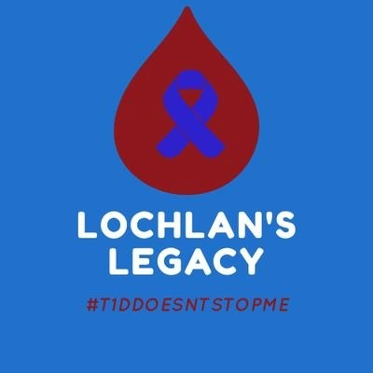 Lochlan needs your help.

We are all shocked and saddened by what is happening in Ukraine. Type One Style are leading a collection for supplies that can be sent to T1D warriors in Ukraine and Lochlan wants to collect as many supplies as he can for them. PLEASE HELP

NO ONE SHOULD DIE DUE TO LACK OF SUPPLIES OR INSULIN!

Can you help? We are in the process of setting up collection points throughout Scotland for you to donate.

Here is what is required…

- Donate test strips, spare glucose meters, lancets, and other supplies. To somebody with nothing, spares or “good enough” kit is critical.

- Donate sweets and non-perishables. In the absence of food, or means to cook food (think evacuation), diabetics face hypoglycemia. Long-life sweets like jelly babies, haribo, chocolate, moams, are important to keep sugars topped up and are easily carried and kept.

- Donate small powerbanks. Powerbanks can help diabetics stay in touch with their families, but also to charge their receivers and phones, and more, to keep their CGMs and pumps running and stay safe. We will charge them before we ship them.

We need to show solidarity with diabetics in Ukraine. We need to come together as a global community and support them. Let them know that they are not alone, and their struggle is not forgotten.

PLEASE DO NOT DONATE INSULIN WITHOUT CONTACTING US FIRST.
Contact us via email Lesley@lochlanslegacy.co.uk … message our social media or call 07769550024

https://www.typeonestyle.com/pages/support-diabetics-in-ukraine
