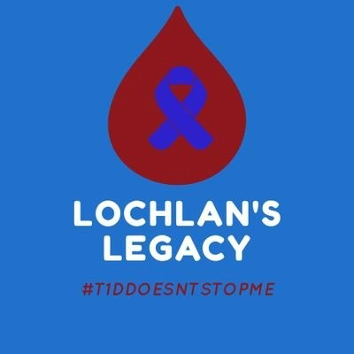
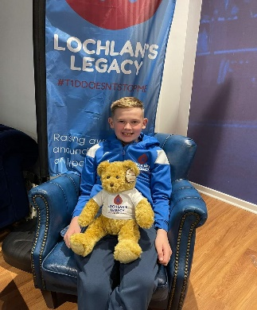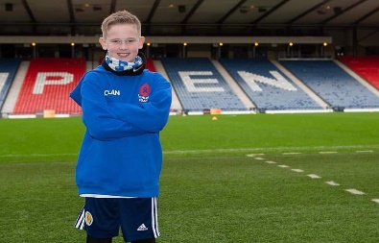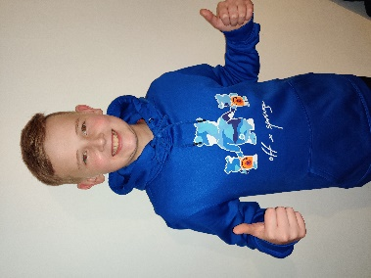
Lochlan's Legacy-SCIO
CHARITY REGISTRATION NO; SC050543
Our vision is to raise awareness and understanding of what Type 1 Diabetes is and how it impacts on daily life. Sharing information on T1D with everyone and anyone will lead to better knowledge and understanding to help reduced stigma surrounding the condition and break down some of the barriers people face. We aim to build a strong T1D community.

We will offer information sessions, workshops, e-Learning, Get-Together days and so much more.

​
Our charity was established in October 2020 after Lochlan wanted to help make a difference to people living with type 1 diabetes like he does. Lochlan was diagnosed on 27th August 2013, aged 4. Hearing the diagnosis of T1D was life changing to say the very least but with his usual determined attitude and zest for life, Lochlan rose to the challenge with the biggest smile on his face. When he should have been playing he was comforting me, his very proud mum, and telling me it was all going to be alright. His T1D diagnosis brought out a warrior within him. Life changed in the blink of an eye and we left hospital with a fear of what our new life would bring. Finger pricks, insulin injections, high blood sugar readings and strange looks when asking Lochlan if he was HIGH, ketones, DKA fear, hypos and endless supplies of jelly babies, sleepless nights, insulins pumps, CGMs, scared friends and relatives, lacking trust but most of all sheer and utter pride at how a little boy could manage such a condition with a smile on his face and a football at his feet. Now 13 Lochlan wants to help others. In 2018 Lochlan broke his leg playing his beloved football. This not only affected his type 1 control but severely impacted on his mental health. This was extremely hard to witness in a strong 9 year old but we received the support and guidance to allow Lochlan to recover. After 2 operations on his knee and recovery from acute cellulitis Lochlan decided to organise a charity event called Lochlan's Stadium Marathon. 9 months after his leg break Lochlan walked 2miles around all SPFL stadiums , Hampden Park and Townhead Park, the home of Cumnock Juniors, totalling 28 miles in 4 days. This event was the catalyst to the birth of Lochlan's Legacy-SCIO. Words fail me on how proud we all are of Lochlan and the journey he has chosen. Lochlan’s determination to make a difference is inspirational. With continued support, his drive and determination will lead to great things.
Lesley Murdoch
Co-founder of Lochlan’s Legacy

