St Patrick’s Primary School

Child Protection and Safeguarding Policy

Revised August 2024

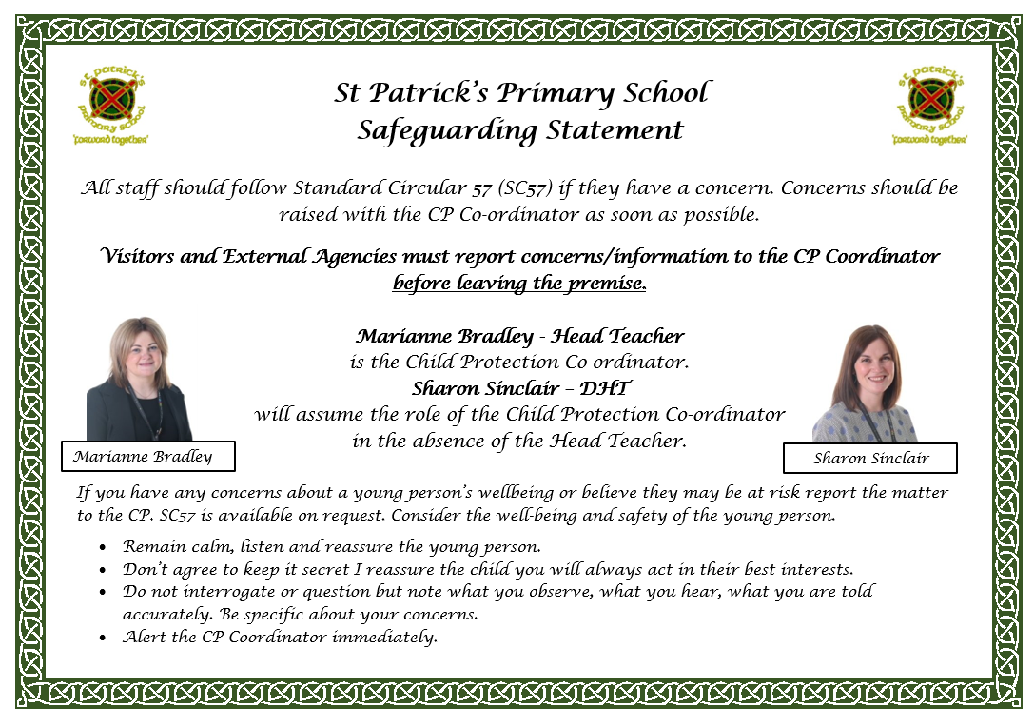

**Section 1: Policy Overview and Definitions**

**What do we mean by Child Protection and Safeguarding?**

# Child Protection

Protecting a child from child abuse or neglect.

Abuse or neglect need not have taken place; it is sufficient for assessment of risk to have identified a likelihood or risk of significant harm from abuse or neglect.

# Safeguarding

This is a much wider concept than child protection and refers to promoting the welfare of children, young people and protected adults.

It encompasses protecting from maltreatment, preventing impairment of their health or development, ensuring that they are growing up in circumstances consistent with the provision of safe and effective care and taking action to enable all children, young people and protected adults to have the best outcomes. Child protection is part of safeguarding.

# The purpose of the Child Protection and Safeguarding Policy

St Patrick’s Primary School recognises that it has an explicit duty to safeguard and protect children from abuse and neglect as defined in the National guidance for child protection in Scotland 2021 https://www.gov.scot/publications/nationalguidance-child-protection-scotland-2021/

The overall intention and purpose behind the school’s child protection policy is underpinned by the fundamental principles of the Children and Young People (Scotland) Act 2014and the UN Convention on the Rights of the Child (1989):

**What is Child Abuse and Neglect?**

The Scottish Government’s National Guidance for Child Protection in Scotland (refreshed in 2021) states that Abuse and neglect are forms of maltreatment. Abuse or neglect may involve inflicting harm or failing to act to prevent harm. Children may be maltreated at home; within a family or peer network; in care placements; institutions or community settings; and in the online and digital environment. Those responsible may be previously unknown or familiar, or in positions of trust. They may be family members. Children may be harmed pre-birth, for instance by domestic abuse of a mother or through parental alcohol and drug use. Abuse/Neglect can be categorised as:

• **Physical abuse** • **Emotional abuse** • **Sexual abuse** • **Neglect**

(Further details and definitions can be found in EAC SC57)

# Indicators of Risk

The following circumstances are considered to be indicators that a child **may** be at increased risk of harm within their families:

* Domestic abuse
* Parental problematic alcohol and drug misuse
* Non-engaging families
* Children and young people experiencing or affected by mental health problems
* Children and young people who display harmful or problematic sexual behaviour
* Female Genital Mutilation (FGM)
* Honour based violence and forced marriage
* Fabricated or induced illness
* Sudden unexpected death in infants and children

Further detailed information on all of the above circumstances can be found within Part 4 of the National Guidance for Child Protection in Scotland 2021 (page 131. This can be accessed online at https://www.gov.scot/publications/national-guidancechild-protection-scotland-2021/

Further information on Child Protection and Safeguarding can be accessed at [Child Protection · East Ayrshire Council](https://www.east-ayrshire.gov.uk/SocialCareAndHealth/Protecting-people/Child-protection/ChildProtection.aspx)

# Section 2: Policy Objective and Statement of Adherence

St Patrick’s Primary School’s Policy is based on East Ayrshire Council’s

Child Protection Operating Procedures, SC57. All staff should be familiar with these documents and refer to them for further detailed information and guidance. Refresher training for staff will take place annually and training provided for new staff.

Everyone in our school shares an objective to safeguard and protect children by:

* Providing a safe environment for children to learn in.
* Supporting children’s development in ways that will foster a sense of self-esteem and independence.
* Identifying and responding to children in need of support and/or protection.
* Working in a manner that places the safety and wellbeing of pupils at the forefront.

# School Commitment to Safeguarding

At St Patrick’s Primary School, we will

* establish and maintain an ethos where children feel secure and are encouraged to talk and are listened to.
* ensure all children have effective means of communication with more than one adult in the school.
* give opportunities for class or group discussions of thoughts and feelings in an atmosphere of trust, acceptance and tolerance.
* include in the curriculum activities and opportunities for PSHE/Citizenship, which equip children with the skills they need to stay safe from abuse.
* ensure all aspects of school life including Risk Assessment, Curriculum Design, Information Sharing etc. take account of the best interests of pupils at all times.

# Section 3: Action Guidance for all staff What to do if you have general concerns about a child

If a member of staff is worried about a child, they should report their concerns to the Child Protection Coordinator (Head Teacher), via the Pastoral Care Form, who will record this information on a Chronology of Significant Events (via Seemis Pastoral Notes) and follow East Ayrshire procedures on reporting Child Protection Concerns. (See Appendix 2)

If this information is more of a Care and Welfare issue, the Head Teacher will decide on the appropriate course of action. This may be:

* To monitor the situation
* To discuss the problem with the parent
* To discuss with the parent and with their consent contact another agency
* To refer to the reporter or another agency or seek advice of Social Work

Resources

Information must be as accurate as possible. If a member of staff has a concern, it should be noted on a Pastoral Care Form and kept as a record of the event/ concern. This should be passed to senior clerical staff to record on SEEMis pastoral notes. This may also be used to monitor a situation and to help identify any emerging patterns.

The SLT will complete appropriate RFA paperwork if being forwarded to another agency and record this on SEEMis Pastoral notes. Following the guidance in SC 57. This will be sent to the named person service.

**What if a child makes a concerning disclosure?**

# Action Points for All Staff (Appendix 2 part A)

* Immediately report any grounds for concern to the Head Teacher. If the HT is unavailable, report to the Depute Head Teacher
* Do not wait to gather evidence.
* Do not keep information secret.
* Do not discuss the matter with others.
* Follow the guidance given by the Head Teacher, Depute Head Teacher
* You must provide a handwritten record of the incident using a Pastoral Care form
* You must date and sign the record of the incident.
* Under NO circumstances discuss your concerns with parents/carers unless instructed to by SLT.

# Supporting the Child

When a child is disclosing abuse, a member of staff should respond in the following ways.

* Listen and observe with care.
* Treat the allegation in a serious manner.
* Reassure the child that he/she is right to tell.
* Do not give a guarantee of confidentiality or secrecy.
* Do not ask leading questions.
* Seek clarification using **open-ended questions** only.
* Do not interrogate the child.
* Do not show disbelief or shock.
* Do not introduce personal or third-party experiences of abuse.
* Avoid displaying strong emotions.
* **As soon as possible**, record the conversation using the words of the child and any questions or comments made by yourself on a Pastoral Care Form.

# Action points for Head Teacher (or DHT in the absence of the HT) (Appendix 2 part B)

* Act promptly.
* Treat the grounds of concern as a priority action.
* Consider the immediate needs of all children involved.
* Gather information and if appropriate seek clarification (not proof).
* Ask staff to record all relevant information
* Immediately report the grounds for concern to the duty social worker at the local area office and follow any instructions given.
* Immediately report a medical emergency to the medical services and ensure first aid if required.
* If appropriate, contact the police.
* Alleged involvement of staff in child abuse should be reported to the Chief Education Officer
* Record (on the same day) the grounds for concern and action taken using the chronology of significant events
* Co-operate fully with all statutory agencies that may become involved.
* Support the child or children involved as necessary and appropriate.

# Pupil Progress Records

* Significant changes, events and decisions should be recorded and monitored.
* At transition stages all pupil records must be transferred to the receiving school following the EAC protocols for the transfer of pupil records.

# Co-operating

Education staff should co-operate fully with enquiries, investigations and support plans as directed by the HT and Education Resource Staff. Staff should provide reports, attend case discussions, case conferences and reviews as required.

5. **What happens to the child and family?**

Once enquiries have been completed, one or more of the following might happen:

* No further action.
* Support or advice offered to the family.
* Referral to another agency or service.
* Referral to an appropriate legal agency such as the Children’s Reporter.
* Where Child Protection concerns are identified, a multi-agency meeting will be held to decide the best way to protect the child and support the family.

# Section 4: Additional Safeguarding Procedures

All adults working with or on behalf of children have a responsibility to safeguard and promote the welfare of children.

Education staff have a responsibility to report suspicions of child abuse and have a professional and contractual obligation to report such suspicions.

All staff are required to follow with guidelines and procedures contained within

EAC’s **SC57** which is available on the intranet.

All staff will be informed of their responsibilities in being alert to the signs of abuse and the procedures for referring concerns to the Designated Person – Head Teacher. This will take the form of annual Child Protection Training in August or during staff induction meetings at other times of the year.

The designated person for child protection will receive regular training.

Staff will be supported through opportunities to talk through their anxieties with the Designated Person if required and directed to the employee counselling service if required.

Ensure that a named teacher (Head Teacher) is designated for Care Experienced

Children and that an up-to-date list of children is regularly reviewed and updated.

# Additional Guidelines and Procedures

All staff have access to information and training

Parents may access the school’s child protection procedures via the school blog or safer schools app

Written records of any concern regarding a child’s safety will be kept in a file in a locked cabinet in the Head teacher’s office.

The school recognises that it does not have the responsibility to investigate cases of suspected child abuse.

Staff will co-operate with relevant external agencies in any enquiries regarding child protection matters, including representation at case conferences, core groups and multi-agency planning meetings.

Parents will be advised of the intention to refer to Social Work and their views and co-operation sought, unless we have good reason to believe that to do so would place a child at greater risk of harm.

All staff will make it clear to any child disclosing information that they cannot guarantee confidentiality, but they will only pass the information on to the people that can help them.

Information concerning children at risk will be shared with all members of staff on a “need to know” basis. The Designated Person will make a judgement in each individual case about who needs and has a right to access particular information.

Where there are concerns about a child, a teacher may be asked to keep a log of observations or Pastoral Notes. This will be kept securely, separately from generally accessible pupil and class records. The Head Teacher will transfer this information to Click and Go Pastoral Notes and be responsible for maintaining chronologies if required.

All records are subject to General Data Protection Regulations (2018).

# Staff and Volunteer Recruitment

Staff working in St Patrick’s Primary School have been part of East Ayrshire recruitment and Selection Procedures. They have been checked by the PVG system in place at the point of employment. All volunteers coming in to school regularly to help with activities, after school clubs or outings should have current PVG certificates. A register of all volunteers is maintained.

**Attendance and absence procedures (school).**

Each child’s attendance is recorded on the SEEMIS system for registration. At any time SLT and office staff can obtain a summary of a child’s attendance. If there are any concerns regarding a child’s attendance or absence, the class teacher should speak to the SMT and note the concern on a Pastoral Care Form. This helps identify any emerging patterns.

In the first instance, parents are notified by letter accompanied by this summary and asked to support the school in ensuring regular attendance at school. Should the situation continue to be a concern the parents will be invited to an interview with the Head teacher. If this does not improve the child’s attendance the Head Teacher may notify Social Work and/or the Children’s Reporter.

The school has clear procedures for the notification of absence and parents are reminded of this on a regular basis through newsletters. It is the parent’s responsibility to notify the school by telephone on the first morning and to keep the school office updated.

A note is made by the office staff and details are entered into the absence file. The office staff inform the class teacher of parental calls and relevant information. Staff complete a pupil register and this is accessed by the office for recording in SEEMIS.

The register is checked by office staff and if no contact has been made by parent or guardian, the office staff will telephone the parent or guardian to make sure that the child is safe.

If contact cannot be made with the parents, emergency contact details will be used.

If there is a Child Protection or Care and Welfare concern the relevant agency will also be contacted. This will normally be Social Work.

# Responsible User Agreement

Annually the school sends out information to parents regarding the use of the internet and photographic images of the children. Parents are asked to sign the accompanying forms to give permission for their children to use the internet safely within school and that photographic images may be used for educational purposes.

Children are given guidance on the safe use of the internet and are directed to the potential dangers of putting personal details onto the web as part of the Personal Safety element within our Health and Wellbeing Programme.

# Mobile Phones

Children are asked not to use their mobile phones during school time and must keep them switched off and in the desginated safe place within the classroom or office. They are not allowed to take them into the playground. Where a mobile phone is seen within the school, it will be handed in to the school office for collection at the end of the day. Where appropriate, parents will be informed and asked for their support in helping to keep their children safe. Children should not take photographs or video footage of any school activities on personal mobiles without permission from staff.

# Complaints Procedure

Any complaints or concerns that a member of staff has been involved in any form of child abuse must be reported without delay to the Head Teacher (or if the head is the subject of the suspicion or complain, the report should be to the Chief Education Officer.

The Head Teacher would undertake preliminary enquiries in terms of the appropriate disciplinary procedure.

The Chief Education Officer) would be informed and would agree an appropriate course of action with the Head Teacher.

**Date of Review: August 2024 Date of next review: August 2025**

# Appendix 1: Pastoral Care Form

**St Patrick’s Primary School**

Pastoral Care Form

|  |  |  |  |
| --- | --- | --- | --- |
| Date |  | Time |  |
| Pupil Name |  | | |
| Stage |  | Teacher |  |
| Person making  referral (if different) |  | Post Held |  |
| Notification of  Concern    (Continue on back if necessary) |  | | |

Signature: SLT Signature:

|  |  |
| --- | --- |
| Details on any follow-up by SLT |  |

**Appendix 2**

