Ayrshire College School-College Application Guide for Guidance staff

Dear colleague

Important information

All the information and every step in this guide is needed to make sure that your learners apply for the right Course and supply the right information to help us process their application accurately.

It’s very important that your students know before they start exactly what Course they are applying for. You need to have considered their suitability for the Course and be confident that they meet any criteria/pre-requisites we’ve set and that they have the maturity to make the transition to the College environment and sustain their learning for the full duration of their course. Please do not allow your students to apply for a Course that you have not approved in advance.

Our College application process needs your learner to register and to do this they need to use an email address and enter a password. Students should use a valid personal e-mail address when applying for a course. After registering with a valid email address students will be asked to validate their email. Please ensure students use an email address that they will be able to access in school either on a PC or their mobile phone. This will enable us to communicate directly with the student regarding application acknowledgement, interview dates and offers. Please note any correspondence sent electronically will also be sent via post. The relevant school contact will also receive a spreadsheet detailing this information.

Please use the format Password1 so that if you need to access the site again it’s quick and easy to remember. It is suggested that the guidance team keep note of all email addresses and passwords used to apply. This will help with those students who struggle to remember their log in details.

The SCP team will communicate any changes in the applications to the relevant school contact.

STEP 1: Getting ready

Before students access the website there is a list of important information that they need. Please make sure they have:
- Home postcode
- Emergency contact details
- Personal email address (if applicable)
- Scottish Candidate Number (please ensure student is registered at SQA)

STEP 2: Finding the right Course

Go to the Ayrshire College website

http://www1.ayrshire.ac.uk

On the College website make sure you use the schools tab, then select Schools College Courses – Apply. This is the best way to access the school college courses.

This will bring up the full list of courses available to school students. It will list the course names and which campus they are available. Courses are in alphabetic order of areas. | 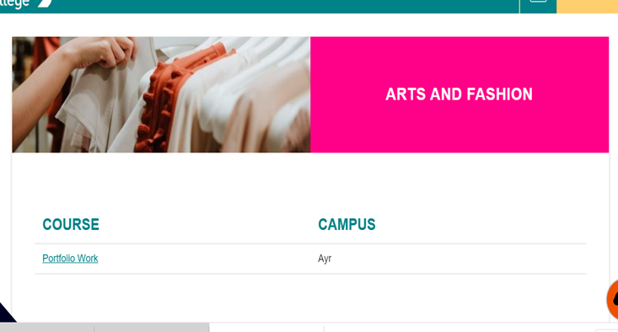
- Find the exact Course you want to apply for.
.
- Click on the course which will take you to the course information

Select the correct Campus on the right hand side and click the “Apply now” button
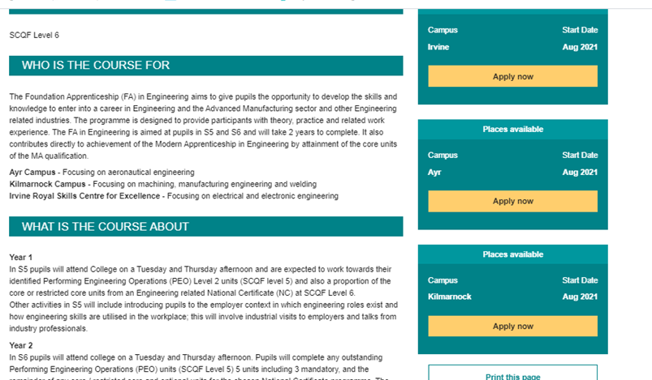
This will then take you to your “Basket”. Make sure the course that is showing is the correct course and campus and click the “Apply now” button
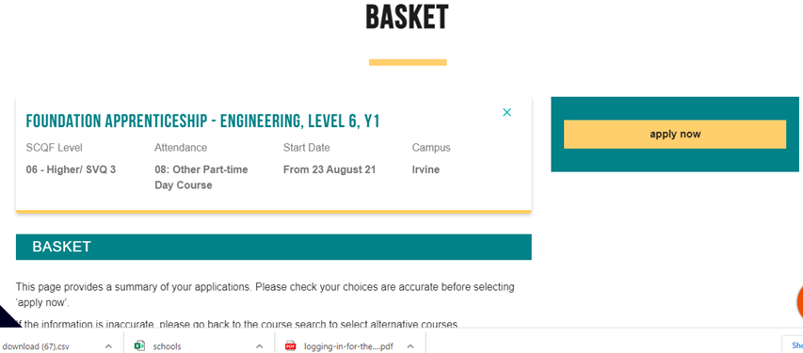

STEP 3: Registering

Students will need to register with an email (username) and a password (Password1 or something that they will remember as they will need to access to amend or add courses).

The course will be added to the basket:
Before you can apply, you need to register and confirm username and password by accessing your email account to accept:
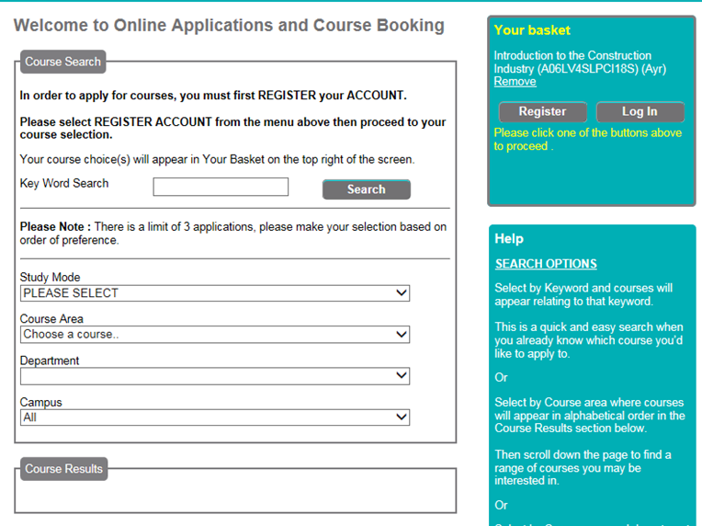
Important, please ensure all mandatory fields marked with an asterix ‘*’ are completed. |  |  | 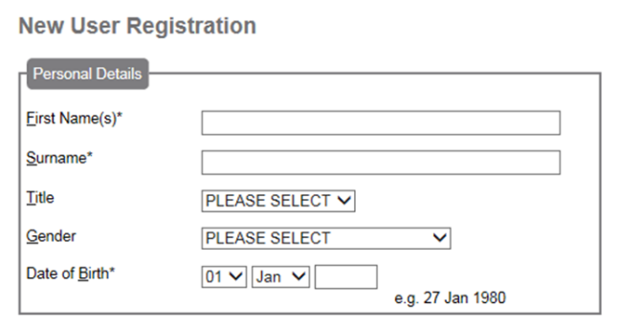
Important, use Postcode lookup for address. |  |  | 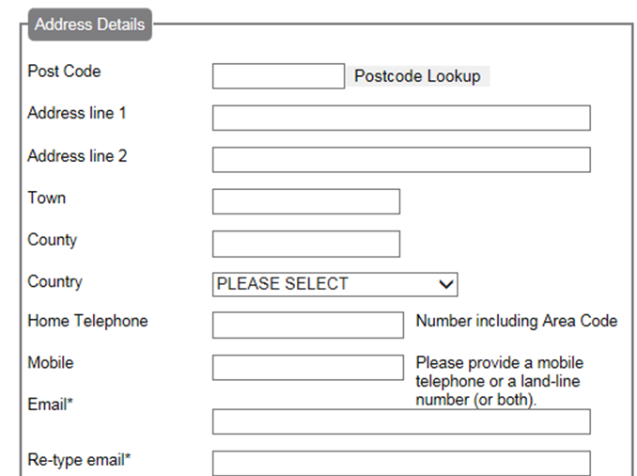
You will be asked to validate your email. At this point please log onto your email account and click the link to validate email and set a password.
Answer “No” to continuing student. |  |  | 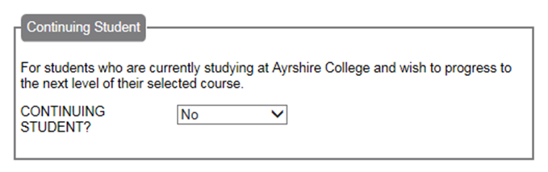
If the student has any of the disibilities listed please tick the appropriate box. This will allow the college to provide support to the student. |  |  | 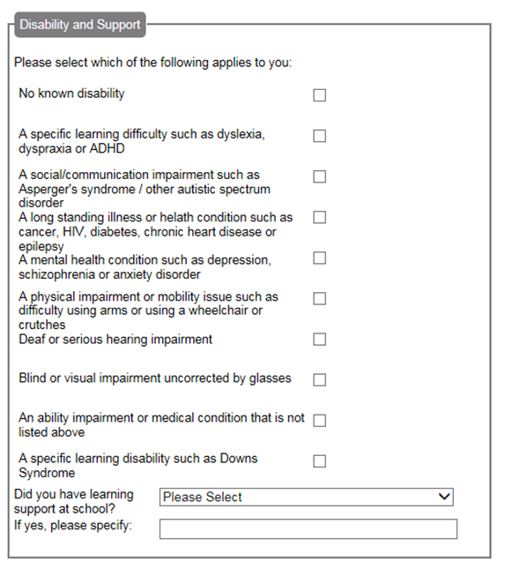
Please ensure the student selects the correct current school to allow the college to communicate application information.  If the student is not 16 they do not need to enter their national insurance number  If the student does not know their Scottish Candidate Number – leave blank  If the student has not yet compelted any exams, please leave blank. |  |  | 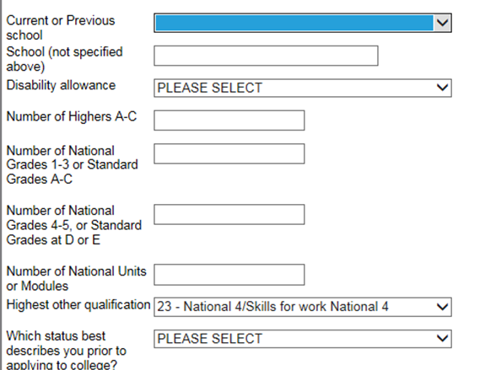
Please ensure the student selects the year group they will be in when commencing the course. |  |  | 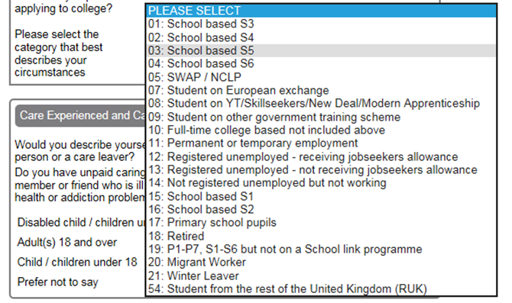
Please ensure emergency contact information is completed and a contact telephone number is inserted. |  |  | 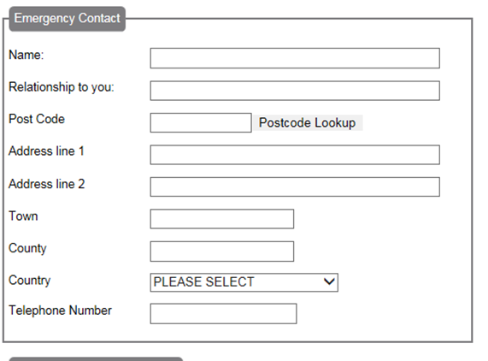
If the student requires any additonal support at interview, please select “Yes” in the first drop down and select the type of support from the second drop down:

Add qualifications individually.  If the student isnt sitting the exam until May, please enter a predicted grade.  If the student is in 3rd year, click next  If an error is made when inputting qualifications this cannot be rectified after the qualification is added and will remain on the student’s application. |  | 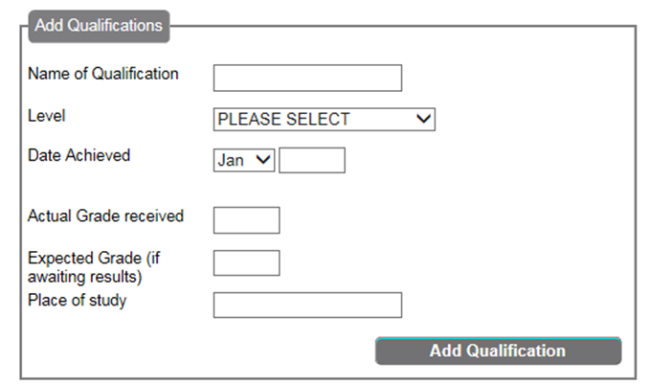
If the student has completed any relevant work experience for the course they are applying for, please enter in the Work/Placement Experience section. If they haven’t completed any work experience click “next”. |  | 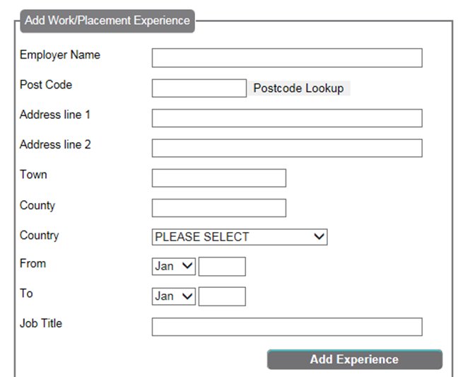
Please select first choice from the drop down. |  | 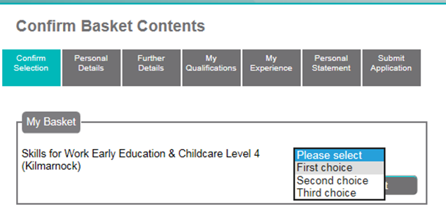
This section will allow the student to give further information on why they have chosen their particular course.  Please see next page for more information on how this should be completed. |  | 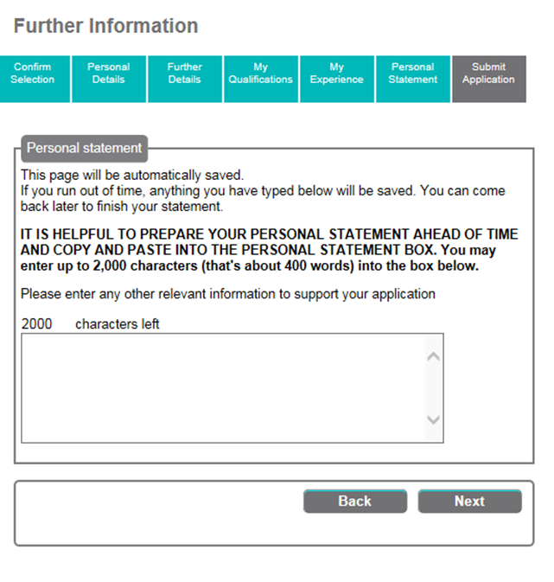

Further information
Students will be asked to submit a personal statement; it would be really great if they could independently write at most a few paragraphs explaining from their own point of view why they are keen to choose this course. This will help curriculum staff to select the most appropriate candidates.
Please note, the application process will timeout and we would encourage applicants to complete their personal statement in a word document and then paste into application.
The personal statement only allows 2000 characters, any text over the 2000 characters that has been entered will be cut off.
It would be great if students could include:
- Year group
- Interest in the course
- How does it fit with progression/career path
- Hobbies and interests that are relevant
- Describe current attendance and commitment to school studies
Here are a few examples of what we are looking for:
“I am in 5th year at the moment and I am really interested in maybe becoming an engineer. I am currently studying maths and I really like practical hands on subjects. Some of my family members are already employed as engineers and I think that I would enjoy working within this area and I understand what would be required to become an engineer.
I enjoy football; this is a team sport which helps me work well in groups. I also have a part time job at ASDA as a customer assistant and have been working towards a Volunteering Award at school.
My attendance at school is good overall, I thrive in more practical subjects and would describe myself as keen to pass all my subjects but some are more difficult than others.”
Please note: If anything is missed they can use the tabs to go back to a specific section

OPTIONAL Step 5: Choosing more than one course

Please note that this is primarily intended for pupils who want to apply to attend 2 Courses at College and NOT to submit a second choice for their one College slot.

To submit a second choice student must log out and follow the steps highlighted in Step 2. Students do not need to re-register; they will log in using their username and password. All previously submitted details will be populated. When confirming basket contents, the student should select 2nd choice from the drop down menu for their second course. A personal statement will be required, however, if relevant to 1st choice then this can be re-used if saved in a word document.

Step 6: Application Confirmation

Students will now be taken to an application confirmation screen where data can be checked before submitting. If any details are incorrect applicants can click the section tabs to amend – please use the tabs along top of page to navigate.

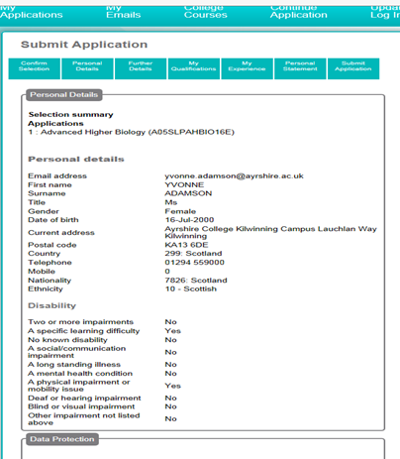

Once checked click “Submit”.

For those applicants that have been unable to click the submit button due to time constraints or are unsure of their choice, they can log back into the system to complete their application.

The SCP team will communicate directly with each school over applications. However if school staff wish to check the status of an application they can log in using the students username and password.

Once submitted “Congratulation you have applied for…” will appear, this then gives the student an application number. It would be helpful if they take a note of this number or better still if they print the screen and the schools have a copy of this.

