S3

Geography

[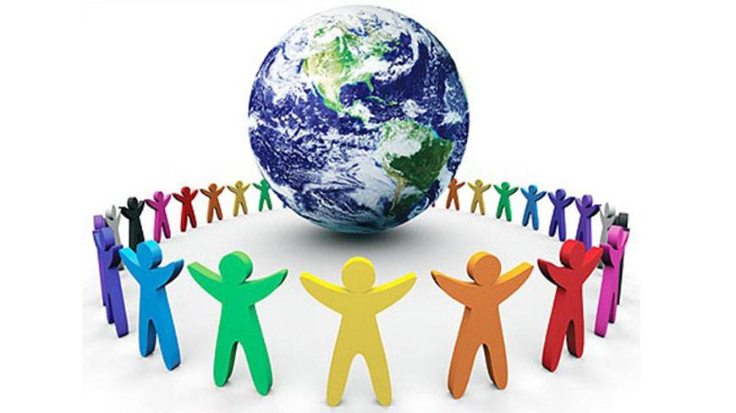](http://www.google.com/url?sa=i&rct=j&q=&esrc=s&source=images&cd=&cad=rja&uact=8&ved=0ahUKEwishtjpjoTNAhVPF8AKHdS5DU8QjRwIBw&url=http://www.jattdisite.com/scraps/world-population-day/&psig=AFQjCNGzdTBk6SY9OfmEGPuEubLrC2znMg&ust=1464777294650281)

Population

**World Population Distribution**

On the 31st October 2011, the world population reached the 7 billion mark. Since then, population is increasing by 70 million people every year. Of this increase, 85% live in the developing world or ELDC’s (Economically Less Developed Countries), and the remainder in developed countries or EMDC’s (Economically More Developed Countries). The land area of the world cover 150 million square kilometres, meaning that, on average, there are over 46 people per km².

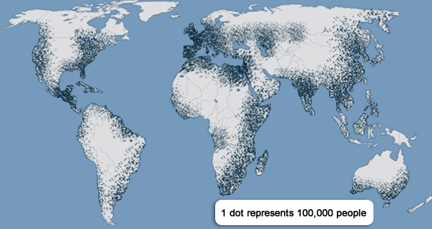

The above map is a dot map showing the distribution of population around the world. You can clearly see that distribution (where people are) is uneven across the world, and there are many reasons to explain why some areas are crowded, and others are sparsely populated.

Climate

People prefer to live in areas that have rain throughout the year, with no extremes of temperature. Climate can limit the amount of people who can live there, eg few people live in northern Russia and Canada where it is extremely cold. The living conditions are unpleasant and expensive as most food has to be imported due to the short growing season. It is difficult to build on ground that is mostly frozen throughout the year. Transport by rail, road or sea can be very difficult in winter. Industry is not likely to locate in remote areas meaning that unemployment rates are very high. Also, areas which receive little rain, such as the Sahara or middle Australia, will have few people. Again, crops are difficult to grow and conditions can be unpleasant. The soil is often worn away by winds or baked by the heat, making it too poor and thin for crops.

Soils

Some river valleys are very crowded, eg Ganges Valley in India. The soil here is very fertile due to alluvium from the river, so it is possible to grow large quantities of food in a small area. The valley is also flat and the river provides people with a reliable water supply all year round. Areas with poor soils are sparsely populated as farms need to be large in order to grow the required food stuffs eg Amazon Rainforest.

Resources

Population density is higher where the environment provides useful resources such as coal and forests. Where there are large mineral deposits, industries have been attracted, meaning that there are a large number of employment opportunities eg north-east USA. Other natural resources include attractive scenery that encourages tourists to the area, leading to job creation eg California.

Relief

People prefer to live in flat, lowland areas. Mountainous areas, such as the Himalayas, have low population densities. This is partly to do with the cold environment leading to poor soils, and that the areas are too steep to allow for building. This in turns makes it unattractive for industry.

Economic activities

Regions where the main activity is industry or services have high population densities. Large numbers of people can be employed in a small area.

Communications

Areas where there are many roads, airports, ports and railways are more crowded as they attract industries, and conversely people will obtain many employment opportunities

Technological development

Countries with a lot of natural resources, but have little money and skills to exploit their resources, are not crowded eg Democratic Republic of Congo. However, countries such as Japan have higher population densities because of the advanced technology and highly educated and skilled workforce.

**Urban and Rural Population**

|  |  |  |
| --- | --- | --- |
|  | Urban population | Rural population |
| World | 51% | 49% |
| Developed | 78% | 22% |
| Developing | 43% | 57% |

The above table shows that in 2011, more than half of the world’s population live in towns and cities, but this number is much higher in developed countries. In developing countries, many more people make a living by farming, whereas in developed countries, people will generally work in urban areas in offices, factories and services.

Urban and rural populations in 1950

|  |  |  |
| --- | --- | --- |
|  | Urban population | Rural population |
| World | 29% | 71% |
| Developed | 54% | 46% |
| Developing | 17% | 83% |

In developing countries, people are moving to cities because of push factors from the countryside. As the population in these countries is rising, there is not enough land for everyone to make a living through farming. Also, there is the ever present problem of crop failure because of drought and natural disasters. Services are much poorer in the countryside, with fewer schools and medical facilities, and fewer basic amenities such as sewage disposal, water and electricity. On the other hand, cities provide better and more services, including entertainment, restaurants and shops. Most offices and factories are in urban areas, leading to better job opportunities. Although cities have many problems, this is not slowing down the number of people who are attracted.

In developed countries, the push factors from the countryside are similar. Poorly paid jobs in agriculture, lack of services and shops and poor transportation have led to people moving from rural areas. Cities have better paid jobs in services and high-tech industries, and they have a greater variety of housing available. However, there are problems such as high levels of crime, pollution and traffic congestion. This had led to the recent migration of people away from cities.

**Megacities**

A megacity is classed as a city that has over 10 million people living within it. As would be expected, the pattern is similar to the global distribution of people. Although developed countries have a higher rate or urbanisation, it is the developing countries in which most of the megacities are found. In developed countries, people have a choice of many cities in which they can move, whereas developing countries will have a limited number of opportunities.

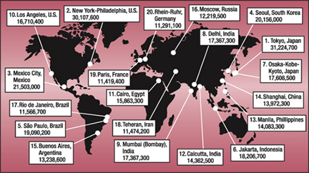

**Population Change**

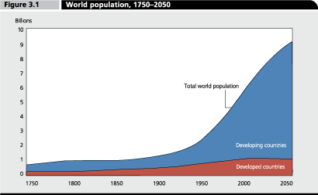

The above diagram shows the changes in the world’s population since the year 1750, and shows the projected rise. This composite line graph shows the population increases in both developed and developing countries.

Birth and Death Rates

The number of people in the world is increasing because there are more people being born than there are dying. The number of people being born is called the birth rate and is defined as the number of births per 1000 people per year(‰). The number of people dying is called the death rate and is defined as the number of deaths per 1000 of the population (‰). The difference between the birth and death rate is called the natural increase (NI).

The average birth rate throughout the world is 20‰ and the average death rate is 8‰, giving a natural increase of 12‰. Birth and death rates are much higher in developing countries.

In the UK, we have a birth rate of 12.26‰ and a death rate of 9.33‰. Japan has a birth rate of 8.23‰ and a death rate of 9.27‰, so has a decreasing population. In Afghanistan, the birth rate is 39.05‰ and death rate is 14.35‰.

Why do you think there are such large differences between developed and developing countries?

Factors Affecting Birth Rates

Developing countries have a higher birth rate due to:-

* Children can take care of their parents in old age
* Children are economically important – can help to earn money by working on the family’s farm or elsewhere
* Lack of family planning and contraception
* Infant mortality rates (number of children that die before the age of 1) are high, so parents will have more children to ensure survival of some
* In some cultures, the larger the family, the more powerful the man and the higher status they have in their society

Developed countries have lower birth rates because:-

* Women are educated, so choose to have careers. This means they marry later and have fewer babies
* Contraception an family planning are readily available
* Children are very expensive to raise

Factors Affecting Death Rates

Developing countries have higher death rates because:-

* Many families live in poor housing with poor sanitation
* Lack of clean water, leading to many water-borne diseases spreading easily eg cholera
* Many do not have enough food to eat
* Overcrowding leads to diseases spreading eg malaria
* Few doctors and hospitals

Although the death rates for developed and developing countries are similar, it is important to note that deaths in developing countries occur at a much younger age.

Developed countries have lower death rates due to:-

* Proper sanitation and clean water
* People have good diets and enough to eat
* Advanced medical facilities and advice are available

**Effects of Population Growth**

Rapid Population – Structure

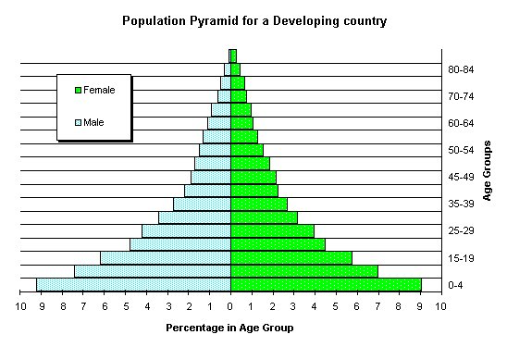

The above diagram is a population pyramid for a developing country. A population pyramid shows the structure of the population in terms of age and sex. If a population pyramid has a wide base, it shows that the country has a high birth rate. Those aged 0-14 are classes as young dependents and 65+ are old dependents. The people in between (15-64) are classes as the economically active population.

There are many children because the birth rate is high. Often, as much as one-half of the total population is under 15 years of age. There are fewer people of working age because, until recently, the death rate was high and children did not survive until adulthood. This is the same reason why there are few old people.

The population structure of a developing country brings many problems. Less than half of the population is of working age, and they have to provide for all of the dependent populations. As there are so many births, the country needs to spend a lot of money on hospitals, doctors and nurses, as well as providing schools and teachers for the large number for children.

Advantages of rapid growth

Some developing countries are glad to have a rapidly growing population. They can become more powerful and less vulnerable to attack as they have a large number of people to join the armed forces. There is also an increased number of workers, allowing production to increase on farms, in factories and offices. More workers means that wage rates are low which attracts international companies to set up in these countries to reduce labour costs.

Disadvantages of rapid growth

Problems also arise with a rapidly growing population. In rural areas, the farms are becoming smaller and farmers have to use more intensive methods to ensure they grow enough food, which leads to soil losing its fertility. More and more trees are being cut down to create more farmland or provide building materials and fuel. This leads to the soil being blown or washed away as it is not protected. The land then becomes even more infertile, fewer crops can be grown, people become poorer and hungry, and then will be forced to move to cities in search of better opportunities.

In urban areas, the population is increasing much more rapidly because of migrants from rural areas. The local authorities cannot build enough houses for the people, leading to the creation of shanty towns which lack basic amenities such as running water and toilets. Unemployment is high as there are not enough jobs and crime rates increase. Traffic congestion can worsen. Services such as hospitals and schools cannot cope with the extra people, meaning not everyone will gain access to these.

Controlling rapid growth

Most developing countries wish to slow down population growth, and there are a number of ways in which this can be achieved:-

* Laws limiting family size eg China’s one-child policy
* Increased education for women, leading to later marriages and fewer children
* Education on how to reduce births eg more family planning clinics and access to contraception
* More opportunities for abortions and sterilisations
* Incentives for reduced family sizes eg free health care

At the same time, countries are trying to improve farming techniques so they can feed the population. High-yielding crop varieties are used, more fertilisers and pesticides applied, and more land is being irrigated.

**The Effects of Slow Population Growth**

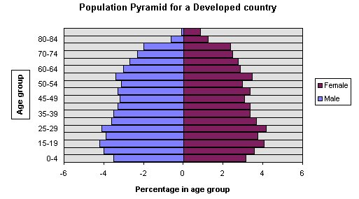

In most developed countries, the birth and death rates are low and their populations are rising slowly, if at all. There are few children in the population and many adults as, in the past, the brith rate was higher and many born survived into adulthood. There are also many old people because the death rate is so low and most live into olf age.

The structure has advantages over the developing countries one as there are more people of working age and less money needs to be sepnt on education because there are far fewer children. However, there are disadvantages because of the rapidly growing number of old people (the greying population). More money is needed to pay for pensions, care services such as day care centres, sheltered housing and old people’s homes are required. Old people use health services more, so this cost rises. The cost of these services are paid for through taxes, but there are now fewer people of working age who pay tax. This means the active employed population will have to pay higher tax contributions and will work for longer before they will receive the state pension. There is a descreasing number of people for the armed forces and fewer potential parents, so birth rates will continue to decrease.

Solutions to a slowly growing population

Many developed countries are concerned about their slow population growth and have adopted a number of solutions:-

* More paternity leave to encourage parents to have more children eg in the UK, fathers are now entitled to two weeks paid paternity leave
* More maternity benefits eg in France, mothers with three children can take a year off work and receive a wage from the government to stay at home. Families also receive cheaper public transport and holiday vouchers
* Raise retirement age to increase the number of taxpayers and reduce pensions eg, the retirement age is set to rise to 68 in the UK
* Encourage more women to work to increase the workforce and the number of taxpayers eg provision of crèches at many workplaces
* Allow more immigrants to fill the employment gaps and increase the number of taxpayers
* Encourage people to take out private pension schemes to reduce the money that is paid out from the public pension pot.

**The Demographic Transition Model**

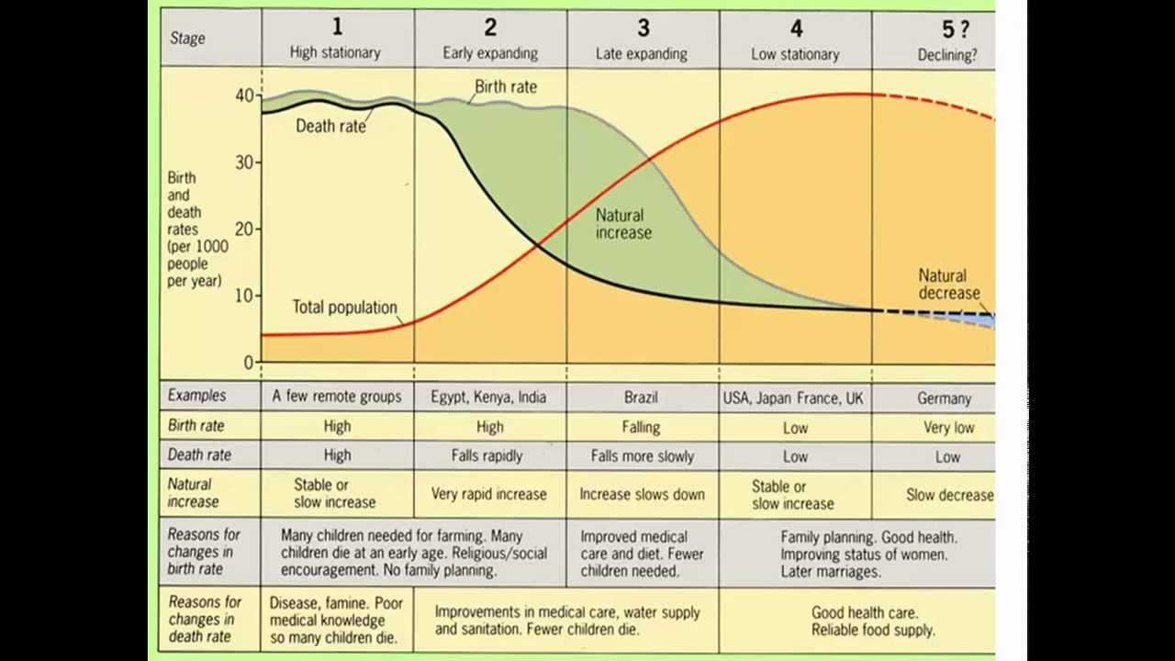The Demographic Transition Model (DTM) shows the changes in birth rates and death rated of a typical country over time. It has four main stages, and countries move through the stages. Developing countries are mostly in stage 1 or 2, and developed countries are mostly in stage 4. There is now evidence for the addition of stage 5 where populations are decreasing.

Stage 1 – high stationary population

* Both birth and death rates are very high
* Total population is very low
* Natural increase is low

There are very few countries at this stage today, possibly only remote groups in the rainforest. The Uk was at this stage before 1750

Stage 2 – early expanding population

* Birth rates are high
* Death rates are falling
* Total population is increasing
* Natural increase is high

Some of the poorest countries are still in stage 2, such as Bangladesh and Malawi. The UK was in stage 2 between 1750 and 1900.

Stage 3 – late expanding population

* Birth rates are falling
* Death rates are continuing to fall
* Total population is increasing
* Natural increase is quite high

Most developing countries are in stage 3, such as India and Brazil. The UK was in this stage between 1900 and 1950.

Stage 4 – low stationary population

* Birth and death rates are low
* Total population is steady
* Natural increase is quite high

Most developed countries are in stage 4, such as the UK and USA.

Stage 5 – declining population

* Death rates are low
* Birth rates are low and decreasing
* Total population is decreasing
* Natural increase is negative

Some developed countries are now in stage 5, eg Japan and Germany

**Measuring Development**

Most countries are trying to improve the conditions in which their people live. Any improvements that are made to the standard of living is called development. It is measured using indicators of development so that comparisons can be made between countries. We will look at examples of economic and social indicators.

Economic Indicators of Development

These measure the wealth and level of industrialisation of a country, including:-

* Gross domestic product (GDP) per person – value of all the goods produced and services provided in a country in one year. This is then divided by the number of people living in the country to indicate the wealth of the average person
* Gross national product (GNP) per person – similar to GDP but also includes service earned abroad
* Energy used per person – amount of energy (coal, oil etc) used indicates economic development. Countries with lots of industry will use a lot of energy. People with a high standard of living will use lots of petrol in cars and lots of electricity in their homes.
* People employed in agriculture – a country with a high percentage of people working in agriculture will have little industry to produce wealth. This then indicates that a country is less developed.

Problems with economic indicators

* Although a country may produce a lot of wealth, it may not be distributed evenly to all of the people. Eg in many oil rich countries eg Saudi Arabia, they have a high GDP but the resources are owned by only 5% of the population
* The amount of wealth does not give enough information on people’s quality of life eg how educated they are
* The amount of income and wealth does not even show how well-off the people are. It needs to be compared with the amount of disposable income people have.

Social Indicators

These show how a country uses its wealth to improve the quality of life for its people. Some measure health eg:-

* Population per doctor
* Infant mortality
* Life expectancy

Others look at diet:-

* Calories per person per day
* Protein per person per day

Some measure education, including:-

* Percentage of children attending primary school
* Adult literacy

Problems with social indicators

* They use averages, so they do not tell the differences within a country eg some people may live on over 3000 calories per day, but others may be severely malnourished
* One indicator on its own does not give enough information on quality of life. Although people may be well fed, they may not be healthy or well educated.

Comparing Social and Economic Indicators

Generally, countries that score highly on economic indicators do well with social indicators too because they can use their wealth to provide proper schooling, medical care, food and housing. Some countries appear more developed according to social indicators while others appear more developed according to economic indicators. For example, a country’s income per person increases, so does the life expectancy. However, there are some exceptions. People in Mexico have a higher life expectancy than people in Estonia, but their average income is much lower.

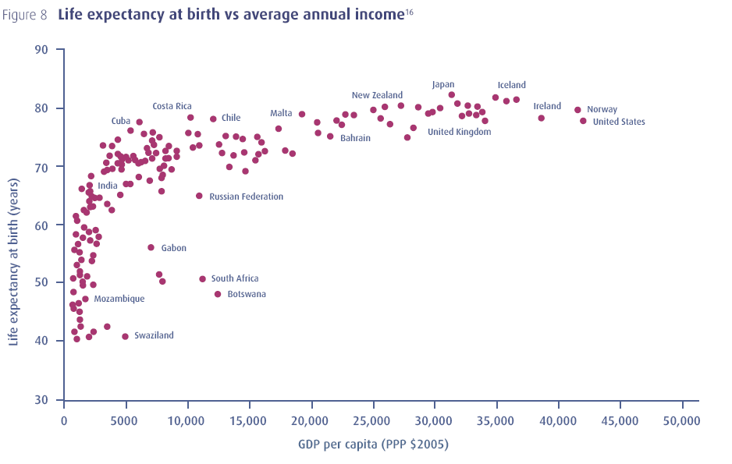

Combined indicators of development

|  |  |  |
| --- | --- | --- |
| Indicator of development | China | India |
| GNP per person ($) | 4940 | 1410 |
| Energy used per person (kg) | 1807 | 566 |
| Life expectancy (years) | 72 | 64 |
| Calories per person per day | 2970 | 2300 |
| Adult literacy (%) | 92 | 74 |

Because different indicators give different results, it is more reliable to use several indicators. Often, a range of social and economic indicators are used eg, to compare the development of the two most populous countries in the world. According to all five indicators compared above, China is more developed that China. Alternatively, a range of indicators can be used to produce a single combined index and these are:-

* Physical Quality of Life Index (PQLI) – this combines life expectancy, infant mortality and adult literacy to produce an index from 0 to 100. The higher the PQLI, the higher quality of life in the country. A PQLI over 77 is considered good.
* Human Development Index (HDI) – this combines life expectancy, adult literacy, GNP/person, cost of living and school enrolment to produce an index from 0 to 1, where an HDI over 0.8 is developed

HDI is often seen as being the best combined indicator as it uses both social and economic indicators, and is the one used most by United Nations to compare countries. Using this indicator, Norway is the most developed country and Democratic Republic of Congo is the least.

|  |  |  |
| --- | --- | --- |
|  | Highest PQLI | Highest HDI |
| 1 | Ireland | Norway |
| 2 | Switzerland | Australia |
| 3 | Norway | Netherlands |
| 4 | Luxembourg | USA |
| 5 | Sweden | New Zealand |
| 6 | Australia | Canada |
| 7 | Iceland | Ireland |
| 8 | Italy | Liechtenstein |
| 9 | Denmark | Germany |
| 10 | Spain | Sweden |

**Reasons for Differences in Development Levels**

Global variations in development

Using indicators of development allow the world to be split into developed and developing countries. Developed countries are fewer in number, nearly all are in the northern hemisphere and most are in temperate latitudes. Developing countries have 75% of the world’s people and can be found in both northern and southern latitudes. They also include all the countries within the tropics. The map below shows the north-south divide.

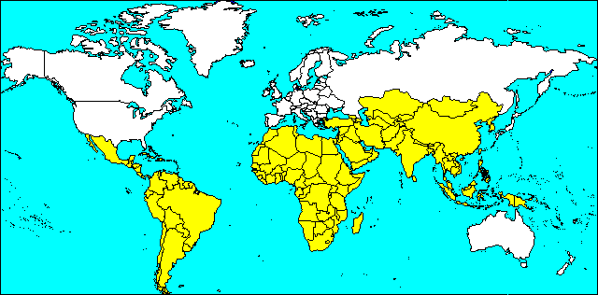

There are big differences in living standards within developing countries. For example, the average income in South America is 6 times higher than in Africa and people can expect to live around 15 years longer. Also, within Africa, people of Libya earn 50 times more than those of Democratic Republic of Congo and live 30 years longer.

There are many reasons for the huge variations in standards of living around the world, and can be divided into human and physical factors.

**Physical Factors**

|  |  |  |  |
| --- | --- | --- | --- |
| Factor | Problem | Why is this a problem | Example |
| Climate | Very cold | * difficult to build roads and railways  * remote and unlikely to attract industry  * too cold to farm  * expensive to live because high heating bills, food expensive  *houses difficult to build because of permafrost | Mongolia |
|  | Very dry | * Barely enough rain to grow crops  * always at risk of crop failure and famine  * remote and unlikely to attract industry  * soils made poorer by wind erosion | Ethiopia |
| Relief | Very steep | * difficult to build roads and railways, so remote and unlikely to attract industry  * poor farming due to steep land, inability to use machinery and thin soils | Nepal |
| Resources | Lack of minerals | * no valuable minerals (eg gold) to sell to other countries  * no fuels to encourage industry | Malawi |
| Environment | Unattractive scenery  Much disease | * not attractive to summer tourists (no beaches) or winter tourists (no slopes)  * country unable to develop if many people suffer from disease and unable to work | Burkina Faso  Sierra Leone |
| Natural disasters | Floods, droughts, earthquakes, volcanoes, hurricanes | * areas prone to natural disasters have harvests ruined, factories and homes destroyed, roads and railways unusable  * coasts millions and may cause famine and unemployment  * may take years for area to recover | Bangladesh |

**Human Factors**

Some countries find it difficult to develop because of their physical environment, but there are many states that have overcome the problems of a harsh environment and enjoy a high standard of living, such as Japan, Canada and Australia. Therefore, there must be human factors as well that have to be considered.

|  |  |  |
| --- | --- | --- |
|  | Developing countries | Developed countries |
| Average birth rate (per 1000) | 22 | 10 |
| Average death rate (per 1000) | 8 | 8 |
| Average natural increase(% population) | 14 | 2 |

**Population growth**

Population is rising seven times faster in developing than in developed countries. This leads to problems.

In the countryside, farms become smaller, as there are more people needing land. So farmers produce less food for their families to eat, have an increased risk of going hungry, and are less likely to have additional crops to sell.

In the cities, the city authorities cannot provide enough homes, schools, hospitals and jobs for the increased population. So many people live in shanty towns, are underemployed and have little chance of getting medical help if they are ill.

There are many young children in developing countries due to the high birth rates. In Niger for example, over half of the people are under 14 years of age, putting a huge strain on the country. The children do not produce wealth, but they need to be kept healthy, well fed, educated and properly clothed.

**Industrialisation**

|  |  |  |
| --- | --- | --- |
|  | Developing countries | Developed countries |
| % people working in:  Agriculture  Manufacturing  Services | 45  23  32 | 3  27  70 |
| % world’s industry | 15 | 85 |

There are far fewer factories and offices in developing countries. Factories and offices produce profits that increase a country’s wealth, employ many people and give a regular wage to those employed. Without industry, a country finds it difficult to develop. Although there is little industry, the population in developing cities is rising rapidly, meaning that there are more people unemployed and have a low standard of living.

Factories and offices are less likely to set up in developing countries because there are few people there who are rich enough to but their products, so the goods will have to be transported to other countries, meaning costs will increase. The roads and railways are also poorer and there are fewer banks from which to borrow money. With fewer colleges and universities, there are not many people with the necessary skills, eg information technology, to work in a modern office. Some industries will locate in poorer countries, but these are foreign-owned (multinational companies), so the profits do not stay in the host country to increase its wealth.

|  |  |  |
| --- | --- | --- |
|  | Developed countries | Developing Countries |
| Imports | Manufactured and primary goods | Expensive manufactured goods |
| Exports | Expensive manufactured goods | Cheap primary goods |
| Trade balance | Surplus | Deficit |
| Debts | Lend money to poorer nations | Borrow money at high interest rates |

**Trade**

With few factories, most developing countries have only primary goods to export eg minerals and crops. Their prices are generally low and can fluctuate greatly. Eg, in 2012 coffee prices were half of that from the previous year. Developing countries need to import manufactured goods, but they are expensive and rise in price, so the money they receive from their exports does not pay for their imports. This means they cannot afford to provide services (eg hospital equipment) to enable people to enjoy a higher standard of living. It also means that they have borrowed large amounts of money over the years from developed countries and now spend much of their income repaying interest on these debts.

Developing countries find it difficult to export the few goods that they do produce because other countries put up trade barriers to protect their own industries. Developing countries may find that they are only allowed to export a limited number of goods to countries such as USA(quota) or find that a tax or tariff is put on their goods so that their price is too high for people to buy.