What is happening around the world?
The 2019 Hong Kong Protests
PROTESTS continue to engulf Hong Kong after an extradition law moved thousands to the streets - even shutting the airport down.

What is happening in Hong Kong?
Protests have gripped Hong Kong since June 2019, sparked by highly controversial legislation to extradite those convicted of crimes to mainland China and Taiwan.
Dictionary check-
Extradite- to send individuals convicted of crimes in China and Taiwan back to these countries from Hong Kong so they may be tried for their crimes.
Weeks of demonstrations started on Sunday, June 9, when a procession of people almost two miles long marched for seven hours through central Hong Kong. In August 2019 operations at Hong Kong airport were suspended for a two days after protesters occupied terminal buildings. Tuesday 13th saw the fifth consecutive day of sit-ins at the airport, with protesters demanding greater democratic freedoms and opposing Chinese influence in the territory. Protesters have been demanding greater democratic freedoms and opposing Chinese influence in the territory.

What are people protesting about?
That bill has been shelved for now - but the protests have mushroomed into a broader backlash against the government amid fears of the growing control of China's Communist party. Hong, a former British colony in south eastern China, has long enjoyed a special status under the principal "one country, two systems".
The Basic Law dictates that Hong Kong will retain its common law and capitalist system for 50 years after the handover in 1997. Essentially Hong Kong operates as though it is its own country. This is not to be changed in anyway until 2047. But there are fears China is extending its influence over Hong Kong long before this deadline. Protesters see the move to try Hong Kong citizens under Chinese law as deeply problematic - in 2015, 99.9 per cent of those accused in China's courts were convicted.
But there are other issues at stake too. Protesters also believe their leader should be elected in a more democratic way that reflects the preference of the voters.
The chief executive, Carrie Lam, is currently elected by a 1,200-member election committee - a mostly pro-Beijing body chosen by just six per cent of eligible voters.

Who is protesting?
A huge cross-section of society including lawyers, journalists, activists and business figures have joined in widespread protests across the region. Activists say they won't stop until their main demands are met. These include the resignation of the Hong Kong's leader, Carrie Lam, an amnesty for those arrested and a permanent withdrawal of the bill.
On August 9, anti-government protesters dressed in black descended on Hong Kong's airport to draw international awareness to the movement - the first of three days of unauthorised rallies in the Chinese territory. They were seen waving banners in different languages denouncing Carrie Lam and the police.

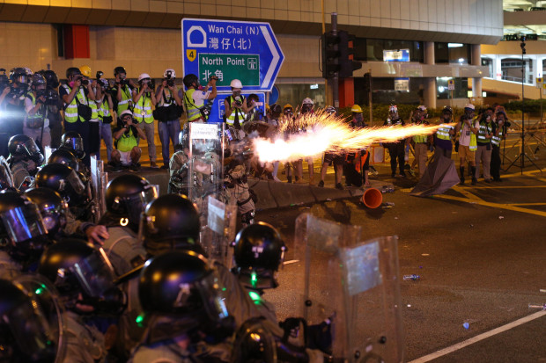
How is the Chinese government reacting to the protest?
Beijing has reacted furiously to the protests, warning those involved not to "play with fire". China's military recently released a threatening video showing them conducting anti-riot drills.
The footage - believed to have been filmed in the region - shows armed troops descending from helicopters and shooting their way through the streets and into people's homes. Chinese police and soldiers have been seen training with “giant forks” as Hong Kong braces itself for another weekend of protests across the city.
Security forces were spotted carrying out crowd control exercises with the terrifying weapons at the Shenzhen Bay Sports Centre just 4.5 miles from the border with Hong Kong. In a press briefing on August 6, a spokesman for the Hong Kong and Macao Affairs Office of the State Council issued China's firmest rebuke yet. It said the months-long "radical protests" had negatively impacted Hong Kong's "prosperity and stability, pushing it into a dangerous abyss".

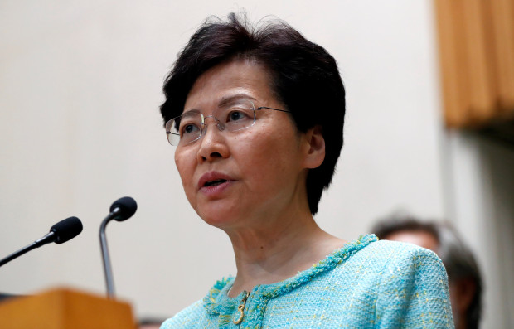
Who is Carrie Lam and how have Hong Kong's government reacted to the protest?
Carrie Lam, 62, is Hong Kong's Chief Executive - the state's most senior politician. Lam suspended the bill a month after the demonstrations started - however she did not fully withdraw it leading to criticism from the protest movement's leaders.
Speaking on July 9, she said the extradition bill was "dead," adding the government's work on the bill had been a "total failure". The bill would allow extraditions to any jurisdiction that does not already have a treaty - including mainland China and Taiwan.
The government claims the measure would prevent the seven million strong population from becoming a magnet for fugitives. Facing deafening calls to resign, Ms Lam retreated for a fortnight. On August 5, her first address in two weeks, she warned that Hong Kong was "on the verge of a very dangerous situation". And she accused activists of using the extradition bill to hide their real goal, which she claims is to "destroy Hong Kong".

How has the UK and the international community responded?
In July, UK Foreign Secretary Jeremy Hunt, who has since been ousted and replaced by Dominic Raab, tweeted that Britain’s “support for Hong King and its freedoms is unwavering.” He said the UK couldn't just "gulp and move on" in response to the ongoing situation in the former British territory. Hunt warned there would be a diplomatic showdown if the Sino-British declaration on Hong Kong was not honoured by Beijing. A spokesman said the Beijing government was "extremely dissatisfied" with the way Britain had "continuously gesticulated" about Hong Kong. The US updated its travel advisory to the territory on Thursday, August 8.

HONG KONG HISTORY
Hong Kong became a British colony with the end of the First Opium War in 1842.
The British fought the war to preserve the right of the East India Company to sell opium into mainland China.
The establishment of the colony gave Britain control over a number of ports to which foreign merchants could deliver goods.
Britain obtained a 99-year lease for the territory in 1898, and relinquished control when that lease expired in 1997.
Hong Kong now operates as a semi-autonomous territory, with control over its own trade, tax, and immigration policy.
Under the terms of the 1997 handover, that status is protected until 2047.
What happens after then is currently undecided, but opponents of the Beijing government fear that China will seek to gain control of the territory.

Title- Hong Kong 2019 protests- Questions
Read fully the Hong Kong protests article. You MUST answer these questions in detail and in full sentences. I will be collecting in jotters to mark these questions. We will also be discussing this in class Wednesday. Once complete move onto the extension task below.
Q1. Fully explain the events that have unfolded in Hong Kong which is the cause of the 11 week protests.
Q2. Who is the head of the Hong Kong executive? Why are protestors asking for this individual to resign?
Q3. Give two examples of the actions taken by the protestors to influence democracy in Hong Kong?
Q4. Is Hong Kong apart of China? Explain.
Q5. What is Hong Kong’s relationship with the UK?
Q6. Many protestors are calling for the UK to intervene and end the protests and stand up against China- why are protestors involving the UK?
Q7. What is the purpose of the treaty signed by Margaret Thatcher’s UK government in 1997? Was this beneficial for Hong Kong?
Q8. China operates under the one-party system and is ruled by the Communist Party, how is Hong Kong ruled and explain how this system is different to the Communist china.
Extension- Using your notes so far gathered in your jotter about China create an informative fact file using either A4 or A5 paper. This should contain information about; China’s history, the flag, the revolution, Communism in China, the one-party system. You should also contain information about China’s political system in comparison to Capitalism countries. You should note at least 4 differences between a capitalist system and a communist system. Use all notes in your jotter to help you with this task.

