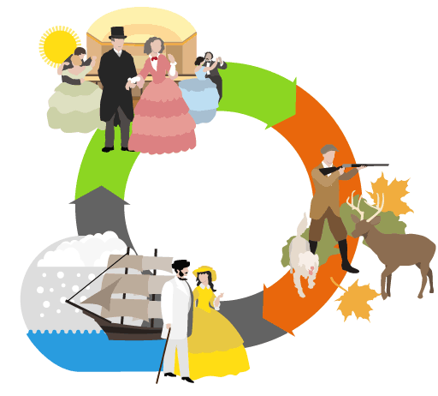**Life for the Rich around 1900**

Birth mattered more than income. A lazy, good for nothing cousin of a duke would be acceptable in high society. A self-made millionaire might not. It was all about ‘old money’ i.e. your family had been rich for centuries

A rich baby boy had governesses and nannies, then went to a public school such as Eton or Harrow, finishing his education at Oxford or Cambridge.

Girls were mostly educated at home with an emphasis on getting ready for marriage. Some girls went to boarding school and, towards the end of the 19th century, a small number were able to go to university.

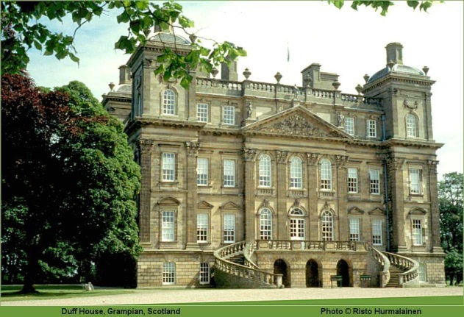The eldest son inherited his father's estates and titles. Many younger sons went into the army where they would pay a sum of money to receive an officer rank. Other younger sons went into the Church.

Some lords had a large house in the country, and a town house in London. They would be waited on by scores of servants, who worked 'below stairs' and slept in the attic.

Most MPs and those in government came from this part of society, and for most of the 19th century they had been reluctant to allow the lower classes to participate in politics

May to July was 'the season', when the family moved to London for the social life – theatre, dances and parties. August to November was the shooting season, when lords moved to their country homes to shoot grouse or stags, and go fox-hunting. In the winter, many rich families went abroad.

Some aristocratic Victorians didn't always behave according to the values of the time. Victoria's son Edward had at least 55 lovers, even after he got married. Occasionally, there would be a great scandal in the newspapers.

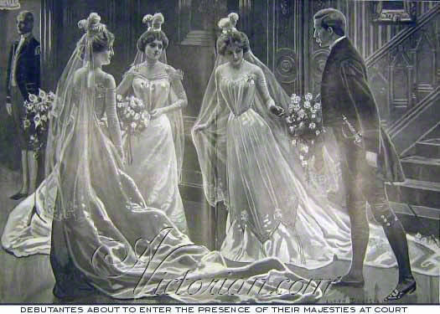A young aristocratic lady who was eligible for marriage would 'come out' as a debutante, when she was presented to Queen Victoria. On this special occasion she wore a white dress, and a headdress with three feathers.

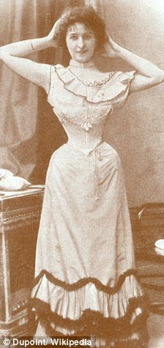Women were expected to look a certain way for men. A tiny waist as little as 30 centimetres was fashionable. Women wore a whale-bone corset laced tight. This damaged their internal organs, and explains why Victorian ladies fainted so easily. The women wore strong smelling salt in necklaces to bring them round when they fainted

Men and women were seen to operate in separate worlds. After a fancy dinner, it was common for all the men to leave to discuss politics and money over brandy and cigars. It was not believed that women should participate in such activities.

Upper class children were expected to be ‘seen and not heard’. Children were brought up as little versions of their parents and the aim was to find them a suitable match to marry from a young age.

Upper class children would rarely play outside and instead read books, played piano and girls might sew or do embroidery. The occassional game of bowls or croquet might be played outside in nice weather.

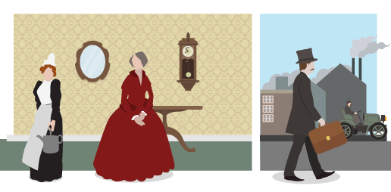**Life for the middle class**

Many middle-class people aspired to join the upper classes. Wealthy middle-class businessmen would socialise with the aristocracy.

Many middle-class boys went to grammar schools, or second-rank public schools, where they played healthy games and sports, and studied Latin, Greek and Ancient History.

Girls increasingly went to school, but they were still expected to put their effort into getting a husband and learning how to run a home.

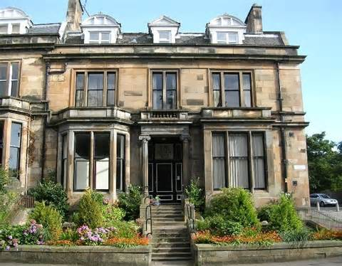Middle-class men worked for a living, but in non-manual occupations – from rich lawyers and bankers, through teachers and engineers, down to shopkeepers and clerks. Many middle-class people were 'self-made men', who had created their wealth through success in business. Very few women worked, although some supported their husbands running shops and small businesses.

Many lived in a house in the suburbs and commuted to work in the City. Even the poorest middle-class home would have a servant.

After the Parliamentary Reform Act of 1832, the middle classes had the right to vote.

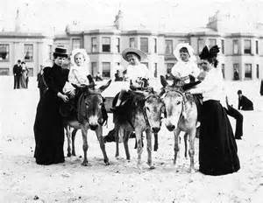Many were 'do-gooders', who believed in teetotalism, also known as 'temperance', and who joined the local Society for the Suppression of Vice that worked to ban dances such as the can-can

By the end of the century most Victorian middle-class people took an annual holiday. The wealthier went abroad, the well-to-do went to places like Ayr and Scarborough.

Behaviour in a typical middle-class family was 'proper'. Children called their father 'sir' and spent most of their time with their nanny. Many middle-class people believed that a mother's job was to stay at home and be 'the angel in the house' ie tell the servants and tradesmen what to do.

The middle classes held 'Victorian values' – religion, patriotism, duty, charity, modesty, cleanliness, self-improvement and hard work.

For entertainment:

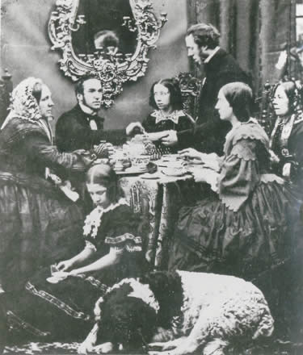Families held musical evenings when they gathered around a piano and sang.

Hobbies included photography, stamp-collecting and butterfly-collecting.

Middle-class Victorians enjoyed the theatre

Middle-class Victorian women enjoyed shopping – the first department store, Whiteley's, opened in London in 1863.

The Victorians were the first to have Christmas cards, Christmas crackers, Christmas trees and Father Christmas.

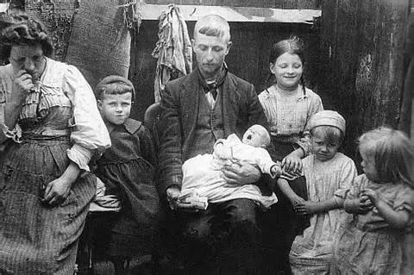**Life for the poor**

Life for the poorest people in 1900 could be summed up in one word – work. People had to work in terrible conditions just to make a living. Even though some laws were introduced to improve conditions, life remained very difficult.

At the start of the 19th century, few poor people received an education, until the 1880 Education Act made primary school, called Board Schools, compulsory.

In poor families, the father was the breadwinner. Many working class men worked in coal mines, shipyards, factories and mills; the pay was low and hours long. Accidents at work were common and men often died from work related injuries.

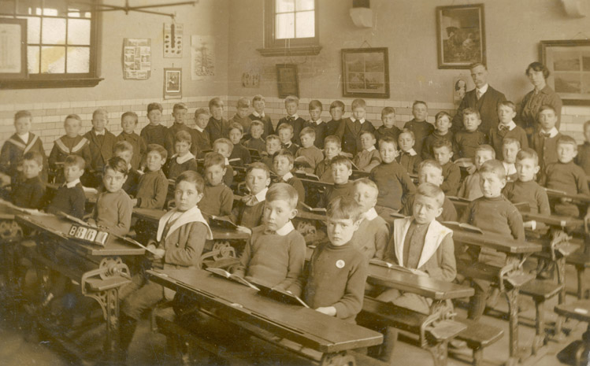Death of the breadwinner in a poor family usually meant the family fell into deep poverty. Older children often had to leave school to earn some money.

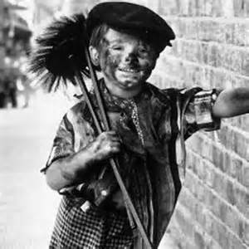Most poor parents had little education in 1900 and although their children may have went to school, the provision of education was generally poor; with very large class sizes and no sanctions for those who didn’t attend.

Many children went out to work to help their family. Common jobs for children in 1900 were working in factories, coal mines or textile mills. Chimney sweeps were usually children. There had been some laws introduced to try and reduce child labour but they were not always successful.

Women from poor families rarely had the option to stay at home as a full time mother. Poor women generally worked in domestic service (as house servants to rich or middle class families) or in sweltering hot laundries or factories.

Poorer families tended to live right in the centre of towns or cities, close to the factories where the work was. The city slums were generally overcrowded, with no running water and no inside toilet. Pollution from the factories 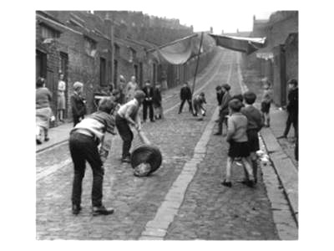caused many health problems.

Poorer children spent most of their time out in the streets which was, in some ways, safer than today with no cars. Kids improvised, chalking hopscotch grids on the ground or making a ball out of some old rags to kick around. If they were lucky, the butcher would give the children a sheep’s stomach to kick about as a football.

Working-class leisure activities included playing or watching football, bicycling clubs, newspapers and trashy, serialised novels called 'penny dreadfuls' and the Music Hall.

Many of the parks today were built in the Victorian Era and many working class families used public parks as they did not tend to have a garden.

The 1871 Bank Holiday Act made paid bank holidays compulsory. Some working-class people started to go to the seaside at Scarborough or Ayr on the train if they could afford it.