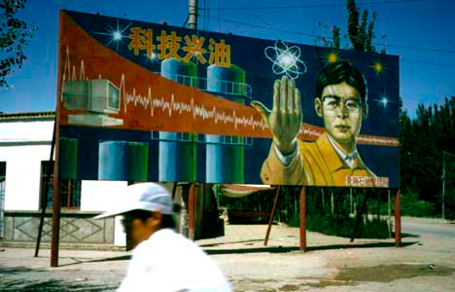Under Chairman Mao, the people and the government alike had *hated scientists and intellectuals.* **The Cultural Revolution** had seen students informing on their teachers and had sent hundreds of thousands of academics into the fields (as farm hands) or seen them simply disappear.

When Deng tried to lead China forward, this **attitude had to change.** For nearly a decade China had gone without training any new scientists or engineers; all research was done in tightly controlled government run institutions.

Deng set out to change this, introducing **Science and Technology as a major national priority**. He not only encouraged Chinese universities to undertake research, but also encouraged them to partner with foreign organisations in an effort to improve research. President Xi Jinping has continued this trend by making Science and Technology one of his key priorities for 2016-2020.

**Today, China is considered the world’s Science and Technology Powerhouse. China is now the world’s number one producer of undergraduates** **with science and engineering degrees** and, since 2007, the country has awarded **more Ph.D. degrees in natural sciences and engineering than any other country globally.** China also accounted for **20% of total world Research & Development spending in 2016.**

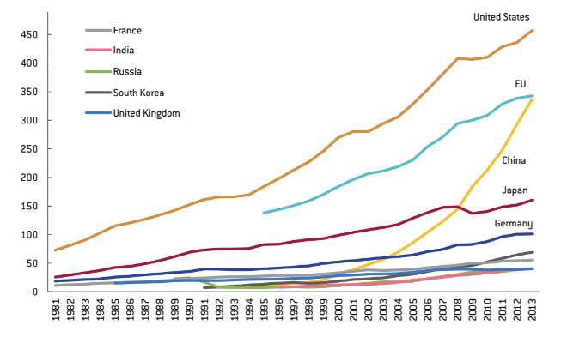*(R&D spending in billions of dollars, 2016)*