[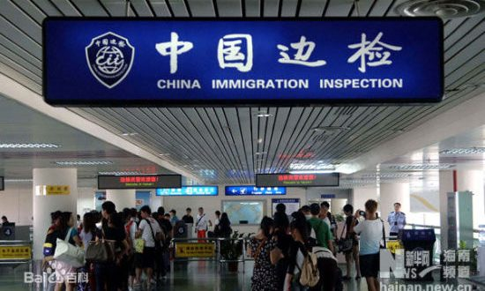](https://www.google.co.uk/url?sa=i&rct=j&q=&esrc=s&source=images&cd=&cad=rja&uact=8&ved=2ahUKEwj7-9bk-uvaAhWPmLQKHYvcDY0QjRx6BAgBEAU&url=https%3A%2F%2Fthecitizenng.com%2Fchina-waives-visas-for-53-countries%2F&psig=AOvVaw0EOEGZ1qJ1Wu0z177PRh-9&ust=1525519927192383)Under Chairman Mao, **China was a country in isolation** with very few allies and little contact with the Western world in particular. This lack of contact and development **helped Mao to maintain his tight grip of control over the Chinese people** and carry out his numerous polices such as the “Great Leap Forward” and the “Iron Rice Bowl” with little interference from outsiders. So closed off from the world was China that in the 30 years from 1949 to 1978, **only 200,000 Chinese people travelled abroad** in total.

Since Chairman Mao’s death however, successive Chinese Presidents have **pushed for China to become a leading member of the international community**; a “**superpower**” which maintains its own independence but influences and works well with its many allies.

[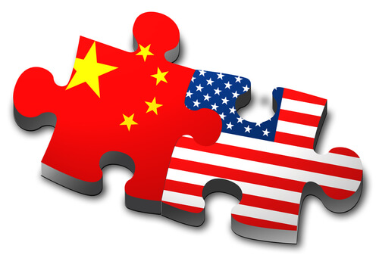](https://www.google.co.uk/url?sa=i&rct=j&q=&esrc=s&source=images&cd=&cad=rja&uact=8&ved=2ahUKEwjzq6WU_OvaAhXBZVAKHd4ZCoYQjRx6BAgBEAU&url=https%3A%2F%2Fwww.shusterman.com%2Fchinese-us-immigration%2F&psig=AOvVaw0EOEGZ1qJ1Wu0z177PRh-9&ust=1525519927192383)China has been a member of the United Nations since 1971 and is **one of 5 permanent member states of the UN Security Council**. This gives China massive international influence as it is the job of the UN Security Council to ensure international co-operation, peace and security. In recent years, China has provided more soldiers for UN Peacekeeping duties across the world than any other nation, to highlight its **commitment to maintaining international peace.**

However, China has also **faced criticism in the international community** for pursuing its own independent agenda. For example, China has come under fire for refusing to condemn the use of heavy weaponry against innocent civilians in Syria since 2012.

Internationally, **China has become more open to foreigners in recent years** and has attempted to open its borders to far more people not just for business purposes but to spread Chinese culture across the world. In 2008 for example, 48 million foreigners travelled to China. Of the companies listed in the Fortune 500, 480 have investment in China, and Chinese companies are currently doing business in roughly 160 countries and regions across the world.