[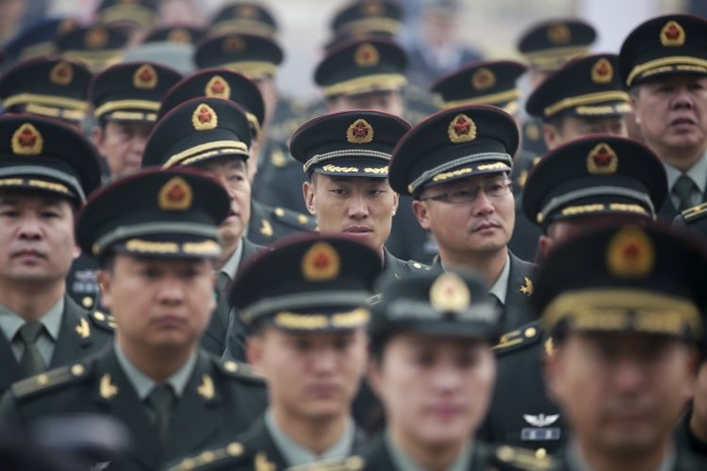](http://www.google.com/url?sa=i&rct=j&q=&esrc=s&source=images&cd=&cad=rja&uact=8&ved=2ahUKEwiNg6zK9-vaAhUEEVAKHX5WB-oQjRx6BAgBEAU&url=http://www.businessinsider.com/chinese-us-military-comparison-2016-8&psig=AOvVaw3s4kENHm3sYBtSlfW4MCQL&ust=1525519064922258)Under Chairman Mao, the military had become a **political force** that had a huge amount of power because of its **huge membership** and the willingness of its membership to **brutally enforce Communist values. The People’s Liberation Army** was under Mao’s direct control for most of his presidency.

Deng wanted a **more Western-style, modern army** that served the government, rather than the other way around. Deng placed civilians in key leadership positions and changed the law so that the army had to report to Communist Party officials. Deng also sought to reduce the number of soldiers (which stood at around 4 million soldiers in 1976) and **increase the level of technology used.**

Military service remains compulsory for all men who reach the age of 18 unless medically unfit. Women may register for duty in the medical, veterinary, and other technical services. In 2017, the People’s Liberation Army, **boasted an active service membership of 2,183,000 –the largest number of military personnel in the world.**

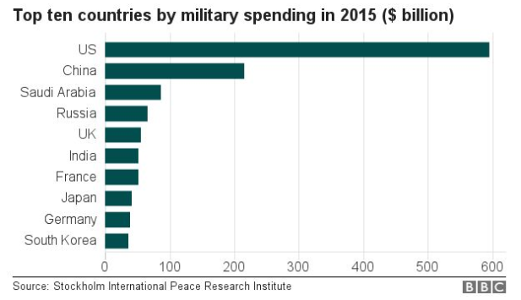**Investment** in the defence industry also increased, and now **China has one of the world’s most advanced militaries**. Although the USA still spends more on its military than any other country in the world, China’s defence budget is believed to be higher than official reports suggest, thanks to the secretive nature of the CPC. **The CPC stated that in 2017 its defence budget was roughly $151 million.**

Key advancements include fielding significant improvements in **missile systems**, developing fifth-generation fighter aircraft capabilities, and growing the size and capability of the **Chinese navy to include their first overseas base in the port of Djibouti.**