[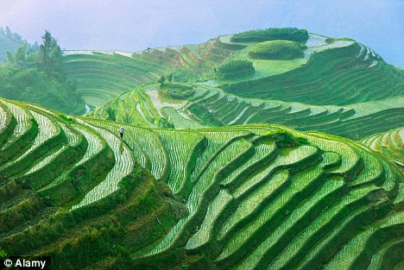](http://www.google.com/url?sa=i&rct=j&q=&esrc=s&source=images&cd=&cad=rja&uact=8&ved=2ahUKEwiHw9aa7OnaAhVSb1AKHe1PDAgQjRx6BAgBEAU&url=http://www.dailymail.co.uk/news/article-2045582/China-open-markets-allow-US-export-rice.html&psig=AOvVaw2c-dniVA0XNEaMlsPZcqD-&ust=1525447307395779)Under Mao, agriculture had operated under the **Commune System**. This meant that whole communities of around 4,000-5,000 families operated as a single unit. At the start of each day, commune leaders assigned each person a specific job that was undertaken for the “good of the commune”.

**Deng** abolished the Commune System, and replaced it with the **Responsibility System**. Now, as long as farmers meet (a much-reduced) quota every month, they are **allowed to sell any extra produce on the open market** and **make a profit**. This can then be used to buy machinery, which can in turn be used to produce even more, and make even more money for the farmers. It is also important to note that there have been no mass food shortages in China since Deng introduced the Responsibility system.

Today, China is a member of the **World Trade Organisation** **(WTO),** which regulates the trading of goods and services between different countries. Through WTO membership, agricultural trade has increased massively for China. According to the United Nations, **China ranks first in the world in terms of the production of cereals, cotton, fruit, vegetables, meat, poultry, eggs and fishery products.**

However, the effects of agricultural modernisations on ordinary Chinese people have not all been positive. Many small farmers have gone out of business because they could not grow enough crops to compete with the large farms and many young men have **abandoned rural areas** because there are no jobs, and headed to the city to try and find work.

Moreover, because of the speed at which China’s population is growing, there is a risk that it may, again, be unable to produce enough food for its own population. Some researchers have suggested that if China is to have enough affordable food for its population in the second half of this century; **it will need to make sure the world grows enough food for 9 billion people.**

