The assassination of the Archduke Franz Ferdinand and his wife was critical in setting off the chain of events that led to the First World War. Not only was it a bad day for the Archduke and his family, but also a bad day for Europe.

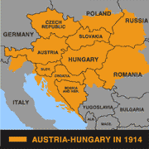
The assassination - the basics

1. Sarajevo was in Bosnia, the province that - to Serbia's anger - had been annexed by Austria-Hungary in 1908.

2. Archduke Franz Ferdinand was heir to the throne of Austria-Hungary. He was inspecting the army in Sarajevo with his wife Sophie. The royal couple arrived by train at 9.28am.


3. Seven young Bosnian Serbs planned to assassinate Franz Ferdinand as he drove along the main road in Sarajevo, the Appel Quay.

4. The first conspirator, Ned Cabrinovic, tried to kill Franz Ferdinand by throwing a bomb at his car. He missed and was arrested.
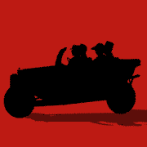
5. The Archduke escaped unhurt. He decided to abandon the parade and visit those injured in the bomb incident in the local hospital.

6. No one had told the driver the route had changed. On the way back, therefore, the driver turned into Franz Josef Street, following the published route and, when told of his error, stopped the car to turn around.
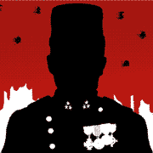
7. Unfortunately, the car stopped in front of Gavrilo Princip, one of the conspirators, who was on his way home thinking he had failed.
8. Princip pulled out a gun and shot at Franz Ferdinand, hitting him in the jugular vein. There was a tussle, during which Princip shot and killed Sophie. By 11.30am, Franz Ferdinand had bled to death.

Here are some extra facts about the assassination:
- Franz Ferdinand was inspecting the army in Sarajevo with his wife Sophie and it was their wedding anniversary. The Austrian Emperor Franz Josef had forbidden him to be seen in public with her on other state occasions because she was a commoner.
- That day - 28 June 1914 - was also Serbia's National Day. Franz Ferdinand's visit was a direct insult to the Serbs.
- The conspirators got their guns and bombs from the Black Hand, a Serb terrorist organisation.
- In Franz Josef Street, the car pulled up in front of Schiller's grocery store.
- After shooting Franz Ferdinand, Princip tried to shoot Potiorek, the Austrian governor of Sarajevo, who was sat in the front seat. However, during the tussle he shot and killed Sophie instead.
Look at the source below.
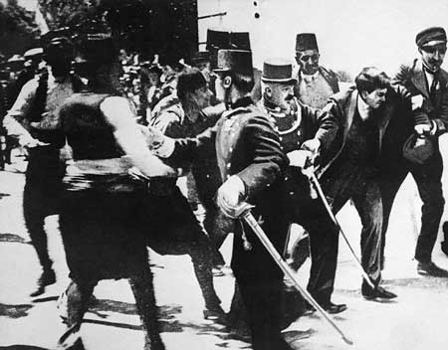
Historical sources can be misinterpreted
This photograph is an example of the problems of historical sources. It is often shown in books as showing the arrest of Princip, but it probably shows the arrest of Cabrinovic.

