**Worksheet 7**

**How does the One Child Policy Work?**

[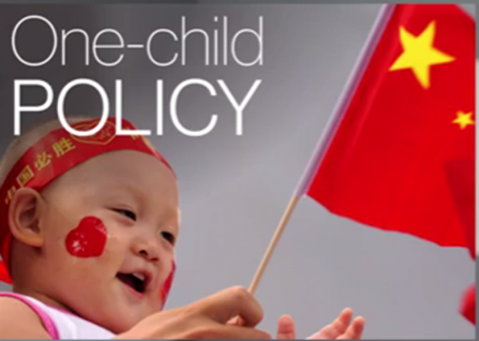](http://www.google.co.uk/url?sa=i&rct=j&q=&esrc=s&source=images&cd=&cad=rja&uact=8&ved=0ahUKEwjmutDqhN3RAhVB1BoKHeQFCPgQjRwIBw&url=http://legalinsurrection.com/2015/11/one-child-policy-hits-china-hard/&psig=AFQjCNH5f1-fIli5sgBimcmgpN-KkuVR3w&ust=1485424806343307)According to the policy couples were allowed to have one child. If that child turned out be a girl, they were allowed to have a second child. After the second child, they were not allowed to have any more children. In some places however, couples were only allowed to have one child regardless of whether it is a boy or a girl. This policy is still in effect today and it is therefore unusual for a Chinese family to have two sons. The policy works by using a ‘carrot’ and a ‘stick’ approach – rewards and punishments

Rewards for following the one child policy

Parents who have only one child get a “one-child glory certificate,” which entitles them to benefits such as:

* An extra month’s salary every year until the child is 14.
* Higher wages
* Interest-free loans
* Retirement funds
* Cheap fertilizer,
* Better housing
* Better health care
* Enrolment for children in better schools.
* Extended maternity leave for women who get pregnant at 25+ years old.

Punishments are there for breaking the one-child policy?

The one-child program is meant to be voluntary, but the government imposes punishments and heavy fines on people who don’t follow the rules.

* Fines range from $370 to $12,800 (the average salary in China in 2010 is roughly $3,500).
* If fines are not paid sometimes the couples’ land is taken away
* Their house can be destroyed
* They may lose their jobs
* Their additional child/children may not be allowed to attend school.
* Children born without a permit may not receive a name, passport.

[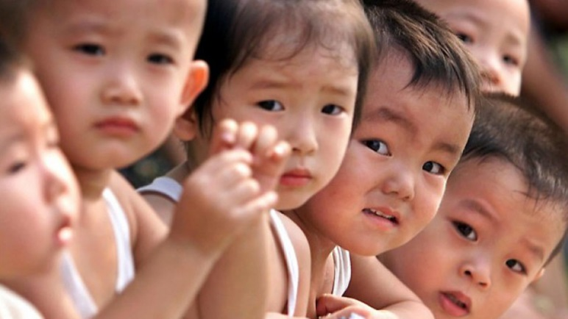](https://www.google.co.uk/url?sa=i&rct=j&q=&esrc=s&source=images&cd=&cad=rja&uact=8&ved=0ahUKEwi1iquOhd3RAhWJtBoKHbV3D4sQjRwIBw&url=https://www.youtube.com/watch?v%3Dh0l0j5e6RGI&psig=AFQjCNH5f1-fIli5sgBimcmgpN-KkuVR3w&ust=1485424806343307)Sometimes the punishments are more extreme. Women who have become pregnant with a second or even third child in some regions have reportedly been:

* Fired from their jobs.
* Forced to undergo abortions.
* Sent to a psychiatric hospital and was still in a labor camp the early 2000s.
* Tortured.
* Forced to have sterilizations (an operation to remove their wombs to stop being able to have children).
* Made to pay fines with grain if they have no money.

**How successful has the one child policy been?**

The one-child policy has been spectacularly successful in reducing population growth, particularly in the cities (reliable figures are harder to come by in the countryside) but there have been other benefits:

* In 1970 the average woman in China had almost six children, now she has about two.
* The one-child policy is estimated to have prevented 300 million births (the equivalent of the population of the USA).
* A smaller population (than what it would have been) has helped China and its people get wealthy.
* A wealthier country has also reduced people wanting children- it costs too much to have kids in some parts of China.
* Women’s position in Chinese society has improved – they work more, earn more and are now more likely to be promoted
* Children in China have a better quality of life – no siblings means more money is spent on them.