**Why is Falun Gong Banned?**

**19 August 2008**

*Leeshai Lemish looks at the history and causes of the Chinese Communist Party’s campaign against Falun Gong.*

If Falun Gong is benign, why is the Chinese government afraid of it?’ After nine years of persecution this basic question remains common. I’ll try answering it here.

In the 80s, Chinese parks brimmed at dawn with some 200 million people performing slow-movement exercises known as qigong. In 1992 Master Li Hongzhi introduced Falun Gong, outwardly a qigong practice like any other. But Master Li uniquely placed emphasis not on healing or supernormal abilities, but on self-cultivation towards spiritual perfection.

Falun Gong became an almost instant hit. Master Li travelled through China introducing the practice and its principles. Word of Falun Gong spread quickly, and it could soon be found in thousands of parks. The Chinese embassy in Paris invited Master Li to teach in their auditorium, and an official study found that Falun Gong saved the country millions in health costs.

Fast-forward to July 1999 and suddenly Falun Gong is public enemy number one. Practitioners are sentenced to ‘reform through labour’ camps where they are starved, beaten, and tortured with electric batons. By 2008, there are over 3,000 documented cases of practitioners killed by state persecution. Increasingly solid evidence suggests many more have been targeted as unwilling donors of kidneys, livers, and hearts. How many more, we have no idea.

*Why, then, this bizarre persecution?[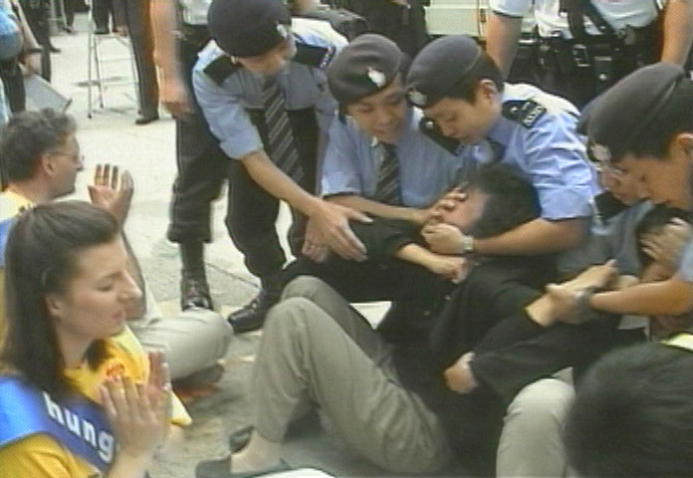](http://www.google.com/url?sa=i&rct=j&q=&esrc=s&source=images&cd=&cad=rja&uact=8&ved=0ahUKEwiO8tu70ePXAhVRa1AKHazvBYEQjRwIBw&url=http://www.upholdjustice.org/node/82&psig=AOvVaw2XlyYyTfdTkzLwc56v7hmX&ust=1512039601568359)*

**Weak explanations**

Facing international criticism and domestic sympathy for Falun Gong, the ruling Chinese Communist Party scrambled to rationalise its campaign. It has claimed Falun Gong is a menace to society - a superstitious, foreign-driven, tightly organised, dangerous group of meditators. State-run media tell gruesome stories of mutilation and suicide, but outsiders aren’t allowed to examine them. When investigators somehow manage to scrutinize such cases, they find stories of individuals who don’t exist and crimes committed by people who have nothing to do with Falun Gong. Human Rights Watch simply calls the official claims ‘bogus’.

Some Western academics have suggested Party leaders feared Falun Gong because it reminded them of past religions-turned-rebellions. But the broad-brush parallels ignored how bloody those groups were – the often-referenced Taiping, for example, was responsible for 20 million deaths. Falun Gong has been strictly non-violent and had no rebellious plans.

One final flawed explanation is that the April 25, 1999 gathering of 10,000 Falun Gong practitioners in the political heart of Beijing startled Party leaders and triggered the oppression that followed.

But the peaceful demonstration actually came after three years of escalating state oppression already taking place. In fact, it was a direct response to practitioners being arrested and beaten in nearby Tianjin and a smear media campaign against them.

**The individual leader explanation**

The incident was pivotal, but for different reasons. That April day, Premier Zhu Rongji engaged members of the gathered group and listened to their grievances. Those arrested were released. Practitioners who were there told me they had felt elated about the open communication between the government and its people.

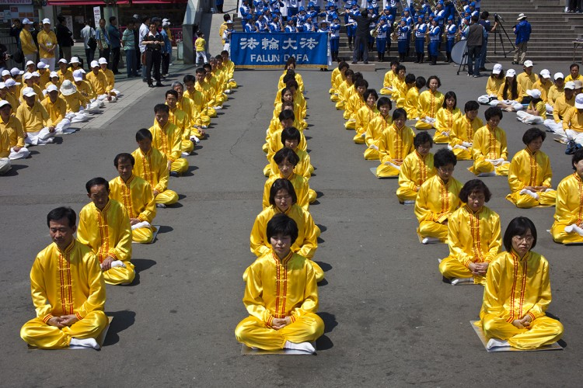But that night, then Chairman Jiang Zemin rebuffed Zhu’s conciliatory stance. He labelled Falun Gong a threat to the Party and said it would be an international loss of face if Falun Gong were not immediately crushed. Indeed, many experts attribute the campaign to Jiang’s obsession with Falun Gong as much as any other factor.

**The popularity explanation**

What appears to have scared Jiang and other Party hardliners (some who are still in top posts, maintaining the campaign) was how popular and cross-social strata Falun Gong had become. In northern cities, workers practiced Falun Gong together in factory yards before heading to the machines. Professors and students meditated on Tsinghua University lawns. Party leaders’ wives and senior cadres had their own little group in central Beijing.

This fear of Falun Gong’s popularity explains why its main text, Zhuan Falun, was banned from publication weeks after becoming a bestseller in 1996. And why, when a government report estimated there were more Falun Gong practitioners (70 million plus) than Party members, security agents began interrupting exercise sessions.

**The predatory Party-state explanation**

For decades the Party has persecuted different groups – intellectuals, artists, clergy, conservatives, reformists – through political movements. Some are targeted because they are outside Party control or have their own ideology. Falun Gong, with its spiritual teachings, sense of community, and independent network falls into that category.

Others are targeted when Party leaders manoeuvre to align power to themselves. Falun Gong appears to be a victim of that, too, as the persecution provided an excuse for strengthening state security apparatuses. It gave the Party an opportunity to oil its machinery - from Cultural Revolution-style purges to Internet surveillance systems.

As torture survivor Zhao Ming told me in Dublin, ‘the Party’s machinery of persecution was there - Jiang pushed the button’.