[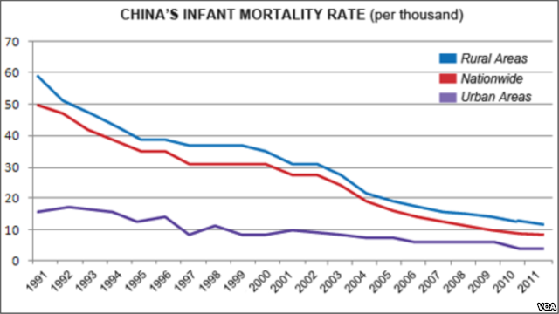](http://gdb.voanews.com/AD7C365C-4AFA-4A32-8A18-C6DD3E8E79CD_mw1024_s_n.png)

Using the information above, give one conclusion about each of the following:

* The change of infant mortality rates over time
* The gap between urban and rural areas

Your answer must be based only on the information above