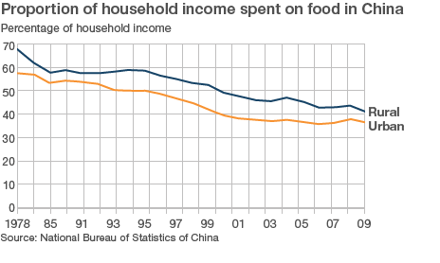

Using the information above, give **one** conclusion about **each** of the following

* The change in the % of income spent on food in China over time
* The gap between Urban and Rural spending