**Has Chinas Economic Growth Benefited Everyone?**

**Who are the Mingong?**

China’s booming economic growth in the major cities has created a demand for cheap migrant labour from the countryside. These migrant workers (people who move to find work) are known as the Mingong. The flow of people into the cities has been described as the biggest movement of human population since the world began. The ‘floating population’ of China is estimated to be at least 100 million people.

**What do the Mingong do?**

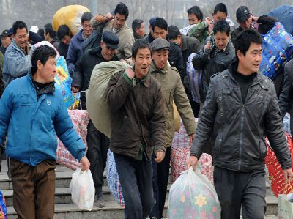The Mingong provide the cheap labour that allows China to produce many of the items that it sells to the rest for the world. The country is sometimes called ‘the Workshop of the World’. China makes 66% of the world’s microwave ovens, 50% of our clothes, 50% of the world’s cameras, 30% of our computers and 25% of our washing machines.

In China, those connected to the CPC get rich, while the Mingong work for little money, often in the most dangerous conditions. They are hidden from view and kept away from the world’s TV cameras and reporters. Some agricultural workers are paid only 60 pence an hour. At the same time, China’s rich can afford to pay the annual fee to play at the world’s largest golf club – Mission Hills, in Hong Kong. Membership cost between 428,000 Yuan to 1.68 million Yuan (£42,000 to £167,000).

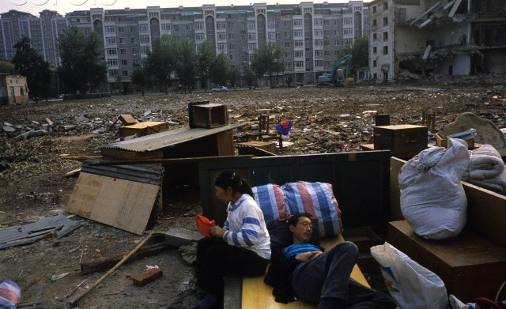

**Chongqing City**

Chongqing is the fasted-growing city in the world, with 31 million people living in its greater area and 1 million more arriving every year. The average annual income is around £3,000. A migrant worker will be lucky to earn one fifth of this. However, in the countryside there is mass unemployment and those who do work earn tiny amounts of money. In China the gap between the rich and the poor is growing and is one of the largest in the World.

**What is the Bang Bang Army?**

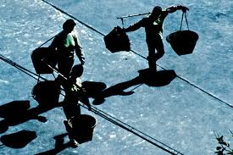The city of Chongqing is built on steep hills in Western China. Any visitor arriving in Chongqing is immediately struck by the large numbers of men carrying heavy loads on their bamboo poles (bang bang). This group of 100,000 hard-working men is known locally as the Bang Bang Army.

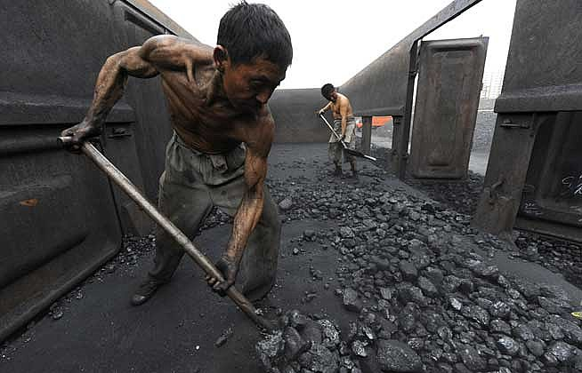Made up of peasant farmers flocking to the city in their thousands, the men are willing to do anything to make a living. Many of them have left their families at home because they cannot afford to feed them or send them to school. The Bang Bang Army work long days and carry heavy loads around the streets of Chongqing for very little money. An average day’s work would pay approximately 20 Yuan (£1.90).

***Answer the questions below in your jotters***

1. **Why could China be described as the ‘*Workshop of the World’*?**
2. **Have the ‘*Mingong’* benefited from China’s economic boom? Provide evidence to support your view?**
3. **Imagine life in Chongqing, the fastest growing city in the world. Write three words in your jotter to describe the sounds, smells and look of the expanding city.**
4. **How big is the ‘*Bang Bang Army’*?**
5. **Why are the ‘*Mingong’* and ‘*Bang Bang Army’* desperate to work despite the dangerous conditions and low pay?**
6. **Why do you think there are no ‘*Bang Bang Army’* men in Scotland?**