**Mao’s teachings**

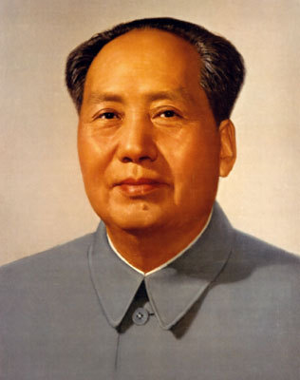Throughout time, the majority of the people of China have experienced much poverty. The wealth of the country was held by a small group known as the **bourgeoisie** or middle class. Eventually, the **peasants** and **workers**, who made up the majority of the population, stood up to the bourgeoisie. They tried to force the bourgeoisie to share the money and property they had with poorer groups in the country.

As expected, the bourgeoisie fought long and hard to stop the poor peasants and workers from taking their fortunes. However, the peasants and workers were too powerful and eventually took control of China. As their new leader, Mao promised that everyone would now be equal: poverty would no longer be a

problem.

Mao Zedong

After so many years of unfair rule by emperors and the middle class, the Chinese people were excited by Mao’s ‘ideas’. These ‘ideas’ or ‘teachings’ can also be known as an **ideology**. The ideology that Mao used was called **Communism**.

**The People’s Republic of China**

Mao Zedong lead the revolution in China. This revolution resulted in the People’s Republic of China being set up in October 1949.

**A revolution is when a strong group of people who are unhappy with the way the government has been treating them takes control of the running of that country.**

Mao Zedong (meaning ‘to shine on the east’) was born on 26 December 1893 in the Hunan province. Mao had always been involved with revolutionary groups and so it was not surprising that he was one of the main founders of the most important political organisation in China: The Communist Party of China (CPC).

The CPC was founded in 1921 and has remained in control of China since the 1949 October revolution. As the leader, or General Secretary, of the party,

CHINA UNDER MAO

Mao was a strong and feared leader as he was both leader of the C.P.C. (Communist Party of China) and President of China. The people of China called him ‘Chairman Mao’. Several key events took place under his leadership which give an idea of how he ruled:

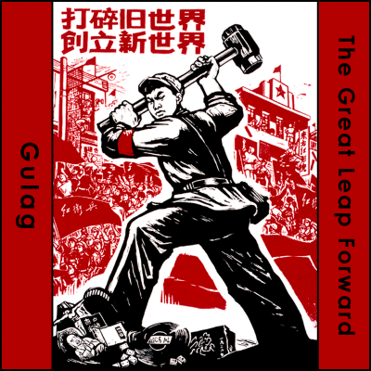

The Great Leap Forward 1958-1960

Mao proposed that China should make a "great leap forward" to modernise China and catch up with richer industrialised nations like Britain and America.

He began a Five Year Plan to improve technology and farming in China. Overnight, fertile rice fields were ploughed over, and factories began to be built. 23,500 communes (communities in charge of their own food and factories) were created. But ex-farmers had no idea how to use factories and land, once used for farming and producing food, went to waste. The Great Leap Forward was held responsible for famine in 1960 and 1961. An estimated Twenty million people starved to death.

The Cultural Revolution 1966-1976

The Cultural Revolution was a ten-year campaign by Mao, his wife and their supporters against their enemies within the CPC. Millions were forced into labour camps, and tens of thousands were executed. The result was massive civil unrest, and the army was sent in to restore order. The Cultural Revolution ended with Mao’s death and the arrest of the [Gang of Four](http://news.bbc.co.uk/hi/english/static/special_report/1999/09/99/china_50/gang.htm), the Four main leaders of the Communist Party during the Cultural Revolution (pictured below). Jiang Qing and Zhang Chunqiao received death sentences that were later commuted to life imprisonment, while Wang Hongwen and Yao Wenyuan were given life and twenty years in prison, respectively. They were all later released.

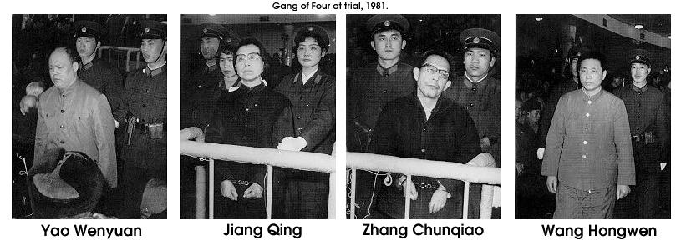

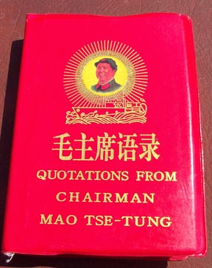Mao’s *Little Red Book*

From May 1966, student members of the Communist Party were encouraged to carry copies of [Mao's](http://news.bbc.co.uk/hi/english/static/special_report/1999/09/99/china_50/mao.htm) Little Red Book of quotations. These youngsters became known as the ["Red Guards"](http://news.bbc.co.uk/hi/english/static/special_report/1999/09/99/china_50/red_guard.htm). They used his quotations and ideas to attack intellectuals whose views differed from Mao’s. Over 1 billion copies of Mao’s Little Red Book have been published, making it the best read book next to the bible.

|  |  |
| --- | --- |
| **Mao’s achievements**   * Pride was restored amongst the Chinese people. * Better educational facilities. * Better health services. * A strong army developed. * Removal of political enemies within the CPC. | **Mao’s mistakes**   * Not enough food produced. * Millions dying of starvation. * People forced to leave university and follow Mao. * Thousands tortured for not believing in Communism. |