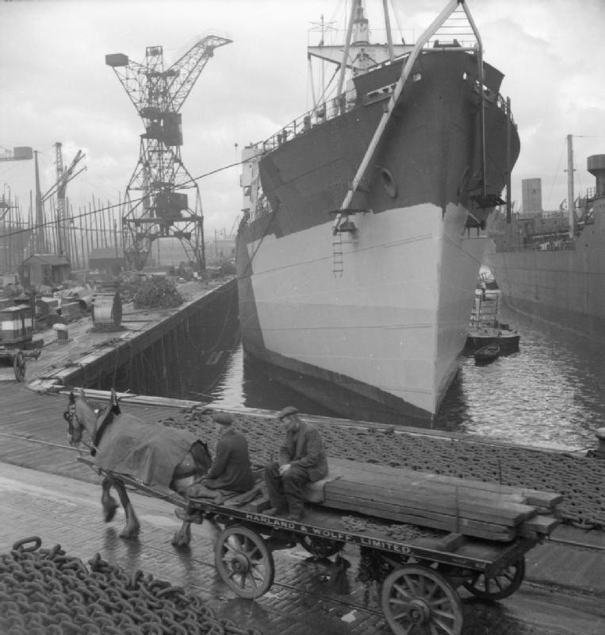**Life in 1920s Scotland**

**Industry**

The war had greatly benefitted Scottish industries between 1914-18 as orders for warships, steel, coal and textiles flooded in. However when the war ended, so did the orders. Heavy Industries in Scotland went into decline, leading to widespread unemployment and reduced working hours.

The fishing industry in Scotland never recovered from the war when the North Sea was taken over by the Navy in case of a German attack. The fishing industry also lost overseas markets in Germany and Russia

The traditional Scottish industries were damaged but new ‘light industries’ replaced them. People gained employment in offices, banks and typists. Factories opened up making new ‘consumer goods’ like radios and clocks. These jobs tended to suit women better, so many women became the breadwinner for the first time.

**Unemployment**

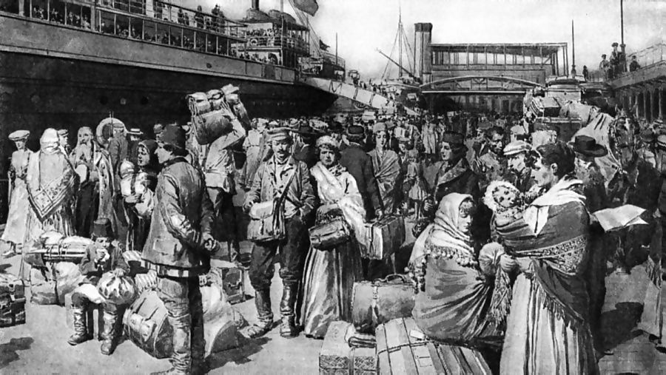Soldiers returned from war in 1918 expecting a Hero’s welcome but this was not the case. Unemployment was high as industry was in decline. Many soldiers found themselves put out of a job because the war was over. There were many protests against the government after the war as men felt they were not providing jobs for the people. The ‘Battle of George Square’ happened in 1919 as men protested for better working conditions and the government sent in tanks and soldiers. Unemployment was at around 10%, higher than England. This led to many Scots emigrating abroad for better opportunities – mainly to Canada and the USA.

**Social Life**

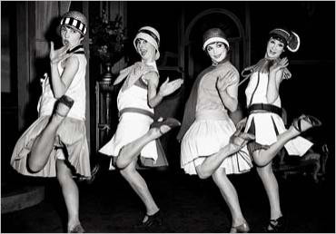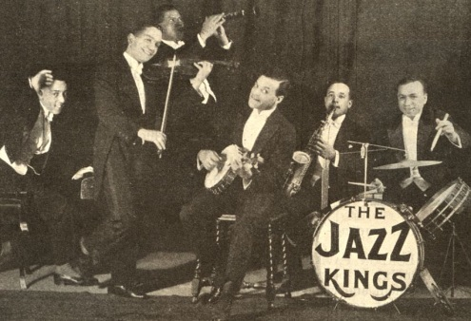Social Life had never been better in the 1920s, particularly for those who had money. The first nightclubs opened and young people flocked to them (many older people said they were for ‘degenerates’.) People drank cocktails for the first time. Music was heavily influenced by the Unites States – Jazz and Swing music. The Big technological advance was the ‘wireless radio’ and people tuned in across the country (if they had a radio) to stations to listen to Jazz bands. Dances like the Charleston were popular.

**Women**

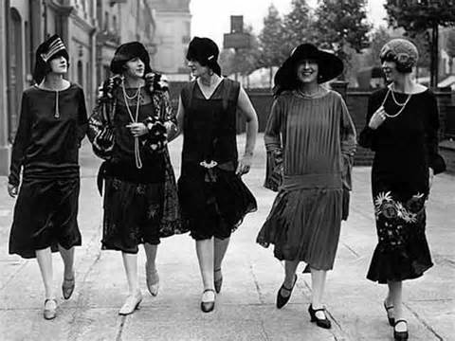Initially, women were sacked from their wartime jobs when the men returned. However, women were not willing to return to their pre-war lives. Many women found work in the new ‘light’ industries in the 20s, working as typists or answering telephones. Women had more independence and freedom and were less likely to do as their husbands said. Women started to wear more makeup, smoked cigarettes, drank alcohol, drove cars and go out without male chaperones. Women were having fewer children which perhaps gave them more freedom.

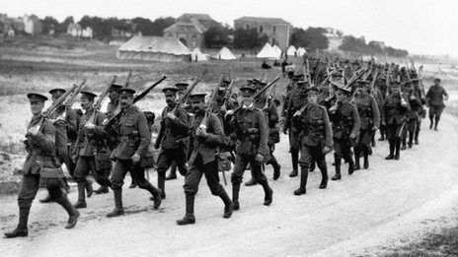**Homes for Heroes**

In 1919 The Addison Act promised to build ½ a million new council houses across the country. These were to be ‘Homes fit for Heroes’ – brand new houses with inside toilets, electricity and gardens for the men returning from war. However the government failed to deliver on this promise due to the economic difficulties of the 1920s. In reality only 200,000 new homes were built and most war heroes remained in poor houses or city slums.

**Other Important Developments**

* 1928 - Scotsman Alexander Fleming discovered penicillin – the first antibiotic, eradicating many killer illnesses like Tuberculosis
* 1926 - John Logie Baird, a Scottish engineer and inventor, gave a demonstration of a machine for the transmission of pictures, which he called 'television'
* 1927 – The BBC is created to ‘inform, educate and entertain’
* 1928 – The first ‘talkie’ – film with dialogue or talking is shown in British cinemas
* 1929 – The First British Labour government is elected with Scot James Ramsay McDonald as Prime Minister