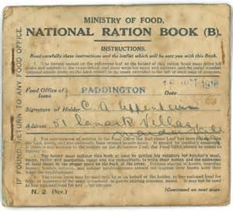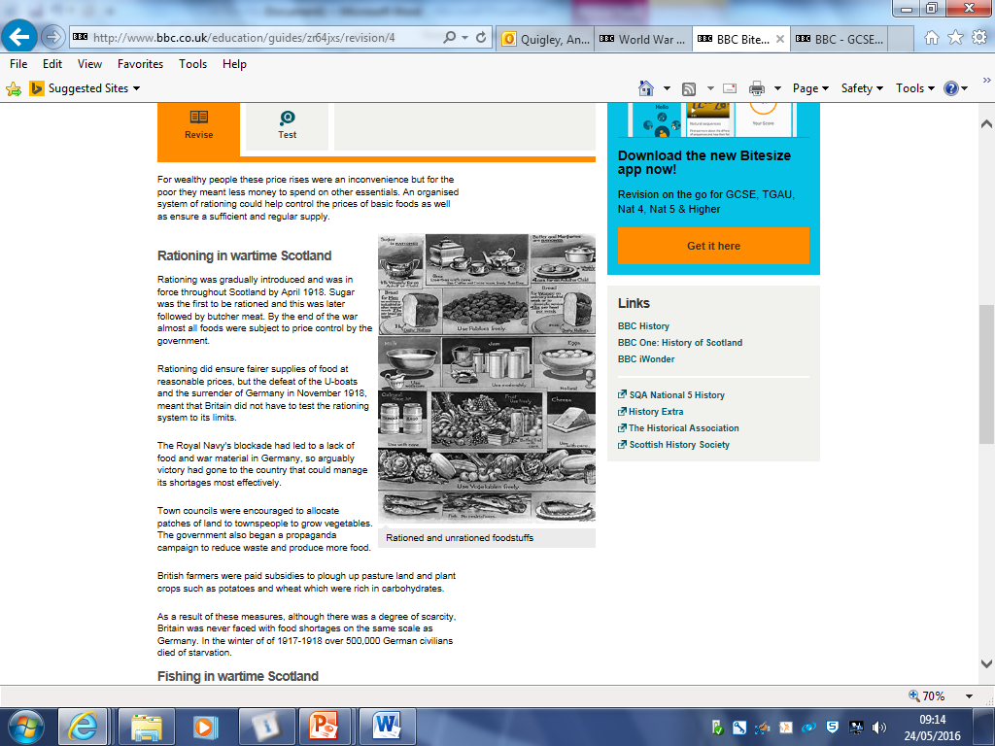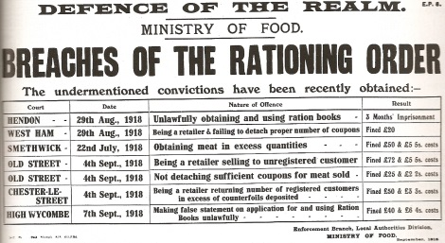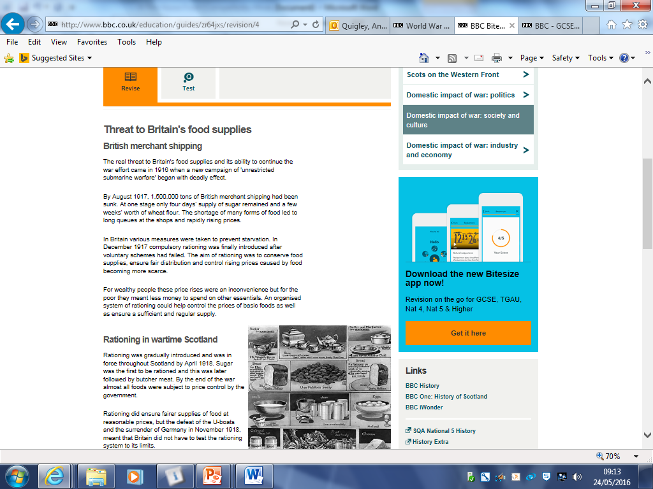Rationing

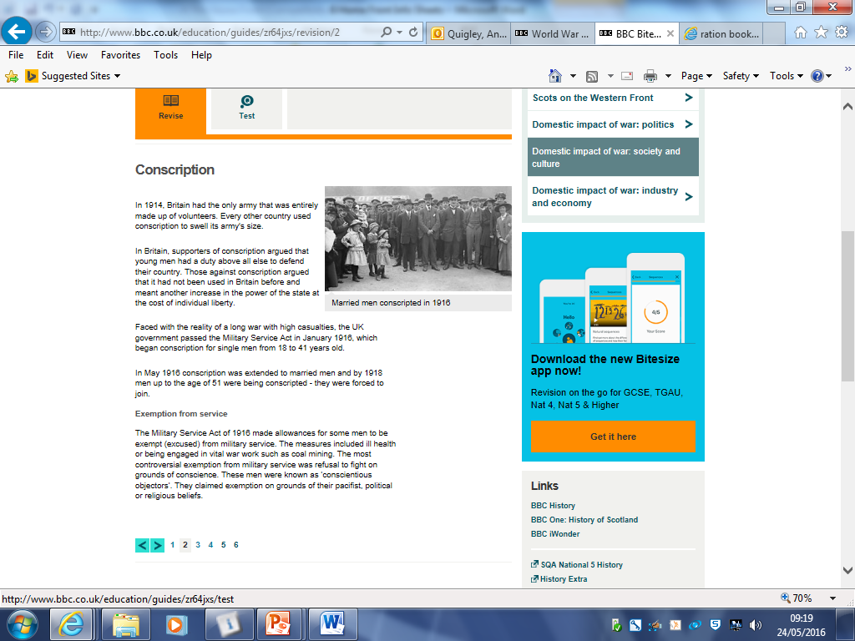Conscription

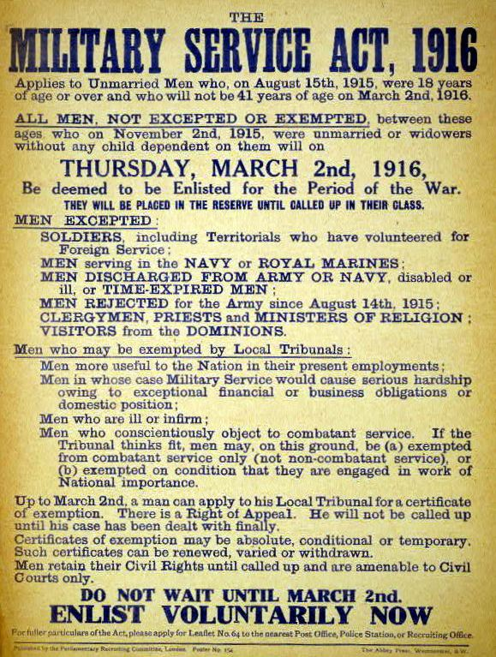

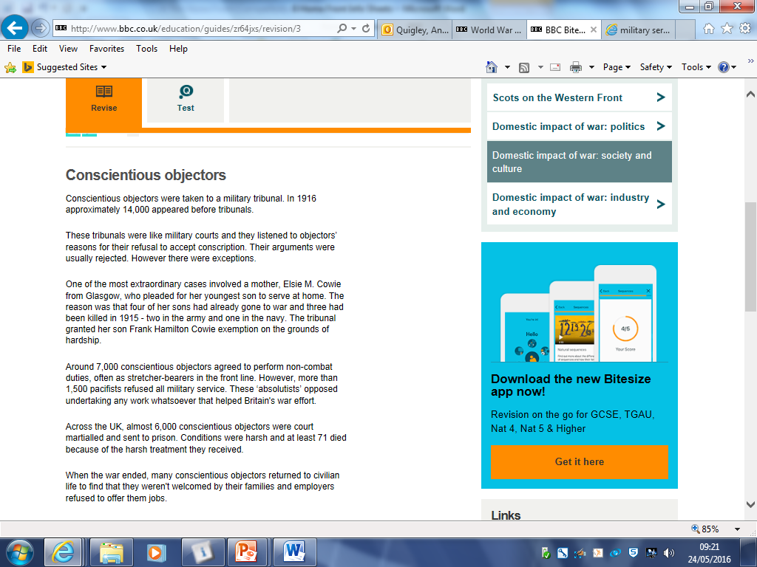Conscientious Objectors

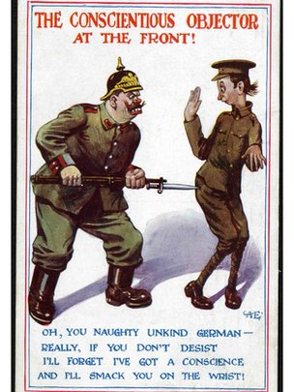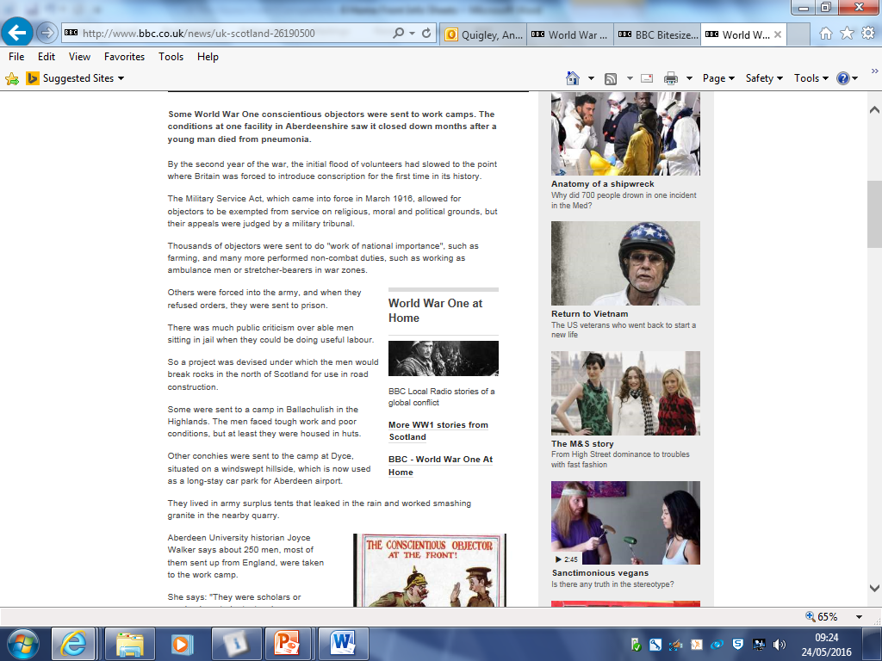

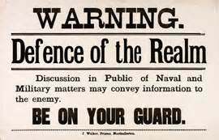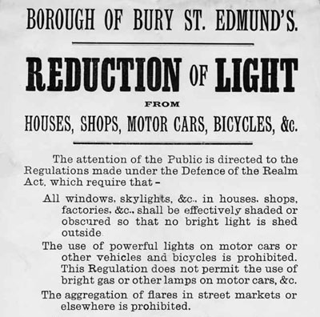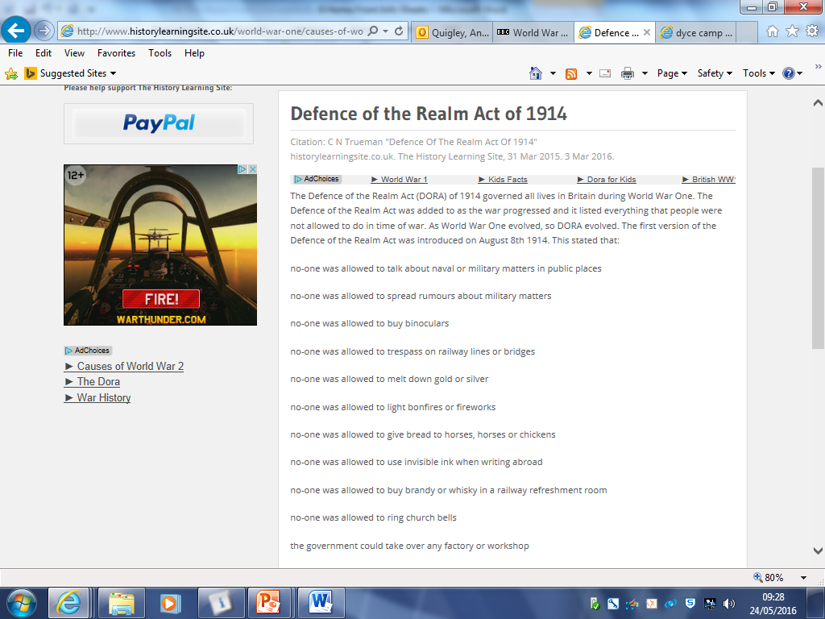DORA

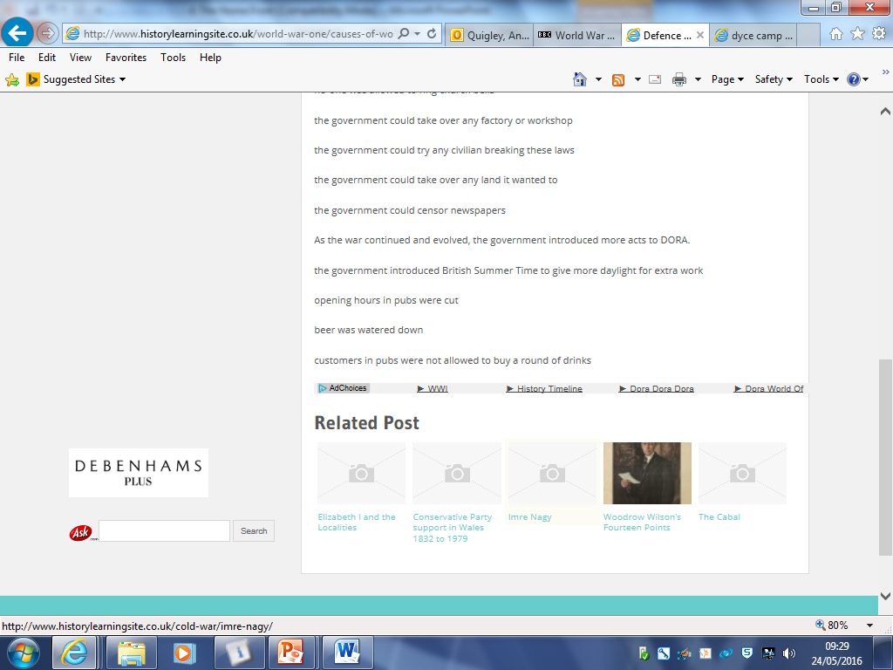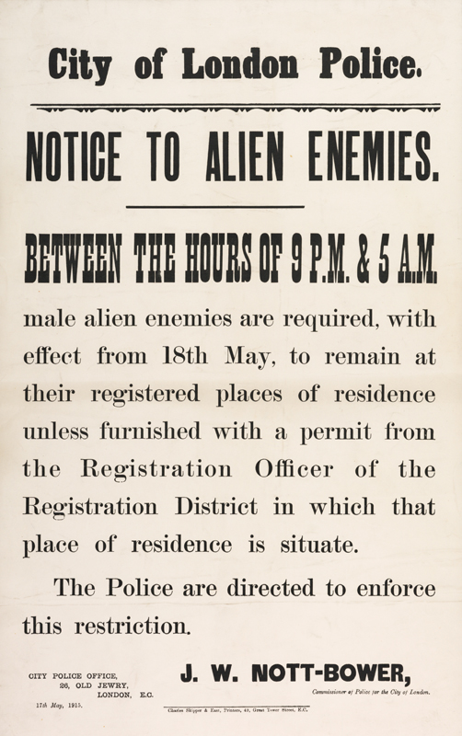

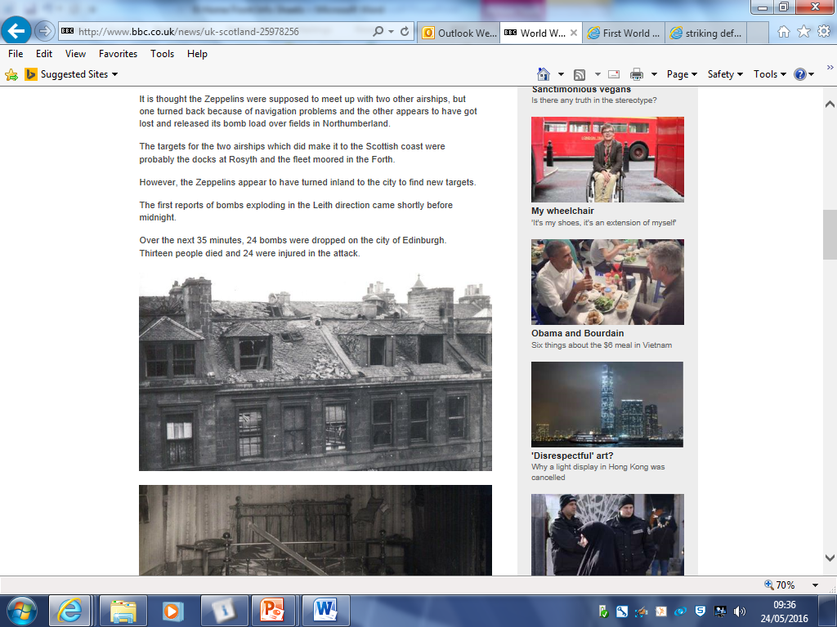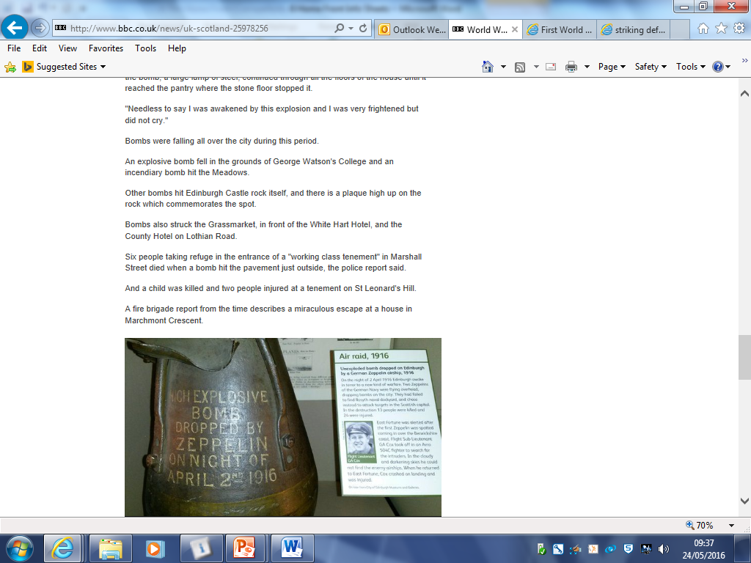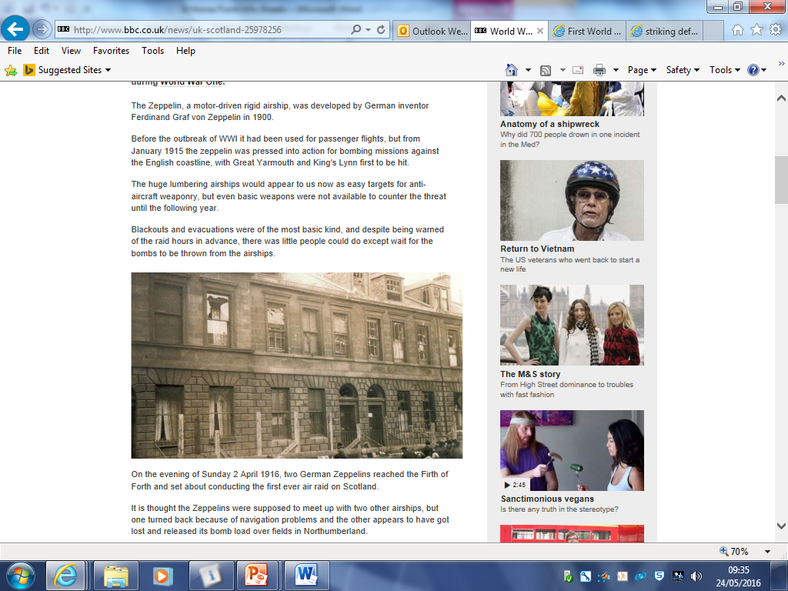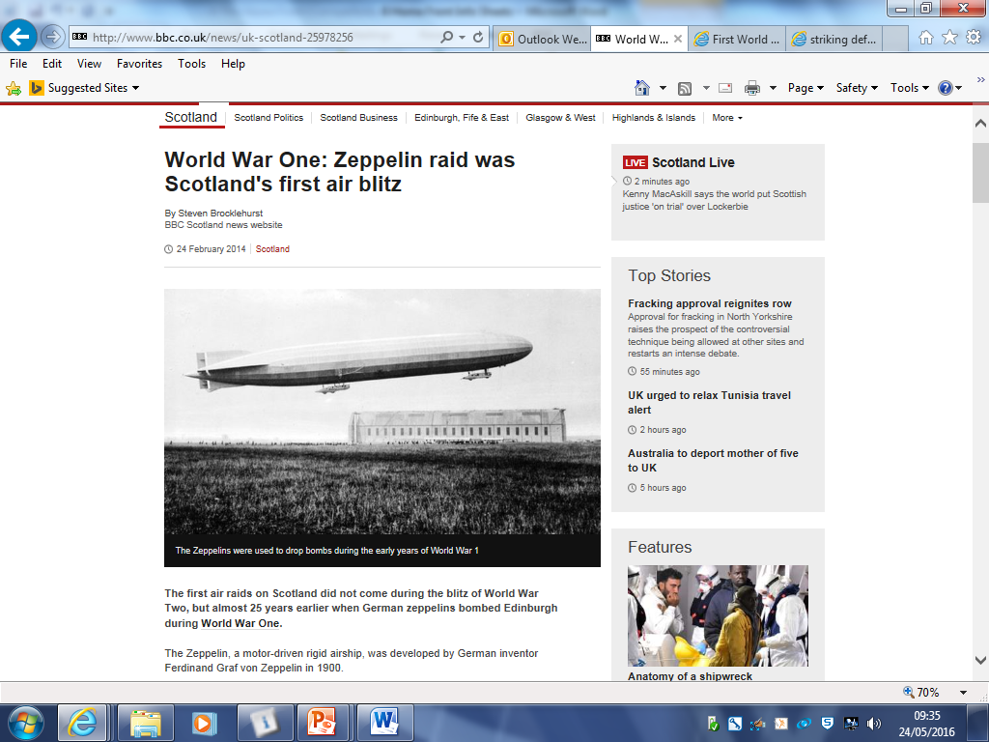Air Raids

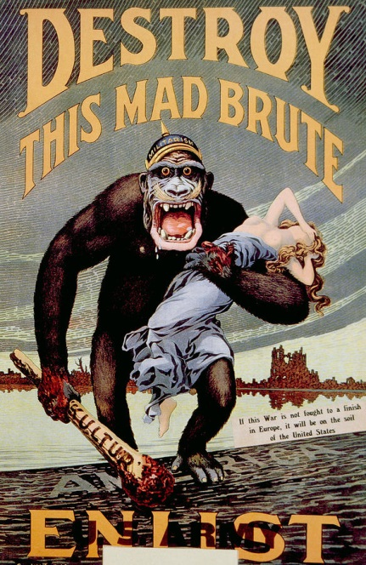Propaganda

Propaganda in the First World War wasn’t just about encouraging men to sign up to fight. Propaganda was aimed at civilians too and propaganda posters were seen as key to winning the war.

**Anti- German Propaganda**

The government produced posters encouraging British people to feel anger and resentment towards Germany and her allies, hoping this would encourage people to get behind the war effort. German soldiers were depicted as brutes and savages and many stories appeared in the press about apparent German atrocities in Belgium, where ‘the Hun’ had treated the defenceless Belgians appallingly.

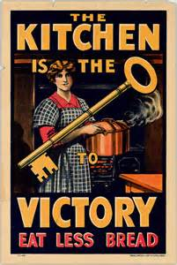

**Conserving food**

Since the introduction of rationing was a last resort, the government tried to encourage people to conserve or save food. People were encouraged to ‘eat less bread’, to have meatless days or to replace meat with fish or beans. Women were encouraged to adopt techniques like canning fruit, where it preserved fruit for longer or pickling vegetables to make them last longer.

Where possible, people were encouraged to plant or grow what they could in order to help the food shortages.

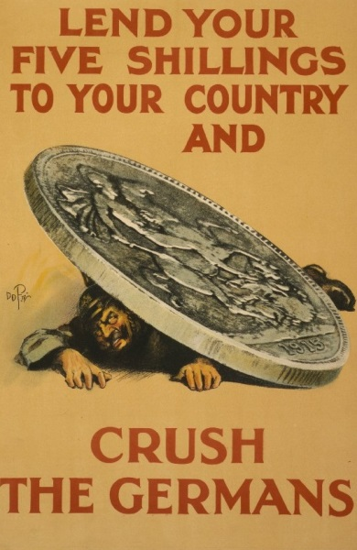

**War Loans**

Fighting was an expensive business and the government encouraged people to invest any money they had in war loans. This was effectively the government borrowing from citizens to fund the war effort and it would repaid in the 1920s/30s. People were encouraged to ‘invest if they couldn’t enlist’ and help the war effort in this way.

Censorship

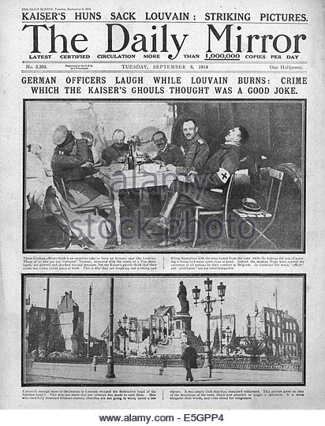Press censorship was part of the Defence of the Realm Act and the War Office controlled what could be printed in newspapers. Their job was to keep anything out of the newspapers which was unpatriotic or that could damage the spirits of British people. It also censored any reports containing military information so that it could not be intercepted by enemy spies.

Even the bloodiest defeat in British history, at the Somme in 1916 - in which Allied troop casualties numbered 600,000 - went largely unreported. The battle’s disastrous first day was reported as a victory. The headline read “We may say it is, on balance, a good day for England and France. It is a day of promise in this war.”

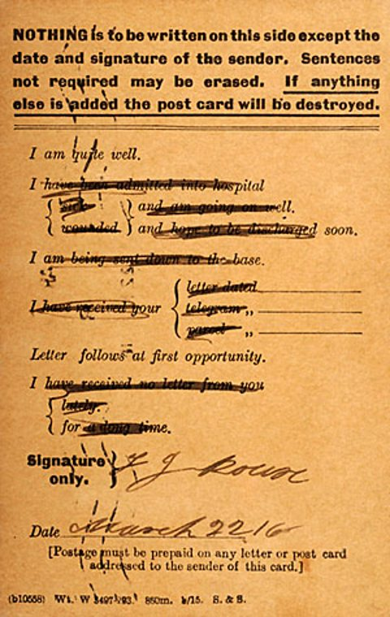Only later did the public learn of the high casualty toll and the horrific nature of trench warfare, such as the use of poison gas and the effects of shell shock. With these appalling conditions in mind, it was no wonder that Prime Minister Lloyd George confided privately in December 1917: “If people really knew [the truth], the war would be stopped tomorrow. But of course they don’t know, and can’t know.”

**Letters from the Front**

The delivery of post was vital for two reasons. Firstly, receiving well wishes and gifts from home was one of the few comforts a soldier had on the Western Front. The majority of them spent more time fighting boredom than they did the enemy, and writing was one of the few hobbies available to them. For some, it was a welcome distraction from the horrors of the trenches.

The British Army took a number of proactive measures to censor what information made it home from the trenches.Forbidden subjects were either ripped out of letters or simply scribbled out. In some cases the censored words remained readable.

**Field postcard**

One method of censorship was the field postcard. These printed cards gave soldiers a number of multiple choice options which they could cross out if they weren’t relevant. They were not allowed to write messages on them.