### Modernisations in Science

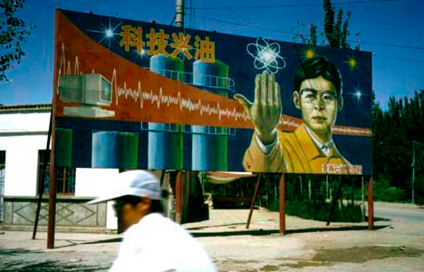Under Mao, the people and the government alike had hated scientists and intellectuals. **The Cultural Revolution** had seen students informing on their teachers for not being sufficiently supportive of communism, and had sent hundreds of thousands of academics into the fields (as farm hands) or seen them simply disappear.

The results of this were not seen immediately, but when Deng tried to lead China forward, this attitude had to change. For nearly a decade China had gone without training any new scientists or engineers, all research was done in tightly controlled state institutions.

**Deng set out to change this, introducing Science and Technology as a major national priority and not only encouraged Chinese universities to undertake research, but also encouraged them to partner with foreign organisations in an effort to improve research.** He also got help from the UN Development Programme to produce *advertising campaigns* designed to improve the reputation of science and technology.