**Modernisations in Defence**

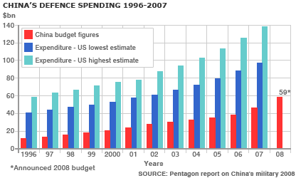Under Mao, the military had become a political force that had a huge amount of power. Deng wanted a more Western-style, modern army that served the government, rather than the other way around. Deng placed civilians in key leadership positions and changed the law so that the army had to report to Communist Party of China officials. Deng also sought to reduce the number of soldiers and increase the level of technology used. Between 1980 and 1987, Deng reduced the size of the **People’s Liberation Army** (PLA) from 4.5 million to 3 million, and massively improved soldier’s training. Investment in the defence industry also increased, and now China has one of the world’s most advanced militaries. This increase in spending has increased into the present day, although a US study suggests that China may actually be underreporting the amount of money they spend on armaments.