**Causes of War One: Alliances**

During the 19th & early 20th century there were Five ‘Great Powers’ in Europe; France, Germany, Austria, Russia and Great Britain. They all had large armed forces, economies and lots of resources.

They began to worry about their own safety and become suspicious of one another and for that reason, they formed formal friendships or alliances between 1987-1907. These alliances were usually the result of treaties or agreements where the countries involved agreed to go to war to protect the other.

These alliances resulted in Europe being divided into two camps or sides:

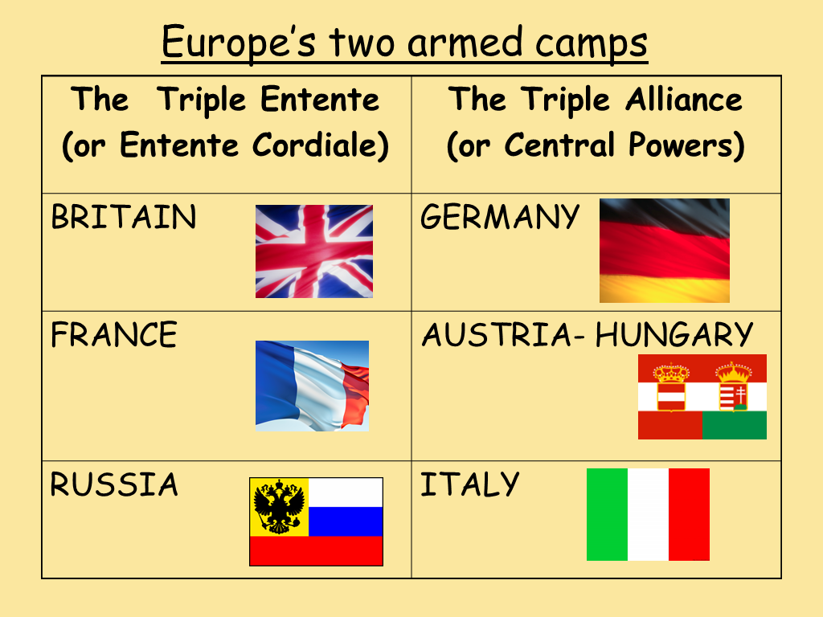

Although this made some countries feel safer, it actually created many problems.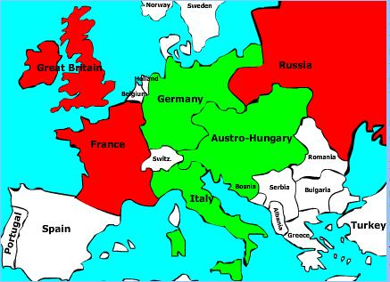

**Result:** The alliance system divided Europe into two armed camps. It meant that if any of the countries involved in alliances quarrelled, it would lead to a war involving all of the ‘Great Powers’.

The signing of alliances created a great deal of suspicion and paranoia between the Great Powers too. Britain for example, worried Germany was planning to attack them in the future– why else would they want to sign a military alliance.

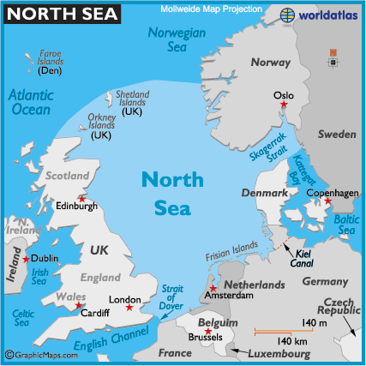**Cause of War Two: The Naval Race**

As an island, the most likely attack on Britain would come from the sea. For this reason, Britain had always had the largest and most powerful Navy in the world. The Royal Navy was the ‘jewel in the crown’ of the British armed forces.

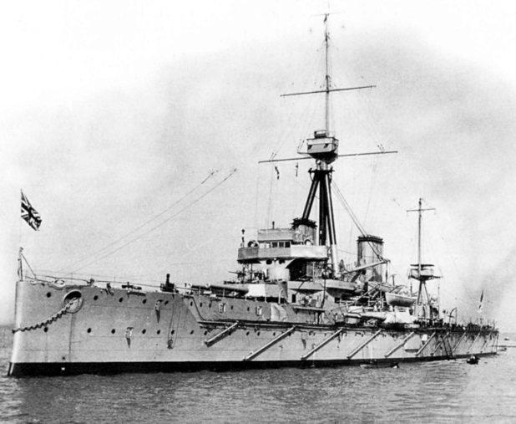Around 1900, Germany started to increase the size of their Navy. This worried Britain. Was Germany planning an attack on Britain? Germany also built the Kiel Canal in 1895, allowing German ships easy access to the North Sea.

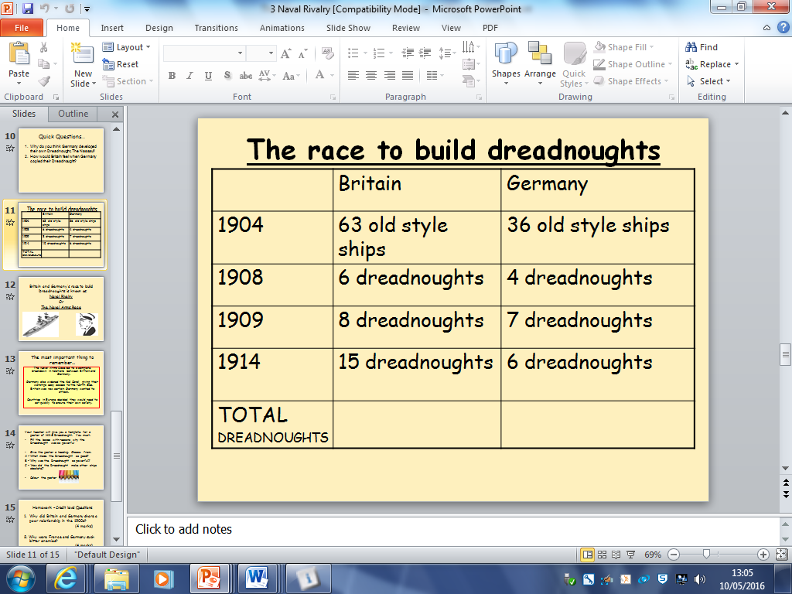To counter the German threat, Britain launched it’s biggest and most powerful battleship of all time in 1906, *The Dreadnought*. It made all previous ships obsolete, and Britain believed this won them the ‘Naval Race.

However, Germany copied the Dreadnought and the next few years saw Britain and Germany compete to build the most Dreadnoughts.

**Result:** Britain assumed that Germany was planning to attack due to the Naval Race. This created much distrust and suspicion between the British King and German Kaiser. The more warships and arms each country had, the more likely they would go to war to use them.

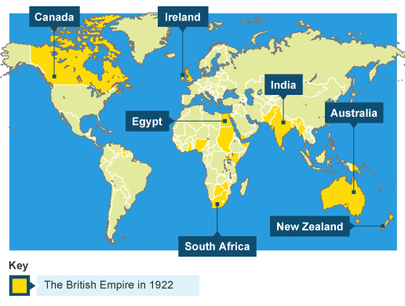**Cause of War Three: The Race for an Empire**

When Queen Victoria was in power 11837-1901, Britain’s Empire was it it’s biggest. This meant Britain ruled lots of other countries, known as colonies. The Empire covered around ¼ of the globe and included countries such as Australia, New Zealand, Canada and India. People said ‘the sun never sets on Britain’.

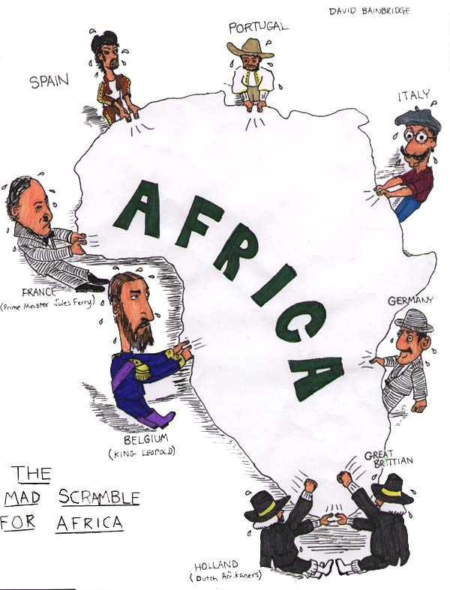These countries made Britain very rich and added to their armed forces, as the other countries would fight for Britain in the event of a war.

The building up of an Empire is known as imperialism. Germany saw what Britain had and wanted an Empire of it’s own. In the late 1800s there was a ‘scramble for Africa’ where European countries desperately grabbed African countries for their own, desperate for an Empire. In 1884 Germany acquired Togoland, the Cameroons and South West Africa (now Namibia). By 1990 a sizeable chunk of East Africa was under German control; this territory was renamed Tanganyika (now Tanzania). Britain felt Germany was trying to outdo their Empire.

**Result:** Britain was becoming increasingly worried about Germany’s determination to outdo Britain in terms of its Empire. Britain started to believe that Germany was planning to go to war with them.

The Scramble for Africa increased tension between all the European Leaders who were competing for an Empire. It led to many disagreements and diplomatic crises.

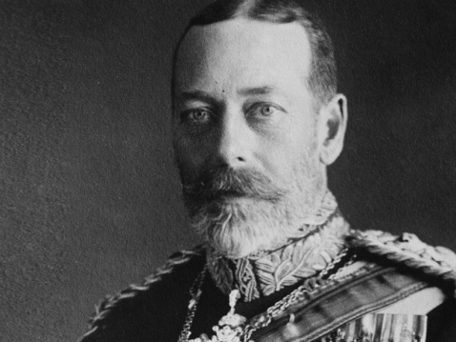**Cause of War Four: Leaders**

The British King in 1914 was King George V, the grandson of Queen Victoria & Albert.

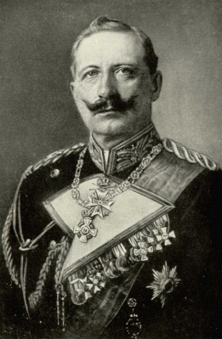The German Emperor, or Kaiser, was Wilhelm, also the grandson of Queen Victoria & Albert. He and King George were first cousins.

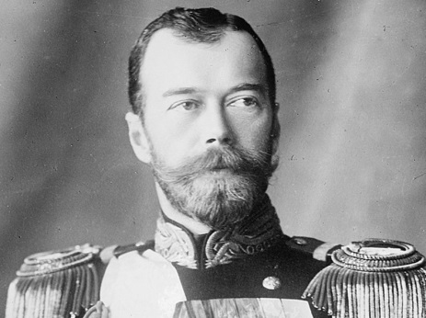The Russian Emperor, or Tsar, was Nicholas. His mother and King George’s mother were sisters, making him also King George’s First cousin.

So in theory, the leaders of Britain, Germany and Russia should have got on wonderfully – this was not the case!

Many historians have commented on the Kaiser’s personality as a reason for the outbreak of war. He built up the German armed forces and in particular, the Navy, moves which angered Britain and let to conflict between the countries. He led the expansion of the German Empire, causing much anger amongst European countries.

The Kaiser also got involved in a war against Britain, known as the Boer War, where the German forces supported the Boers.

Many historians have described Wilhelm as belligerent, meaning he went looking for a fight and did little to stop the war breaking out.

In fact in 1914, he encouraged Austria to go to war with Serbia which was the trigger point of WWI

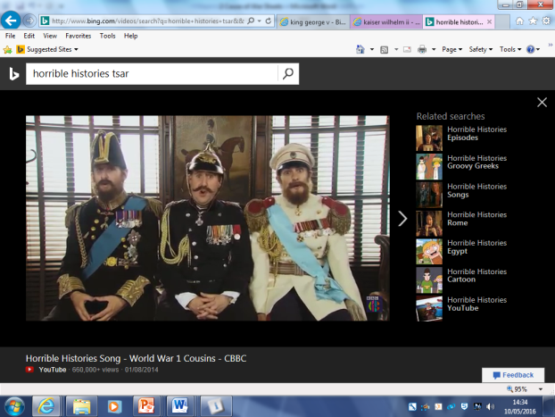**Result:** The Kaiser’s behaviour and the aggressive personalities & policies of many of the European leaders led to war. They competed against one another and did little to avoid war in 1914. The Kaiser particularly made diplomatic moves to deliberately anger Britain. Few of the leaders of the Great Powers cared for negotiation or settling arguments and instead saw war as a better way to settle disputes.

‘First World War Cousins’ on Horrible Histories