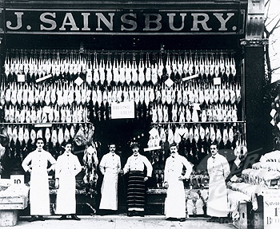
Kilmarnock General Store

Family income:
Family budget after paying rent:

- Coal (for fire/ cooking): 5p (bag)
- Bread: 2p (1 loaf)
- Tea : 5p (1 packet)
- Cheese: (small block) 3p
- Meat: (usually bacon/ sausages): 20p for a family portion
- Milk: 1p a pint

- Cereals e.g. barley, lentils, rice etc for soup, oatmeal for porridge: 2p a packet
- Sugar: 7p a packet
- Vegetables: 5p per bag
- Tobacco (packet 20) – 5p
- Alcohol – 2p a pint
- Soap: 5p per bar
- Potatoes: 3p per bag
- Fruit: 5p (per piece)
- Chocolate: 20p (per bar)
- Cakes: 5p each
- Butter: 2p a block
- Newspaper: 1p
- Whole Chicken: £1
Other costs:

Visit to Doctor: 5p
Prescription Charge: 5p
Dentist – tooth extraction
Music Hall 5p
Bus 1p return ticket
Child’s toy: 50p

