**Ebola crisis – the Guardian briefing**

Sarah Boseley Health editor Wednesday 14 October 2015

The Ebola outbreak has killed about 11,312 people in west Africa, and affected the US and Spain, where people returning from the region have died and transmitted the infection to several nurses. We examine the background to the disease, its spread and its impact

From the epidemic’s beginnings in southern Guinea in December 2013, Ebola spread with lethal effect across **Guinea, Liberia and Sierra Leone**. There were also cases in Nigeria, Senegal and Mali.

Ebola outbreaks in the past have generally been in remote rural areas with swift action to isolate the victims managing to contain them. **The WHO was criticised for not reacting fast enough** to the latest outbreak: it took three months to diagnose the first cases and five months more before a public health emergency was declared.

Liberian nurses escort a suspected Ebola patient into a treatment centre in Monrovia. Photograph: Ahmed Jallanzo/EPA

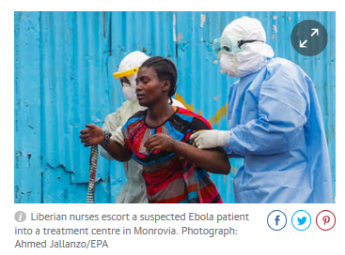An editorial for the New England Journal of Medicine by Jeremy Farrar, the director of the Wellcome Trust, and Peter Piot, the head of the London School of Hygiene and Tropical Medicine, said the exceptional spread of the disease was probably down to a number of factors including **dysfunctional health systems**, **high population mobility** across state borders, **densely populated capitals** and **lack of trust in authorities** after years of armed conflict meaning health advice is not heeded. Fear was also a factor. People were afraid to go to hospital because they thought it could be the source of infection.

**The issues**

**How the disease spreads**  
Ebola is not an airborne disease and can only be spread from human to human through close contact with the bodily fluids of someone who has the disease – in **blood, vomit, semen, urine, tears or saliva**. The incubation period – the gap between an individual being infected and showing symptoms – is up to 21 days, meaning it is possible for an infected person to travel widely before realising they have the disease. **Humans are not infectious until they develop symptoms**, which at first are fever, muscle pain, headaches and a sore throat. These are followed by **vomiting, diarrhoea, a rash, symptoms of impaired kidney and liver function** and in some cases internal and external bleeding.

**Death of health workers**  
The spread of Ebola through bodily fluids puts health workers dealing with such symptoms as vomiting, diarrhoea and bleeding at high risk. By 28 January, 818 health workers had developed the disease across Guinea, Liberia, Sierra Leone and Nigeria, with 488 dead. At the peak of the outbreak there was insufficient protective clothing for health workers. The suits are also uncomfortable to wear in hot climates and risk contamination when they are taken off. An inquiry by Save the Children into Pauline Cafferkey’s infection found it probably happened during the removal of her mask, which was of a different design to those of other volunteers. However, most health workers are infected in clinics treating patients they do not know or suspect have Ebola. **The first symptoms can resemble malaria**, which is common. Some healthcare workers have stayed away from work for fear of the disease, and in Liberia there have been strikes over pay and conditions.

**No drugs or vaccine**  
Until recently, pharmaceutical firms gave Ebola very low priority. Potential drugs and vaccines under development are now being sped into trials. Healthy volunteers in Europe, the US and unaffected African countries have been injected with candidate vaccines to test their safety.A vaccine has now been shown to be highly effective in Guinea, after being given to contacts of anybody newly infected. Drug trials were set up but the numbers infected dropped so rapidly that there were not enough participants to show an effect. Stocks of ZMapp, the experimental drug used to treat several international aid workers and medical staff, quickly ran out.

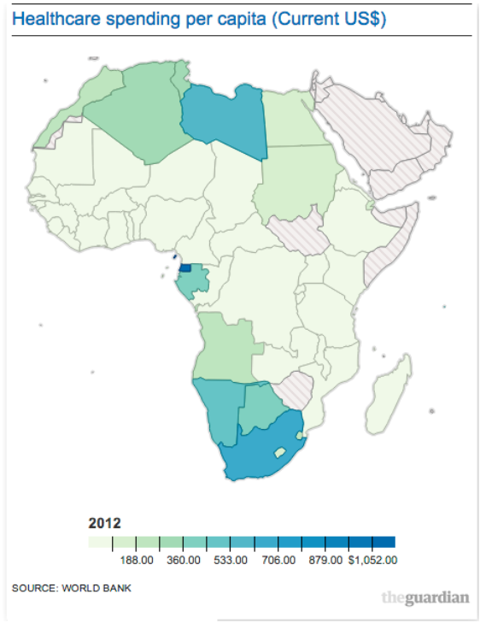**Healthcare system collapse**  
Healthcare in the region was fragile at best before Ebola. It further disintegrated as staff became ill or stayed away for fear of the disease. **Infection control and hygiene were major issues**. Soap and water were unavailable in some areas. Alcohol hand rubs were needed on a large scale. Isolation facilities are vital to contain Ebola, as are labs for testing because rapid diagnosis is very important. Both were in short supply. In some places, until western governments intervened and treatment centres were set up, isolation was nothing more than an area behind a curtain. People with other diseases and women in childbirth were at risk because hospitals are no longer functioning properly.

**Cultural issues**  
Levels of the virus in infected people are highest in the late stage of the disease and in dead bodies. The disease was often spread during traditional funeral practices that involve washing the corpse. Burial teams in protective clothing were dispatched to homes to collect and safely dispose of bodies. Another route of transmission has been **traditional healing practices**, which involve touching. Families are at high risk when they nurse their sick at home, as is traditionally the norm.

Persuading people to change their cultural practices has been hard. There is little respect for government authority in a region still emerging from civil war and where corruption is rife. Advice that runs counter to cultural practices is resented and in the absence of authority, myth and superstition take over.