Zimbabwe’s Smallholder Farmers: Small Grain Project

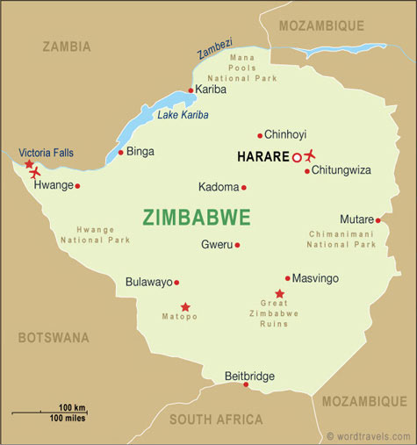
One of the FAO’s newest projects is the Small Grain Project in Zimbabwe.

Zimbabwe is an extremely dry country – it is prone to drought. Despite this, many farmers still attempt to grow crops, such as maize, which require lots of water to grow. When drought hits, the farmers suffer greatly.

They have low crop yields – meaning they have little to sell. This means they have very little money. This then leads to poverty and hunger. The FAO wants to stop this cycle from occurring and reoccurring in Zimbabwe.
In 2010, the Government of Zimbabwe turned to the FAO for assistance in helping farmers in the country's three driest areas as they were struggling from the country’s recent drought.
The FAO’s Small Grain Project aims to focus the farmers on producing small grains such as sorghum and millet. Both are traditionally important crops that can be grown with less water resources - and both are more nutritious than maize. Despite this, farmers in Zimbabwe are reluctant to grow grains such as millet. This is because of the higher cost of seeds, the lower popularity of the grain at market and the labour intensive process required in order to harvest the grains.
Since September 2010, the Small Grain Project has had a great effect in Zimbabwe. It has focused on making sure farmers had a reliable source of high-yielding, improved sorghum and millet seed varieties which are cheaper to buy. The project also trained several farmers as well as government officials in how to properly plant, grow and harvest the grain.
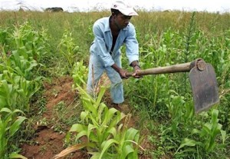
Thanks to demonstration plots, exchange visits and field days, farmers could see first-hand the advantages of using the improved varieties of seed and new technologies introduced by the project, and also discuss and compare different crop management practices.
One such field day drew more than 250 people, including senior community members and councilors. One woman explained that she was encouraging more farmers in her district to give small grains a go, especially as the improved varieties mature early. "I have already harvested enough sorghum and pearl millet crops to feed my family up to the next season and with surplus to sell," she said.
Overall, the project has been deemed a major success. Small grains have excellent potential not only to improve the diet and income of farmers in Zimbabwe's marginal areas, but also national food security.
The FAO project helped lay the groundwork for sustainable small grain production and get more farmers on board, even those outside the project area.

Questions
- What problems do the farmers in Zimbabwe face?
- Why has the FAO stepped in to help? (Think about the FAO’s three main aims)
- Why were the Zimbabwean farmers reluctant to grow grains such as millet?
- What are the aims of the Small Grain Project?
- Who has participated in the project activities? (Hint: not just the farmers)
- Do you think the Small Grain Project has been successful? Explain your answer using examples.

Now go onto the Extension Activity. Complete this for Homework
Extension
Look back over your Millennium Development Goals (MDGs). Answer the following questions using the information in this case study and your notes on the MDGs.
- What MDGs is the Small Grain Project helping to meet?
- Do you think UN Specialised Agencies are important if the MDG’s are to be met?
- Why are so many of the Millennium Development Goals centred on the continent of Africa?
- What kinds of problems are faced in Africa that we do not face in Europe?

