**HIV/AIDS Reciprocal Reading Task**

**PART A**

In many African countries, HIV/AIDS is destroying years of progress. Life expectancies had been increasing, but the AIDS epidemic now kills millions of adults while they are still young, or in early middle age. Without AIDS, the average life expectancy could be as high as 62, but instead it is now 47 years. The effect of the AIDS epidemic on households is far greater than simply the grief of losing a relative. Many families are losing their income earners and have to provide AIDS care for sick relatives. By the end of 2010, there were estimated to be 53.1 million African children under 18 orphaned, 15.7 million of whom had parents who died of AIDS. Such children are often at greater risk of malnutrition, illness and abuse. [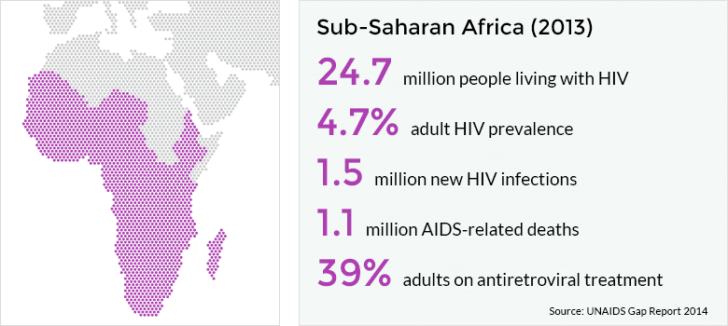](http://www.google.co.uk/url?sa=i&rct=j&q=&esrc=s&source=images&cd=&cad=rja&uact=8&ved=0ahUKEwilt93B78jRAhVCPRoKHY-iBIQQjRwIBw&url=http://www.avert.org/professionals/hiv-around-world/sub-saharan-africa/overview&psig=AFQjCNGOxq3UgiO32d5XNjXqmXGBRK6pvg&ust=1484731872948655)

**PART B**

As HIV/AIDS rates increase in a country, there is a significant fall in GDP*. In African countries with 20 per cent or more of the population infected, GDP may decline by up to two per cent a year. Key workers and professionals, who are necessary for development, such as farmers, engineers, agricultural workers and teachers, are falling victim to AIDS.

Employers, schools, factories and hospitals have to train new staff to replace those at the workplace who become too ill to work.

*\*GDP – Gross Domestic Product. Unlike GNI, GDP does not take into account the value of goods accounted for in foreign trade. GDP is the annual value of goods and services provided in a country.*

[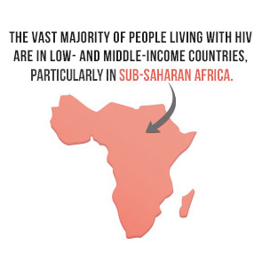](http://www.google.co.uk/url?sa=i&rct=j&q=&esrc=s&source=images&cd=&cad=rja&uact=8&ved=0ahUKEwiexr_Z78jRAhWL2RoKHakxAj8QjRwIBw&url=http://www.celebritydiagnosis.com/2014/12/world-aids-day-2014/&bvm=bv.144224172,d.d2s&psig=AFQjCNGiDUA0Yr1F28rcHz5MlaWCYnU5Xg&ust=1484731936472579)

**PART C**

In 2012 in sub-Saharan Africa an estimated 1.2 million people died of HIV/AIDS and a further 1.8 million people were newly infected, adding to the estimated total of 24 million already living with HIV. A report published by the United Nations warns that HIV/AIDS will kill half of all 15-year-olds in Botswana and Zimbabwe by 2015 if something is not done. Clearly there is an HIV/AIDS epidemic in Africa that shows no signs of slowing down. In killing 6,000 people a day, HIV/AIDS claims more lives than war, famine and floods combined.

In Malawi, devastating food shortages have resulted as a consequence of high rates of HIV/AIDS. It is estimated that by 2020, Malawi’s agricultural workforce will be 14% smaller than it would have been without HIV/AIDS. In other countries, such as Mozambique, Botswana, Namibia and Zimbabwe, the reduction is likely to be over 20%.

In 2008, Toby Solomon, the Commissioner for the Nsanje district in Malawi, summed up the devastation caused by HIV/AIDS on agricultural production: *‘*Our fields are idle because there is nobody to work them. We don’t have machinery for farming, we only have manpower – if we are sick, or spend our time looking after family members who are sick, we have no time to spend working in the fields.’

**PART D**

Older children often take on the role of a mother of father to their younger brothers or sisters. They live in extreme poverty without services or support. In some African countries, a larger proportion of orphans have lost their parents to AIDS than to any other cause of death, meaning that were it not for the AIDS epidemic, these children would not have been orphaned.

HIV/AIDS places huge burdens on societies in Africa. Medical services cannot cope with demand as around 50% of hospital beds in some countries have been given over to AIDS sufferers. The economy suffers and the social problems created are immense.

