**Extension - What causes conflict?**

Conflict happens for many different and often complicated reasons. Some conflicts arise out of differences between people e.g. Sudan. Others arise from weak or corrupt government e.g. Somalia or the DRC. However, in recent years an increasing number of conflicts have arisen from competition over resources such as access to water or other natural resources.

**Number of conflicts**

Although there are several serious on-going conflicts within Africa, the good news is that the number of conflicts has fallen in recent years. Some countries such as Angola and Mozambique are now free from war and as a result have made extraordinary economic and social progress. For example, Angola saw its economy grow by more than 10% in 2012. Free from conflict and with good governance many African countries have the natural resources that would allow them to be far wealthier and not dependent on aid.

**Questions**

1. Explain **two** reasons why conflict may arise in African countries.

2. Study the graph below then answer the question which follows.

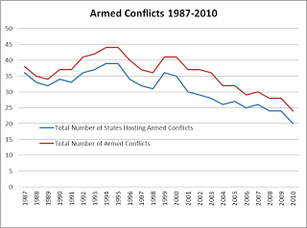 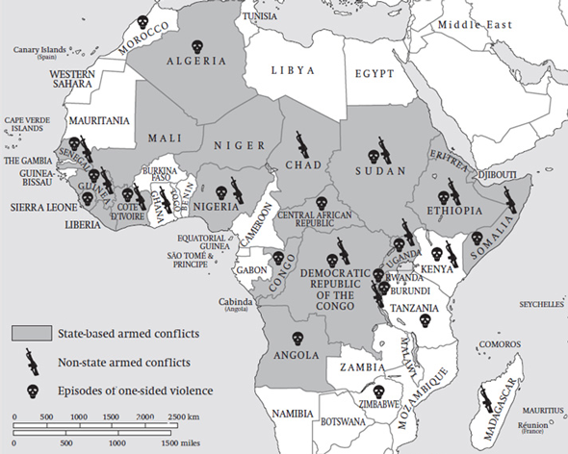

What **conclusions** can be drawn about:

* The trend in the number of armed conflicts across the world since 1987?
* The number of countries in Africa that have been affected by war in recent years?