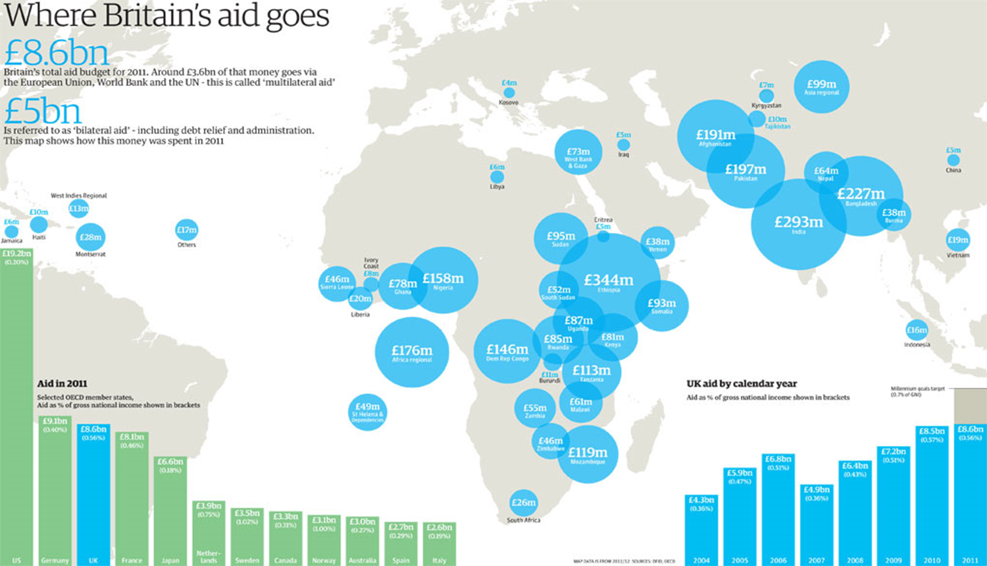**Worksheet 3**

What **conclusions** can be drawn about each of the following:

* The parts of the world receiving most UK aid (main map)
* The amount of aid given by the UK compared to other countries (bar chart bottom left)
* The amount of aid given by the UK between 2004 and 2011 (bar graph bottom right)

For each of the bullet points above use the writing frame below

**One conclusion that can be made about the parts of the world receiving the most amount of aid is …………………….., for example…**