AUSCHWITZ-BIRKENAU

Probably the most infamous of the Nazi concentration camps Auschwitz was created in April 1940 and was closed in 1945. It was based near Krakow in Poland.

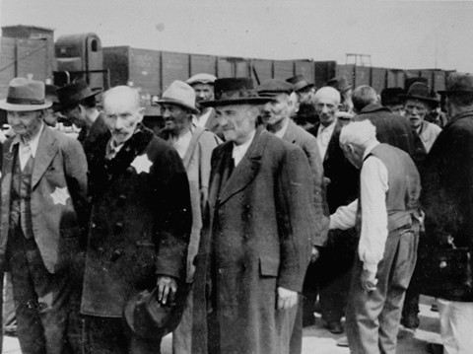
It was used as an extermination and labour camp. This meant some people would be taken straight to be killed in the gas chambers. Others were allowed to live but forced to carry out back-breaking work.

Prisoners arrived at Auschwitz by train. Males and females were separated and were forced to live in separate blocks. Every prisoner was inspected by a Nazi doctor who decided whether or not they were fit enough to carry out the forced labour. Those who were not were sent straight to the gas chambers. This meant that almost all elderly people and very young children were killed straight away.

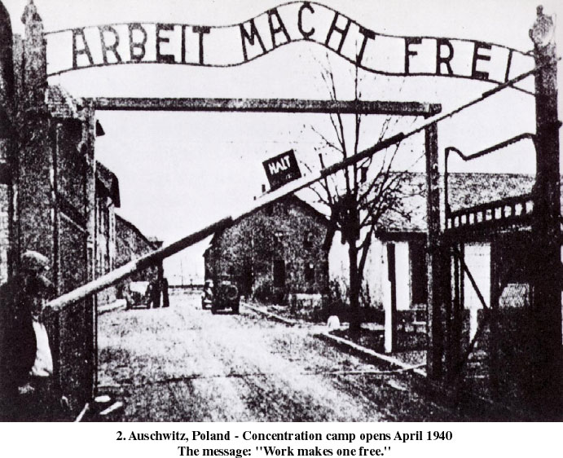
The Nazis put up at the camp entrance saying “Arbeit Macht Frei” – “work makes you free”. This was used to trick the Jews into thinking that if they worked hard enough they may be freed one day.

It is estimated that the camp could hold around 6,000 prisoners at any one time. The estimated death toll in the camp stands at 960,000. However, the Soviets who liberated the camp set this much higher at 4 million.

BERGEN-BELSEN

Bergen-Belsen was situated in North West Germany. The camp functioned from April 1943 to April 1945.

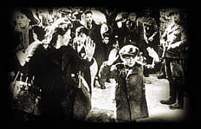
The camp was originally set up as an exchange point. The Nazis hoped that prisoners here could be exchanged for German political prisoners held abroad. As time went on the camp became more of a collection point where prisoners were kept.

The camp was made up of a number of different camps. These were split into camps for prisoners of different nationalities or who had been sent from other concentration camps.

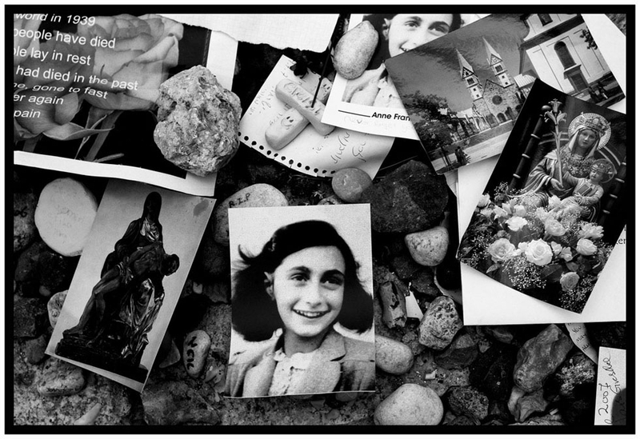
The conditions in Bergen-Belsen were awful. Some people died of Typhus, a disease that causes high fever and affects the mind. Many others, however, died of starvation. The camp was originally meant to hold 10,000 prisoners but when liberated soldiers found there were 60,000 prisoners being held there.

The camp did not have any gas chambers. Over 35,000 people died here of starvation, over work, disease or as a result of horrific medical experiments. It is thought that the Typhus epidemic began as a result of Nazi experiments to try and find a cure for the disease. Anne Frank was amongst the prisoners that died here.
DACHAU

Dachau was located in southern Germany. It was the first of the Nazis concentration camps and functioned from March 1933 to April 1945. The camp was originally set up as a forced labour camp.

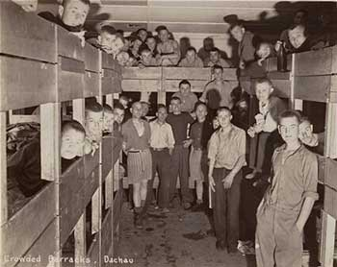
The conditions in the camp were below human dignity. People were crammed in together and sanitation was very poor. This meant when diseases broke out they spread very quickly. People were often worked to death in the camps.

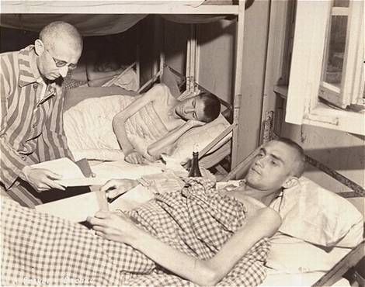
Another major threat was the cruel medical experiments carried out by Nazi doctors. Nazi doctors deliberately infected prisoners with Malaria and experimented with different drugs to see what happened. They also plunged men into freezing cold water to see how long it would take for them to die.

It is thought that in the 12 years in which the Nazis ran the camp over 200,000 prisoners passed through it. It is estimated that around 32,000 people died in this camp.

TREBLINKA

Treblinka was based in Poland. The camp was an extermination camp. People were taken here to be killed. This camp operated between July 1942 and November 1943.

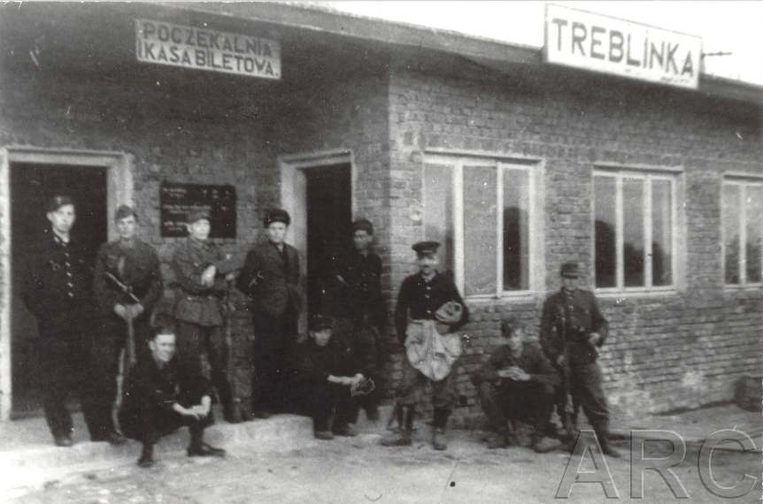
The only function of this camp was to kill groups hated by the Nazis. The camp was disguised to look like a railway station. This was to stop the victims from realising their fate. When prisoners arrived at Treblinka they were separated by gender and ordered to strip naked. In the winter the temperature dropped below -20C. Any prisoners who tried to resist the selection process were taken to the ‘infirmary’ where they were immediately shot.

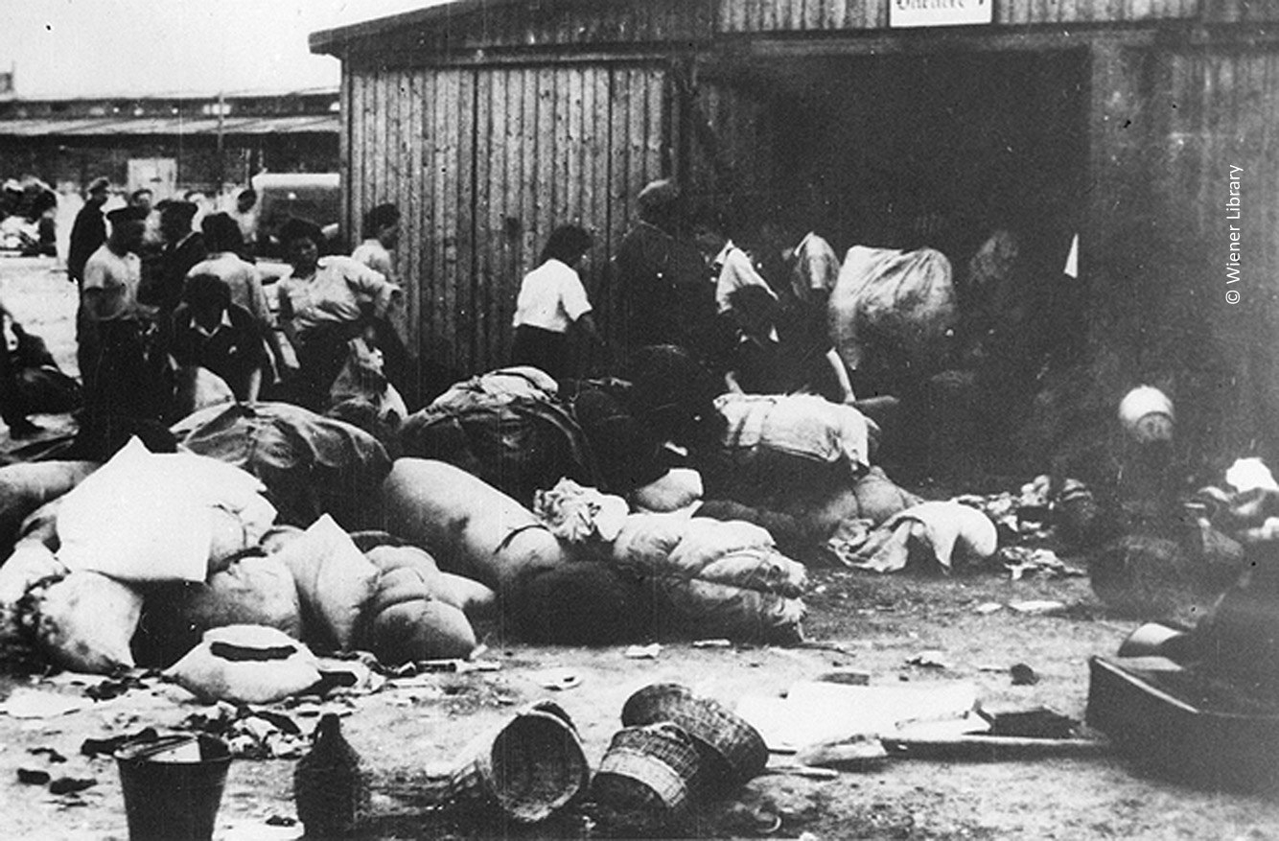
Groups of Jewish prisoners were forced to carry out the necessary tasks involved in mass killings. For example, one group of prisoners were told to take the belongings of those being taken to the gas chambers. Another group of prisoners who had been dentists before the war, were made to remove any gold teeth from dead prisoners. Finally, others were made to remove the dead bodies and take them to the mass graves or crematoriums.

In August 1943, the prisoners tried to rebel. They set fire to the camp buildings and killed some of the guards. Some prisoners managed to escape, others did not. However, soon after the uprising the camp was closed.

It is estimated that 870,000 people were killed here.

