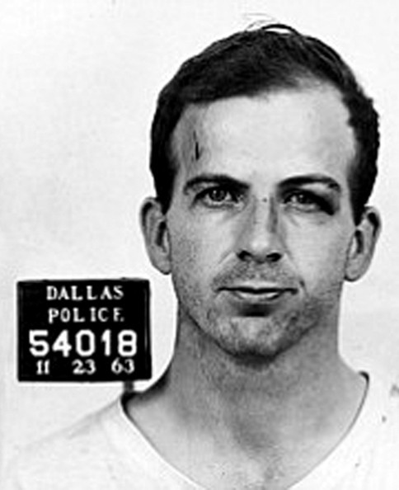**Evidence 1 – Lee Harvey Oswald**

Lee Harvey Oswald was born in 1939. He was a former US Marine who defected to the Soviet Union (Russia) in 1959. He taught himself Russian. He expressed an interest in becoming a Soviet citizen. He married a Soviet woman, Ella German. He lived there for 3 years and returned to the US in 1962.

Oswald was suspected of assassinating retired US Major General Walker, who was anti-Communist. Oswald had purchased a rifle using mail order and in a fake name

Oswald was pro Cuba and pro Fidel Castro. He had handed out pro-Cuban leaflets in New Orleans a few months before Kennedy was killed.

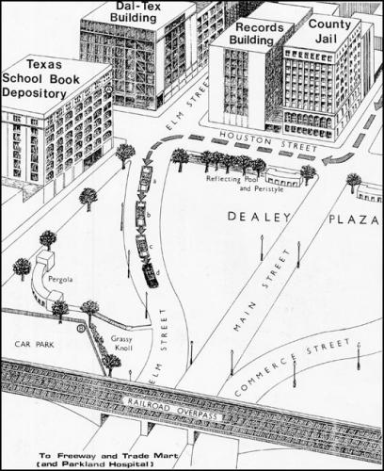Oswald worked at the school book depository in Dallas, Texas. The building overlooked the Presidential motorcade route on 11th November 1963. It had been heavily reported in Dallas newspapers that this was the route.

Oswald had been spotted with a large package in the days before the assassination. He told a co worker it was curtain rods.

Oswald was working on the day of the assassination. He was unaccounted for during the time of the shooting.

Co-workers who saw Oswald soon after the shooting said he acted normally and did not appear to be nervous or anxious.

Shortly after 12.40pm he was found to be missing from work.

**Evidence 2 - The Weapon**

The shots were fired from a Carcano M91/38 bolt-action rifle.

It was found on the 6th floor of the Texas School Book Depository.

In March 1962, Lee Harvey Oswald purchased a Carcano M91/38 bolt-action rifle under the name ‘A. Hiddell’ and had it delivered to a Post Office Box he rented.

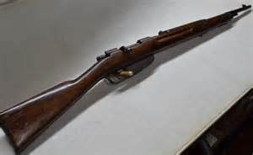

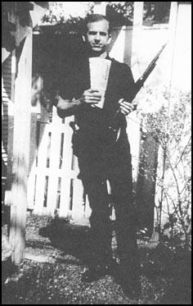

Photograph of [Lee Harvey Oswald](http://spartacus-educational.com/JFKoswald.htm)  
taken on 31st March, 1963.

**Evidence 3 – Witness Statements**

It is estimated that there were around 600 people in Dealey Plaza at the time of the assassination. Witness statements exist for around 200 of them.

Many witnesses said the shots fired came from the direction of the Texas school Book Depository.

However, a majority have said they also heard shots coming from the ‘grassy knoll’, closer to the motorcade.

Some witnesses also said they saw smoke on the grassy knoll.

The behaviour of the police following the assassination also points to shots from the grassy knoll. Police raced to the knoll in the minutes after the shooting to search for the gunmen. Many more police headed there than to the school book depository.

Witnesses do not agree on how many shots were fired. Some say three, but some accounts say there were definitely four or five shots fired.

In the years following the assassination, many of the witnesses to the assassination died in suspicious and unnatural causes. Many of these were gunshot wounds which were put down to suicides.

**Evidence 4 – Babushka Lady**

‘Babushka Lady’ was the name given to an unknown older woman watching the motorcade and assassination who looks as though she was taking pictures.

She was given the nickname due to the headscarf she wore on her head, similar to that of older Russian women.

In the Zapruder film, she is caught on camera taking pictures.

The lady did not come forward to the police or FBI following the assassination. She has never been identified. She may or may not have photographs of the assassination and/ or those involved.

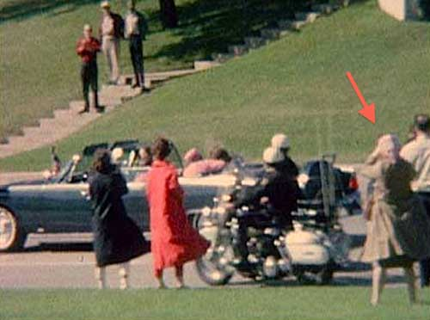

Evidence 5 – Umbrella man

A person popularly dubbed the "umbrella man" has been the object of much speculation, as he was the only person seen carrying, and opening, an umbrella on that sunny day.

He was also one of the closest bystanders to President John F. Kennedy when Kennedy was first struck by a bullet. As Kennedy's limousine approached, the man opened up and lifted the umbrella high above his head, then spun or panned the umbrella from east to west (clockwise) as the president passed by him. In the aftermath of the assassination, the "umbrella man" sat down on the sidewalk next to another man before getting up and walking towards the Texas School Book Depository.

Early speculation came from assassination researchers Josiah Thompson and Richard Sprague who noticed the open umbrella in a series of photographs. Thompson and Sprague suggested that the "umbrella man" may have been acting as a signaler of some kind, opening his umbrella to signal "go ahead" and then raising it to communicate "fire a second round".

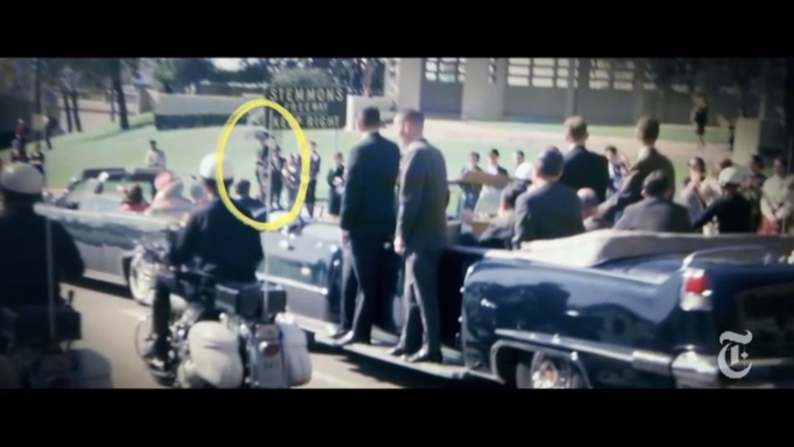

Evidence 6 – Police Officer JD Tippit 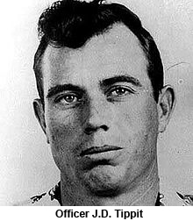

On the day of the assassination, Officer Tippit was on patrol in downtown Dallas.

Shortly after 12.30pm several messages had been broadcast describing a suspect in the Kennedy assassination as a slender white male, in his early thirties, 5 feet 10 inches (1.78 m) tall, and weighing about 165 pounds (75 kg).

Lee Harvey Oswald was a slender white male, 24 years old, 5 feet 9 inches (1.75 m) tall, and an estimated weight of 150 pounds (68 kg) .

At around 1.11 pm Tippit was driving through Dallas City Centre and pulled over Lee Harvey Oswald. Oswald walked over to Tippit’s car and the men exchanged words. Oswald pulled out a handgun and shot Officer Tippt three times in the chest.

Oswald went to the nearby Texas Theatre and ducked inside without buying a ticket. He was seen by eyewitness and arrested by police.

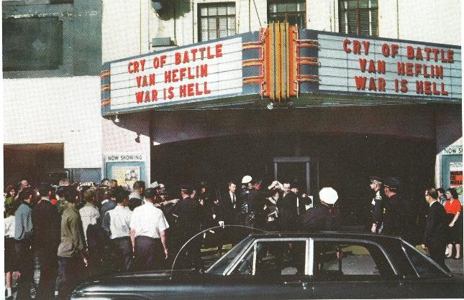Upon his arrest and during subsequent questionings by police, Lee Harvey Oswald denied any involvement in Tippit's murder. Based on eyewitness' statements and the gun found in Oswald's possession at the time of his arrest, he was formally charged with the murder of J.D. Tippit at 7:10 pm. on November 22.

Evidence 7 - The Magic Bullet

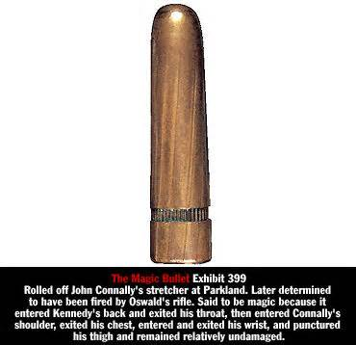Texas Governor John Connally was also shot on the 22 November 1963. Connally sustained injuries to his chest, wrist and thigh.

It was claimed by experts that due to the lack of damage to the Presidential limousine, the same bullet caused the Governor’s injuries and Kennedy’s non-fatal injuries. Therefore this bullet caused seven wounds in total.

If this was true, the bullet travelled through Kennedy’s neck, Connally’s chest then Connally’s wrist then became embedded in his thigh.

Connally always protested that he was 100% definitely not hit by the first bullet. If he was hit by a different bullet, that means more than 3 gunshots and perhaps more than one gunman.

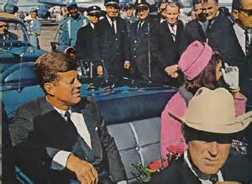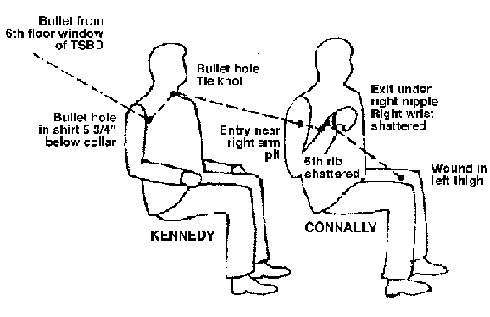The ‘magic bullet’ was found on Connally’s stretcher at the Parklands Memorial Hospital.

Evidence 8 – The Autopsy

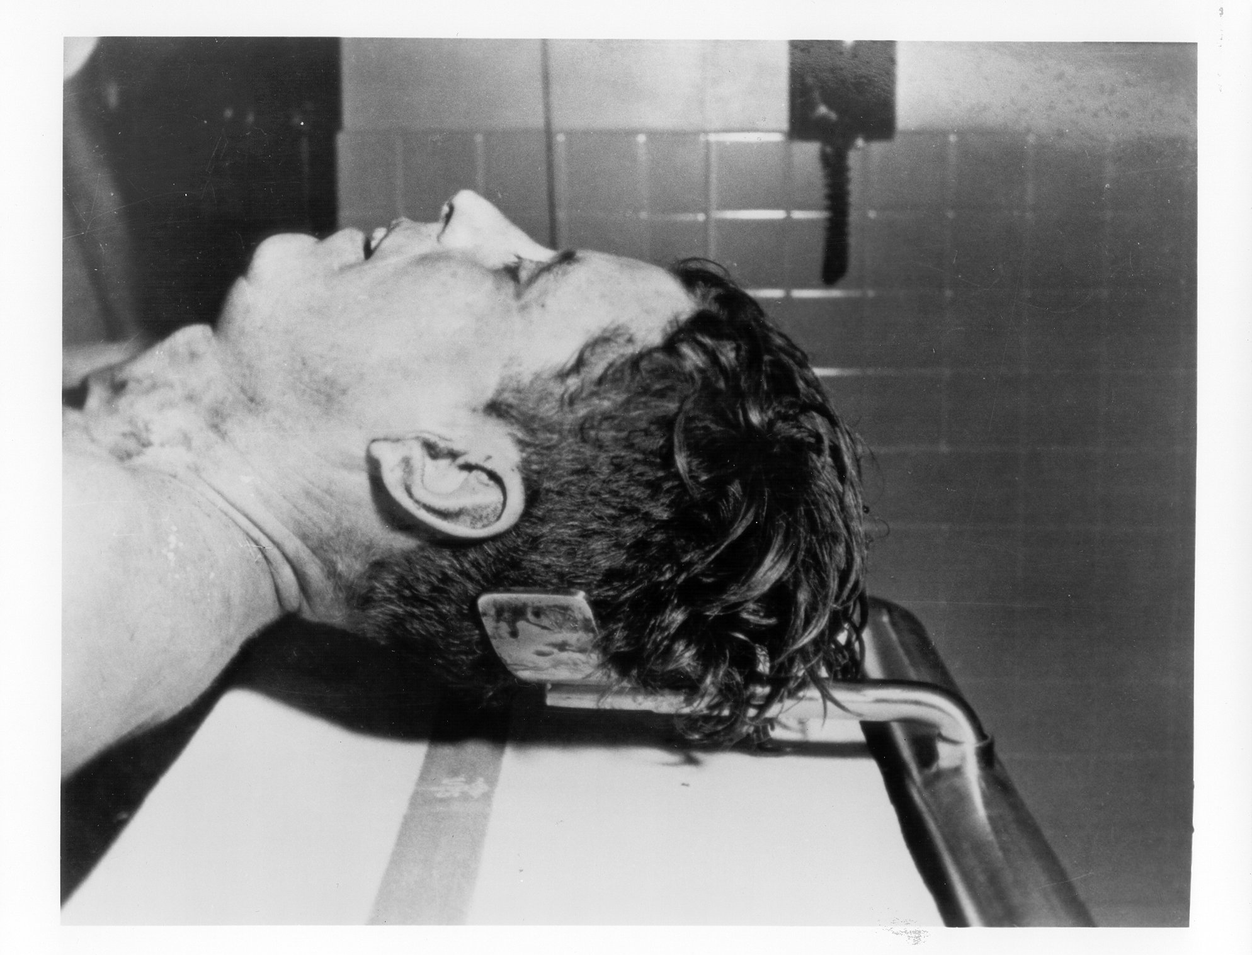According to US law, the autopsy should have taken place in Texas where President Kennedy died.

Dallas County Medical Examiner Earl Rose was told by a Secret Service Agent and Kennedy’s personal doctor that there would be no time for an autopsy as Jacqueline wanted to take her husband’s body home.

Earl Rose objected and stated that the autopsy must be done in Dallas. But Kennedy’s body was removed from the hospital and taken back to Washington on Air Force One.

The Autopsy ruled that President Kennedy was shot twice, once in the back of the neck and once in the head. The Head shot was fatal.

Kennedy’s brain was taken out during the autopsy and put in a stainless steel storage jar.

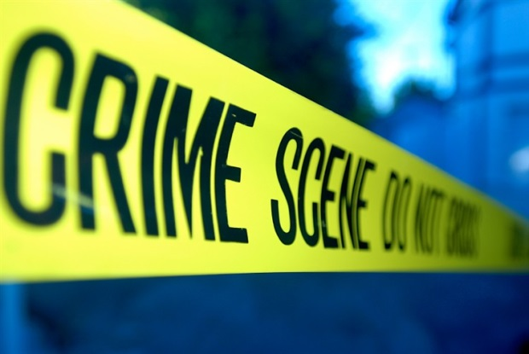In 1966 it was discovered that the brain was missing.

Evidence 9 – The Death of Lee Harvey Oswald

After being charged with the murder of Officer Tippit, also on 22 November 1963, Lee Harvey Oswald was strongly believed to have been the assassin of JFK too.

In his interrogations from police, Oswald always denied killing Kennedy. Oswald claimed he was eating his lunch at the time of the assassination.

Oswald always claimed to be a ‘patsy’ - that he was being used as a cover up for the real assassin. Oswald said his links with Russia had been exaggerated and photos of him holding rifles were fakes.

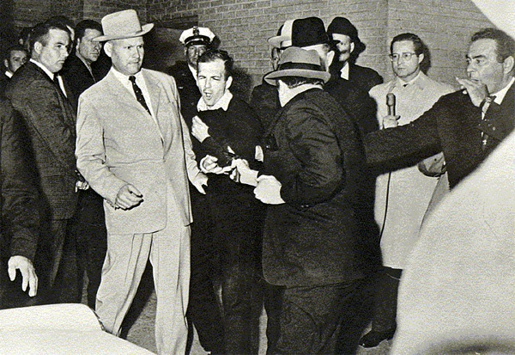On 24 November, two days after Kennedy was assassinated, Oswald was shot dead outside Dallas Police HQ as he was taken to an armoured car.

Jack Ruby was the man who killed Oswald. He said he had been utterly distraught over the Kennedy death and shot Oswald to save Jackie having to give evidence at a trial.

Jack Ruby died of lung cancer in jail in 1967.

Evidence 10 – Rose Cheramie

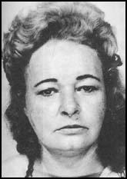Rose Cheramie was found unconsciousness by the side of the road on 20th November, 1963. The Louisiana State Police took her to the state hospital. On the journey Cheramie said that she had been thrown out of a car by two gangsters who worked for Jack Ruby. She claimed that the men were involved in a plot to kill John F. Kennedy. Cheramie added that Kennedy would be killed in Dallas within a few days. Later she told the same story to doctors and nurses who treated her. As she appeared to be under the influence of drugs her story was ignored.

Following the assassination, Cheramie was interviewed by the police. She claimed that Lee Harvey Oswald had visited Ruby's night club.

Rose Cheramie was found dead on 4th September, 1965. At first it appeared she had been involved in a road accident. Later it was argued that she had been shot in the head before being run over by by a car in order to disguise the original wound.