**1 – The Cuban Missile Crisis**

The Cuban Missile Crisis brought the two superpowers, Russia and the USA to the brink of nuclear war. Russia had been a Communist country for many years and this made them an enemy of the USA as a Capitalist country. The USA hated Communism and would do all it could to destroy it.

Cuba is an island just off the coast of America, about 90 miles from Florida. In the 1950s America invested lots of money in this island, it became a bit like a mini-Las Vegas and a playground for rich Americans.

Then, in 1959, there was a revolution in Cuba. A general called Fidel Castro overthrew the government. When Castro took over, he made Cuba communist.

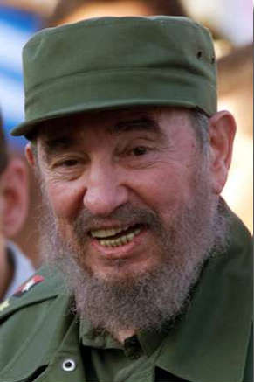

**What Did Castro Do?**

Took over all American companies in Cuba (Shell, ESSO, etc…) All profits now went to Cuba and not the USA.

He took over the Hilton hotel and turned it into a hospital for poor Cubans.

He turned to the USSR for money.

America lost millions of dollars and now believed that there was a communist base only 90 miles away from the coast of America.

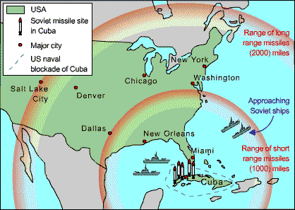Castro turned to Russia to sell Cuban sugar as the USA no longer wanted to trade with Cuba. This brought Cuba and Russia closer together which was a threat to the United States.

Then, things got a lot worse! On Tuesday 16th October 1962, President Kennedy received news that Soviet (Russian) missile sites had been found on Cuba by American spy planes.

Kennedy faced a difficult decision. He felt that Khrushchev the Russian leader was trying to test him as a relatively new and young President. Kennedy knew if he attacked Cuba it would almost certainly mean a nuclear war with Russia. But if he ignored the missiles, it would look as though Russian was winning the Cold War.

Kennedy decided to surround Cuba with US Naval ships in what was known as a ‘quarantine’.

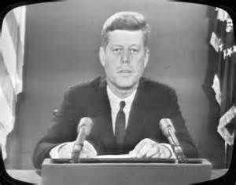On Monday 22 October, Kennedy went on radio and television, describing the secret Soviet build-up in Cuba, proclaiming the quarantine, and demanding that the Soviets remove the missiles

Kennedy sent his brother, Robert, to meet the Soviet Ambassador. Robert said that the USA would be willing to remove their missiles they had on Turkey, if Russia removed theirs from Turkey.

Over the next few days, Khrushchev, the leader of the USSR sent his ships carrying Soviet Missiles to Cuba where they met the American ships. The whole world waited with bated breath for what seemed like an inevitable nuclear war.

In the end, Khrushchev turned his ships around and ordered the dismantling of the nuclear missiles on Cuba.

Historians largely agree that Kennedy was successful in avoiding entering a full on nuclear war with Russia. Kennedy had shown Russia that he would not give in to the Soviets and he was a stronger Khrushchev had first thought. Kennedy had succeeded in keeping the Cold War ‘cold’ for now.

[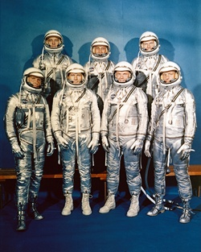](http://www.jfklibrary.org/Asset-Viewer/SgAWa7nljkmN-6qz28tG9g.aspx)2 – The Space Race

Two key parts of the Cold War with Russia were the Arms Race and the Space Race. The Arms race was the way that the USA and Russia competed to build up the most sophisticated and dangerous nuclear weapons which they could use to destroy one another. The Space Race was the public competition to see which Superpower could travel in space first. It was felt that ‘winning’ these races proved the power and success of one country over the other.

In 1957, the Russians launched the satellite Sputnik, and the space race was on. The Soviets' triumph annoyed the American people and sparked a vigorous race in the US to make sure the United States did not fall behind its Communist rival.

On April 12, 1961, when Soviet cosmonaut Yuri Gagarin became the first person to fly in space, reinforcing American fears about being left behind in a technological competition with the Soviet Union

Kennedy was worried. If the United States fell behind in the ‘Space Race’ then people would think the US was losing the Cold War.t looked bad for a Communist Country to be performing so much better in terms of technology.

In 1961, President John F. Kennedy began a dramatic expansion of the U.S. space program and committed the nation to the ambitious goal of landing a man on the moon by the end of the decade.

Kennedy asked Congress for more money to spend on NASA and putting a man on the moon. Kennedy wanted to modernise NASA as he felt that the previous administration (Eisenhower) had not prioritised Space travel.

Kennedy had two new NASA centres built and appointed a new leader to lead the *Appollo* programme. It was estimated to cost $40 billion.

[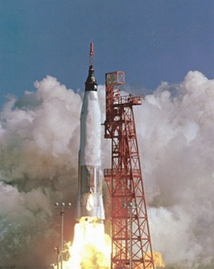](http://www.jfklibrary.org/Asset-Viewer/rq8ZnBljq0aStsBQ61Rulw.aspx)On February 20, 1962, John Glenn Jr. became the first American to orbit Earth. Launched from Cape Canaveral, Florida, the Friendship 7 capsule carrying Glenn reached a maximum altitude of 162 miles and an orbital velocity of 17,500 miles per hour.

**Apollo 11** was the first spaceflight that landed humans on the Moon. Americans Neil Armstrong and Buzz Aldrin landed on July 20, 1969, at 20:18.

Although this was several years after President Kennedy’s death, historians agree that the money and attention Kennedy gave to the Apollo programme allowed the USA to have the first man on the moon.

He also helped raise the morale of the US people, at a time when they felt the Russians were starting to win the Cold War.

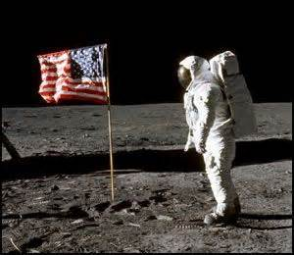Kennedy also appeared on TV in September 1963 asking the Russians to join the US and make the space expeditions a joint project. He thought this would reduce tension between the two countries and allow them to make more progress together. The Russians refused.

3 – Segregation

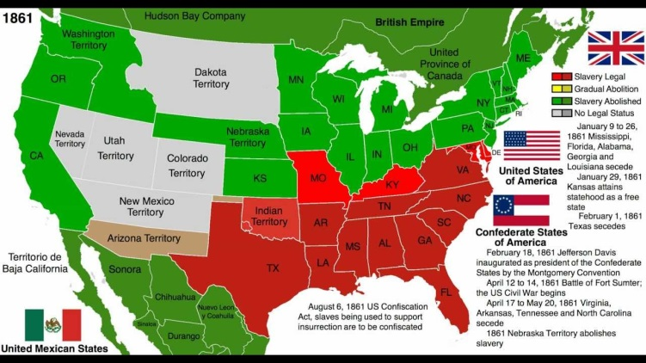

From 1865, slavery was illegal in the United States. However, many states in the South still believed that African Americans should not be treated as equals with white Americans. Since states could make many of their own laws, many States in the South were still passing laws which made life difficult for Black Americans.

President Kennedy needed to protect all US citizens, regardless of their colour. He has promised to help Black Americans achieve civil rights in his election campaign. However, he was presented with many difficulties because many State senators and governors wanted to keep racist laws and segregate white and Black Americans.

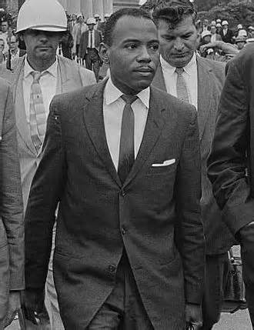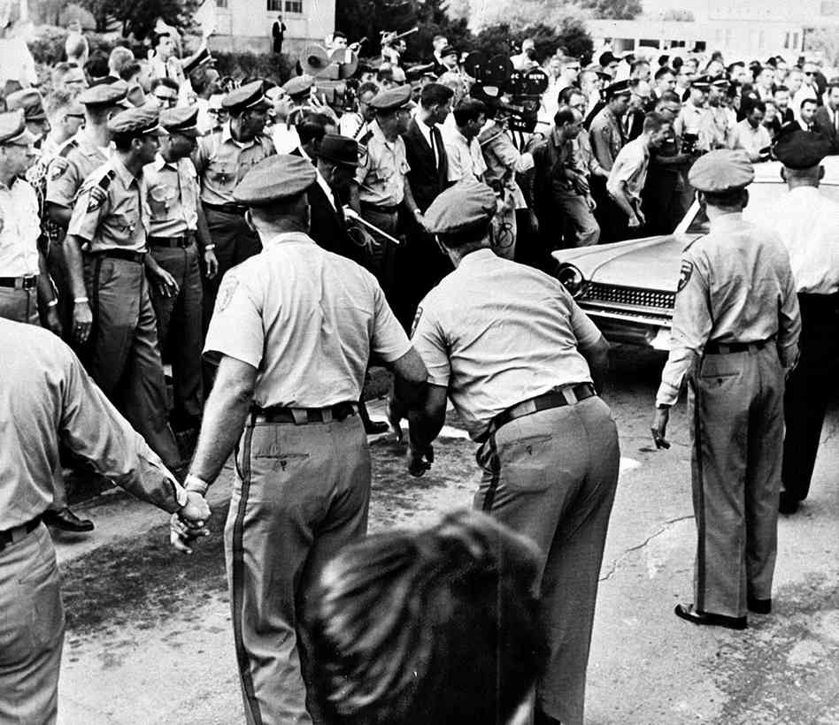For many years the University of Mississippi had only allowed white students to attend. In September 1962, black student James Meredith enrolled. When he turned up on his first day, a racist violent mob stopped him from entering. Riots broke out and two people were killed. Dozens were injured. Kennedy sent in 4000 troops to calm the riots. The following month he passed a new law, Executive Order 11063, preventing segregation in housing and public facilities.

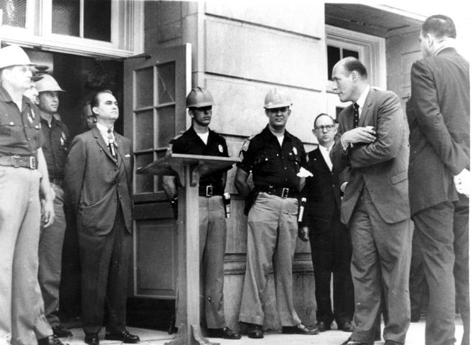In June 1963, Governor George Wallace of Alabama blocked the entrance to the University of Alabama to stop two African American students entering. Again, President Kennedy sent in the National guard to show that he would not allow states to segregate Black Americans. That evening Kennedy gave his famous civil rights address on national television and radio, launching his initiative for civil rights legislation—to provide equal access to public schools and other facilities, and greater protection of voting rights.

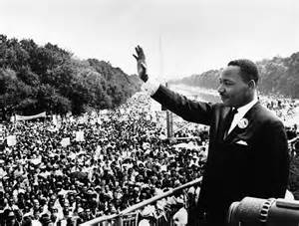Over a hundred thousand, mainly African Americans, gathered in Washington for the civil rights March on Washington for Jobs and Freedom on August 28, 1963. Kennedy gave hundreds of thousands of dollars to the six sponsors of the March, including the N.A.A.C.P. and Martin Luther King's Southern Christian Leadership Conference (SCLC).

To ensure a peaceful demonstration, the organizers and the president personally edited speeches which were inflammatory and agreed the March would be held on a Wednesday and would be over at 4:00 pm. Thousands of troops were placed on standby. Kennedy watched King's speech on TV and was very impressed. The March was considered a "triumph of managed protest", and not one arrest relating to the demonstration occurred. Afterwards, the March leaders accepted an invitation to the White House to meet with Kennedy and photos were taken. Kennedy felt the March was a victory for him as well and bolstered the chances for his civil rights bill.

By intervening in these situations, Kennedy proved he was not going to accept segregation or unfair treatment of Black Americans. He kept his promise to Black Americans that he would help them get equal treatment. However, his actions also made many in Southern States unhappy. Many white Americans wanted to have separate facilities for Black and White Americans. Many states also believed that they should be able to pass their own laws.

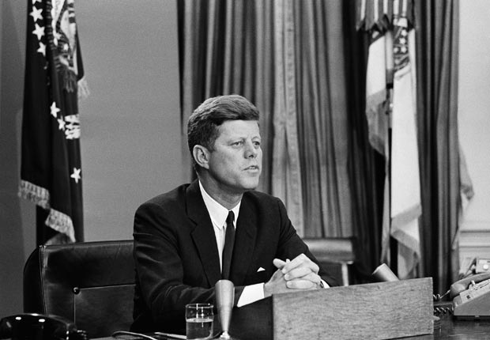The Civil Rights Act 1964 was passed the year after Kennedy’s death. Most historians agree that it would not have come about had it not been for President Kennedy’s hard work in trying to end segregation for Black Americans. The Act outlawed discrimination based on race, color, religion, sex, or national origin. It also ended unfair voting qualifications, allowing more Black Americans to register to vote.