The Battle of Stirling Bridge
Resource Sheet 9

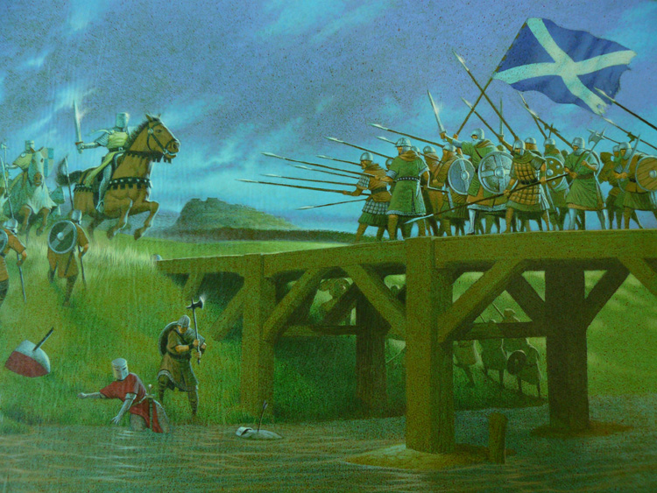

On September 11th 1297, the Scottish army, led by William Wallace came up against the mighty English army, which was led by the Earl of Surrey, at Stirling Bridge. The battle took place in Stirling around 40 miles away from where Glasgow is today.
The Scots chose the area around the bridge at Stirling as the battlefield.
When the Earl of Surrey arrived at Stirling, he tried to convince the Scots to surrender before the battle, but the Scots refused. Surrey then held up his own attack by oversleeping!
Rather than send his men across the River Forth, Surrey decided to attack across Stirling Bridge.
The bridge was so narrow that only two men could advance at once. This was a major mistake made by Surrey.
Another error was that the English were over confident. They thought they would easily defeat the Scots. The fact that the English had heavy armour made it hard for them to cross the bridge easily.
The Scots used the bridge to their advantage. They used a method called a schiltron.
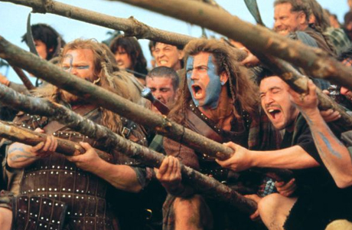
This was where the soldiers held their spears up at different levels to create a hedgehog effect. English soldiers who charged towards the schiltron would either go straight into the spears or avoid them by going in different directions. This split the English army in two making it easier for the Scots to defeat them. The Scots cleverly waited until the English soldiers were half way across the bridge before attacking. Most of the English soldiers were killed and the rest fled back to England.

