The Ragman’s Roll
Resource Sheet 7


- Your teacher will give you a piece of paper or card
- Carefully rip the edges from the paper, being careful not to rip off too much paper
- Scrunch up the paper into a ball, then straighten it out again
- Your teacher will provide you with a tea bag and water – carefully dab a damp teabag over the paper until it looks yellow and aged
- Your Ragman’s Roll now needs time to dry
- Use coloured pens or markers to write on the content of the Ragman’s Roll
- Create the ‘seals’ of the Nobles who signed it from coloured paper and stick on to the bottom – you might want to get classmates to add their signatures on to the seals
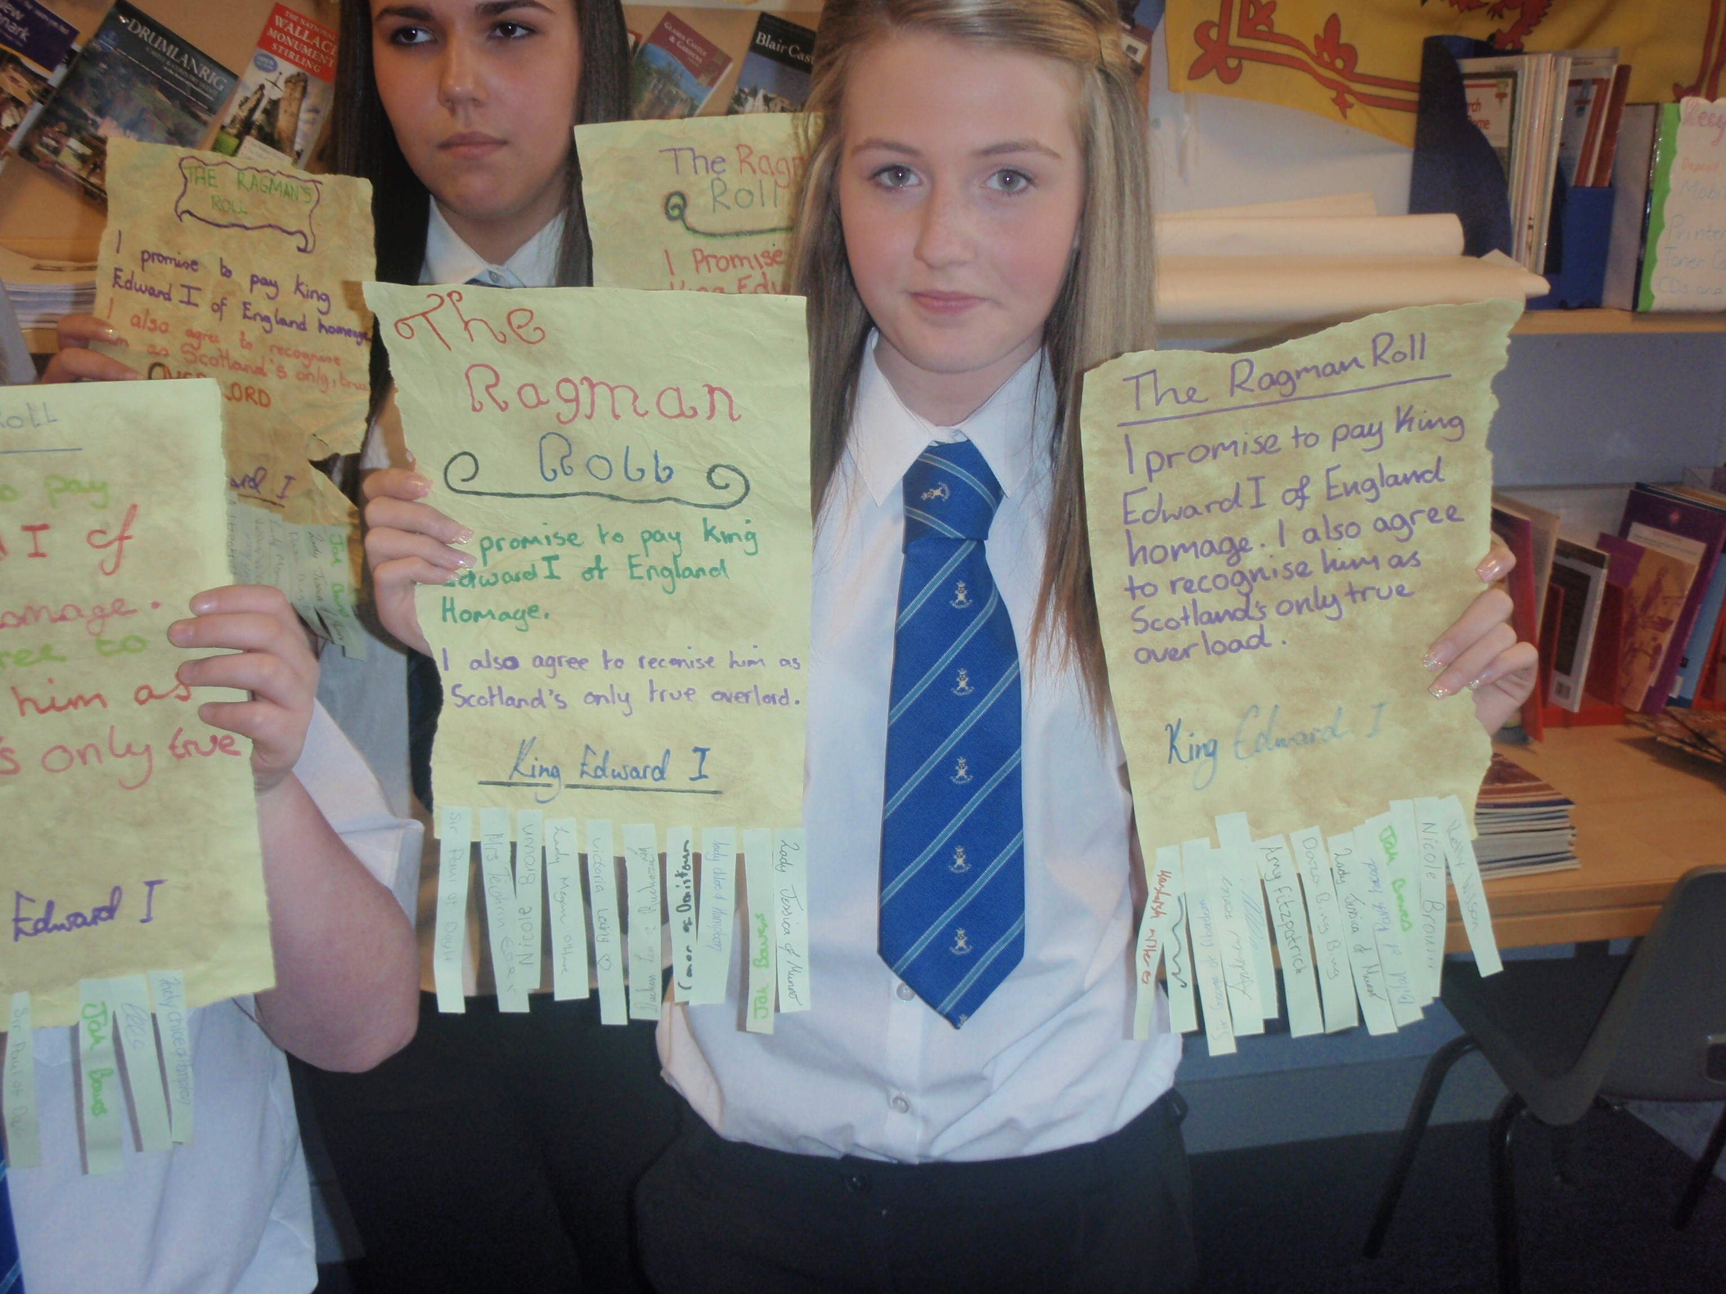

Help Box
The Ragman’s Roll

A document the King Edward made the Scottish nobles sign. The document accepted Edward as their Overlord and ruler of Scotland. It said that Scottish Nobles would obey Edward as if he were King.

